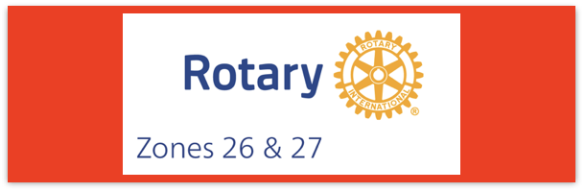

Join us on the “last mile” to end polio!!
End Polio Now Coordinators/Leaders: Mike Crosby & Marny Eulberg
mikePolioPlus@outlook.com and marnyeul@me.com
Almost weekly polio update……….. January 11, 2024
Mostly good news—no new cases of wild poliovirus caused paralysis this week, but 16 positive environmental samples for WPV type 1
Wild Poliovirus Cases reported this week: None
Most recent wild poliovirus cases: Afghanistan: 09/04/23
Pakistan: 10/24/23
Human cases confirmed | As of 1/2/24 | Total | Total | Total | Total
 | 2024 | 2023* | 2022 | 2021 | 2020
WPV (Wild Poliovirus) | 0 | 12 | 30 | 6 | 140
WPV--Afghanistan | 0 | 6 | 2 | 4 | 56
WPV-Pakistan | 0 | 6 | 20 | 1 | 84
WPV- Other countries | 0 | 0 | 8 | 1 | 0
Variant (circulating vaccine derived -cVDPV polioviruses | 0 | 456 | 878 | 699 | 1117
*some cases with onset of paralysis in 2023 still likely to be confirmed and reported.
Virus detected from other sources (environmental) this week (but all collected in 2023, so have been added to 2023 numbers.
Wild poliovirus= 16 cVDPV (variant) Types 1,2,3
7 new cases caused by variant polioviruses this week in 5 countries—(3 in Guinea, 1 in Indonesia, 1 in Mozambique, 2 in Nigeria, 1 in Tanzania)

Rick Barry signed basketballs still available!
Limited edition Rick Barry signed basketballs are available through June, up to no more than 500 balls total, for your District or club to purchase and use for a fundraiser for polio. Contact Mike Crosby at mikePolioPlus@outlook.com for questions or ordering info.

HEADLINES

- WHO grants prequalification to novel oral polio vaccine type 2 (nOPV2) - the World Health Organization issued its first ever prequalification
approval for a vaccine being used under its Emergency Use Listing (EUL) regulatory pathway – novel oral polio vaccine type 2 (nOPV2). Since rollout of this next-generation vaccine began in March 2021, the Global Polio Eradication Initiative (GPEI) has administered nearly 1 billion doses of nOPV2 across 35 countries, protecting millions of children against illness and paralysis. Prequalification will enable additional countries to access the vaccine more easily for more sustainable response to outbreaks of type 2 variant poliovirus (cVDPV2). More.

Big West Monthly Peer to Peer Polio Zoom meeting: Here are the dates for the rest of the 2023-24 Rotary year:
Topic: The Last Mile: Together We End Polio
Time: Jan 25, 2024, 04:00 PM Pacific Time (US and Canada)
Jan 25, 2024, 4:00 PM
Feb 22, 2024, 4:00 PM
Mar 28, 2024, 4:00 PM
Apr 25, 2024, 4:00 PM
May 16, 2024, 4:00 PM
Jun 27, 2024, 4:00 PM
Please watch for the January invitation from Mike Crosby –the link may be changing again since we have been allowed access to the Big West Zoom account instead of requiring Mike to use a Zoom account that he purchased.

Note: This update is going out to those on Bob Roger’s previous list and all Zones 2627 DGs and DPPCs. Let me know if you no longer wish to receive these updates or if you have others that should be added. Email me: marnyeul@me.com
For those of you that send out copies or use this newsletter as a template for sending info to your Polio Warriors, I have added attachments in common formats to this email message.

