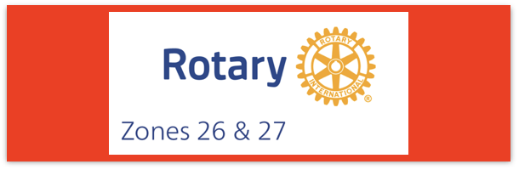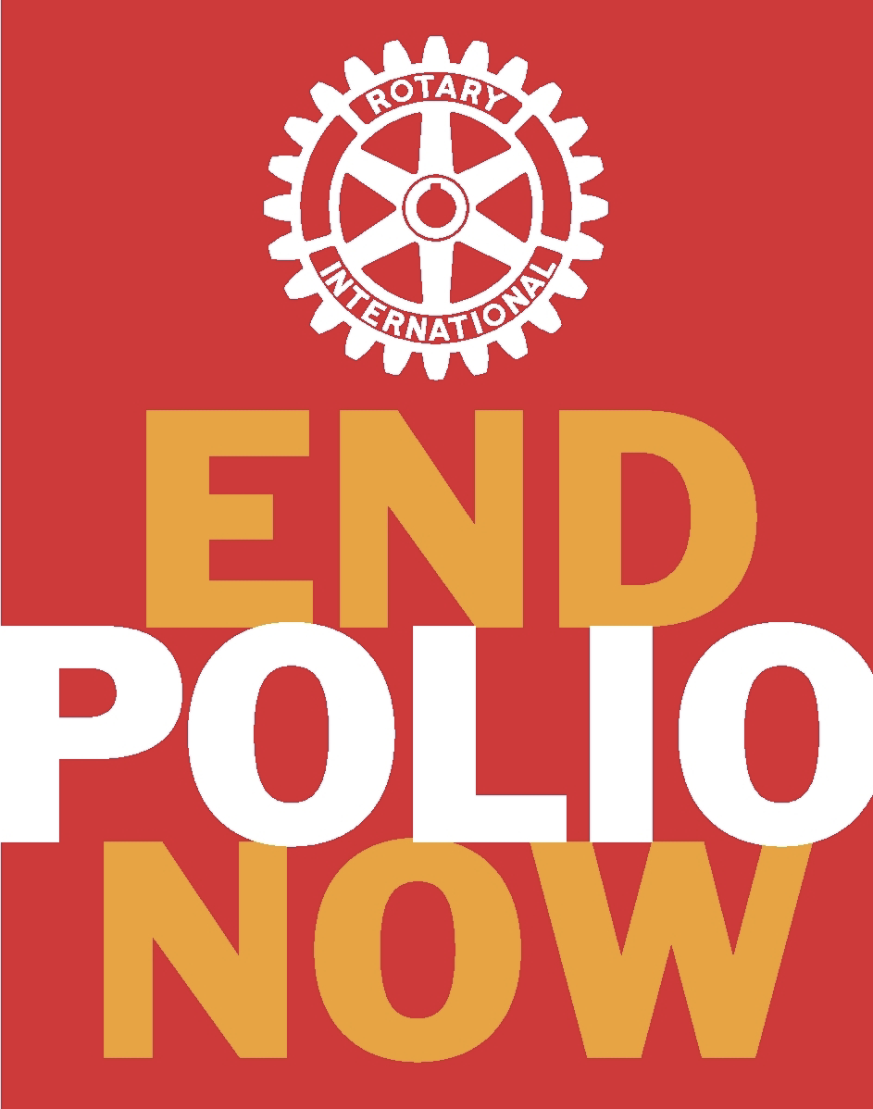
Join us on the “last mile” to end polio!!
End Polio Now Coordinators/Leaders: Mike Crosby & Marny Eulberg
mikePolioPlus@outlook.com and marnyeul@me.com
Almost weekly polio update……….. March 8, 2024
Still no new wildpoliovirus cases have YET been reported from 2024. But three more positive environmental samples for wild poliovirus were collected in 2024 –both from Pakistan. And now in 2024, 3 new variant poliovirus cases
Wild Poliovirus Cases reported this week: None
Most recent wild poliovirus cases: Afghanistan: 09/04/23 Pakistan: 10/24/23
Human cases confirmed | As of 3/5/24 | Total | Total | Total | Total
 | 2024 | 2023* | 2022 | 2021 | 2020
WPV (Wild Poliovirus) | 0 (0 at same time in 2023) | 12 | 30 | 6 | 140
WPV--Afghanistan | 0 | 6 | 2 | 4 | 56
WPV-Pakistan | 0 | 6 | 20 | 1 | 84
WPV- Other countries | 0 | 0 | 8 | 1 | 0
Variant (circulating vaccine derived -cVDPV polioviruses | 3 (10 at same time in 2023) | 517 | 878 | 699 | 1117
*some cases with onset of paralysis in 2023 still likely to be confirmed and reported.
Polioviruses reported from other sources (environmental) this week, and in brackets{} are the total reported from 2023.
Wild poliovirus= 3 {187} cVDPV (variant) Types 1,2,3= 19; {408}
Now, in 2024, reports of 3 variant poliovirus-caused paralysis in one country, Nigeria—and 13 more were added to 2023 totals that were from Chad (1), Guinea (1), Mali (3), Nigeria (5), and Somalia (3)
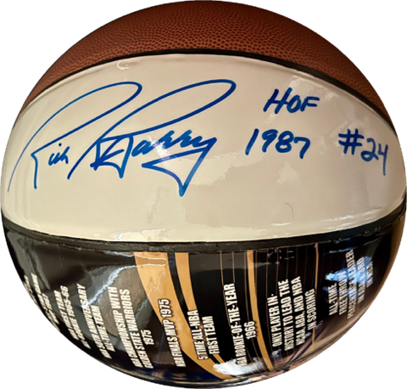
Rick Barry signed basketballs still available!
Limited edition Rick Barry signed basketballs are available through June, up to 500 balls total, for your District or club to purchase and use for a fundraiser for polio. Contact mikePolioPlus@outlook.com for questions or ordering info.

From Reg Ling, Polio Information Officer for R.I. in this week’s “Polio Position”

Early in the week Keith Paver forwarded a WHO epidemiological record. This one was on a 3-day meeting of committees on topics on vaccines safety and common pharmacovigilance issues on vaccines or medicines. Several diseases were covered including the safety of nOPV2.

Approximately 1 billion doses of the vaccine have been administered across 35 countries. In December 2023, nOPV2 earned full licensure from Indonesian regulatory authority as well as WHO prequalification. The use of nOPV2s under WHO EUL is being closely monitored. There were 10 cVDPV2 emergences* derived from nOPV2 but OPV use would have seeded 66 emergences*. In summary, 28 countries reported safety data, and the subcommittee concluded no evidence exists of geographic or temporal clustering,. The same number of countries have functional AFP surveillance.

Regarding the questions on the transition of surveillance in the post qualification period, it was clarified that all monitoring of campaigns is to continue within GPEI. There may need to be a mapping exercise to determine what surveillance networks exist and capacity building for some regulatory authorities may be required. A report should be compiled of best practices and lessons learned.
- Read this carefully,--I had to read and re-read this word before I understood exactly what the word was. This refers to the virus showing up “emerging” and not necessarily an urgent, emergent situation—although we’d all prefer that there had been no emergences at all!
And: Terry Ziegler, incoming EPNC from Texas, is interested to understand whether the experiences with the eradication of polio have brought benefits to Rotary’s other humanitarian efforts. We continue to have exchanges on what they may be, but it is clear that the polio campaign has extended Rotary’s reach and recognition in many ways.
Note: This update is going out to those on Bob Roger’s previous list and all Zones 2627 DGs and DPPCs. Let me know if you no longer wish to receive these updates or if you have others that should be added. Email me: marnyeul@me.com
For those of you that send out copies or use this newsletter as a template for sending info to your Polio Warriors, I have added attachments in common formats to this email message.

