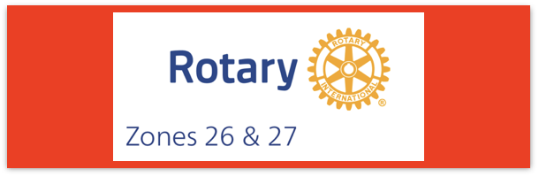
Join us on the “last mile” to end polio!!
End Polio Now Coordinators/Leaders: Mike Crosby & Marny Eulberg
mikePolioPlus@outlook.com and marnyeul@me.com
Almost weekly polio update………….. November 16, 2023
Ugh, 1 more child confirmed to be paralyzed by wild poliovirus this week and 16 positive environmental samples for WPV1.
Wild Poliovirus Cases reported this week: one from Pakistan
Most recent wild poliovirus cases: Afghanistan: 9/24/23 Pakistan:10/27/23
 | As of 11/14/23 | Total | Total | Total | Total
 | 2023 (2022ytd) | 2022 | 2021 | 2020 | 2019
WPV (Wild Poliovirus) | 11 (30) | 30 | 6 | 140 | 176
WPV-Afghanistan | 6 (2) | 2 | 4 | 56 | 29
WPV-Pakistan | 5 (20) | 20 | 1 | 84 | 147
WPV- Other countries | 0 (8) | 8 | 1 | 0 | 0
cVDPV circulating vaccine-derived | 369 (510) | 877 | 699 | 1117 | 378
Positive Environmental (sewage) samples: This week; 2022 total year in brackets { }
Wild poliovirus= 16; {65} cVDPV (variant) 26; {508}
Interestingly, on the very same day I wrote about vaccine misinformation two weeks ago, I received this cartoon from a polio survivor who is a microbiologist
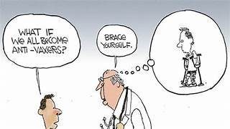
On another note, this week I received a question from someone on our mailing list who carefully reads the Weekly Global Update from GPEI who asked, “While the wild poliovirus cases globally show only 10 cases in 2023, and the cVDPV cases are 342, why are the global AFP cases numbered at 89,282 and the American cases at 1,611?”
In case some of you have had similar questions/concerns, here was my reply:
Acute flaccid paralysis (AFP) is a symptom of many diseases/conditions of which polio is only one. The more common ones that I knew about –very low potassium levels in the body, botulism, Guillian-Barre, and acute flaccid myelitis (AFM) the paralyzing disease affecting children in recent years and sometimes reported as “polio-like illness”. But I found a fascinating article from 2014 in a trauma/emergency medicine journal. They studied 331 adults admitted to a hospital in India with AFP. In their study the most common cause of AFP was neuroparalytic snake bite (51.9%), Guillain Barre syndrome (33.1%), very low potassium (7.5%) and acute intermittent porphyria (4.5%). None of these 133 patients were found to have polio! The limitation of this impressive study was that it only looked at adults who came in with acute flaccid paralysis. It does give an idea of the many cases of AFP with causes other than polio exist and how many laboratory tests need to be done to investigate possible cases of polio that turn out to, fortunately, not be polio!
Rick Barry signed basketballs still available!
Limited edition Rick Barry signed basketballs that are only
available to Rotary clubs in Zones 26 & 27 are still available. Several were ordered at the Zone Institute. Need help? Contact Mike Crosby
mikePolioPlus@outlook.com

Note: This update is going out to those on Bob Roger’s previous list and all Zones
2627 DGs and DPPCs. Let me know if you no longer wish to receive these updates or if you have others that should be added. Shoot me an email marnyeul@me.com
For those of you that send out copies or use this newsletter as a template for sending info to your Polio Warriors, I have added attachments in common formats to this email message.

