Join us on the “last mile” to end polio!!
End Polio Now Coordinators/Leaders: Mike Crosby & Marny Eulberg
mikePolioPlus@outlook.com and marnyeul@me.com

Almost weekly polio update………….. November 3, 2023
No children confirmed to be paralyzed by wild poliovirus this week! Yahoo!
Wild Poliovirus Cases reported this week: none
Most recent wild poliovirus cases: Afghanistan: 9/04/23 Pakistan:/13/23
 | As of 10/31/23 | Total | Total | Total | Total
 | 2023 (2022ytd) | 2022 | 2021 | 2020 | 2019
WPV (Wild Poliovirus) | 10 (28) | 30 | 6 | 140 | 176
WPV-Afghanistan | 6 (2) | 2 | 4 | 56 | 29
WPV-Pakistan | 4 (20) | 20 | 1 | 84 | 147
WPV- Other countries | 0 (6) | 8 | 1 | 0 | 0
cVDPV circulating vaccine-derived | 341 (467) | 876 | 699 | 1117 | 378
Positive Environmental (sewage) samples: This week; 2022 total year in brackets { }
Wild poliovirus= 0; {65} cVDPV (variant) 4; {508}

From Reg Ling’s (RI Polio Information Officer) weekly “Polio Position”
Country news apart, perhaps a more significant item was that from GPEI on misinformation which has derailed efforts to immunize millions of children. While it may be near impossible to eliminate misinformation after it has spread, national health systems can actively monitor for and address misinformation as it arises. The Digital Community Engagement (DCE) initiative is proving effective. Based on the Vaccine Misinformation Management Guide, the DCE was launched as a first-of-its kind misinformation management model in 2021 by UNICEF and The Public Good Projects. The DCE is made up of a central hub that tracks polio misinformation online, develops accurate messaging, and supports digital volunteers and UNICEF country offices through an interactive online platform called uInfluence. Details of implementation in Pakistan, Afghanistan, the DRC and Yemen are given. The article also mentions an ad campaign in January 2023 on Facebook and Instagram in Egypt, Mozambique, Nigeria, Pakistan, Somalia, Togo and Zambia that encouraged parents and caregivers to visit the “Polio Facts” page on the uInfluence website.
We all have to deal with misinformation and it may be getting worse. This came in my email today from Family Medicine Smart Brief: We will need to develop techniques for how to counteract misinformation compassionately and effectively. (Please share with me so I can share any successes you have had dealing with vaccine skepticism and refusal)
Vaccine skepticism, belief in misinformation growing
An October survey of more than 1,500 adults in the US found that a larger percentage question vaccines' safety and efficacy now than in April 2021, and more also believe that vaccines can cause autism, cancer, flu or COVID-19. People who rely on mainstream media for news were most likely to trust public health experts, understand vaccination and be vaccinated against COVID-19 than people who rely on other sources for news.
Full Story: CNN (11/1)
Rick Barry signed basketballs still available!
Limited edition Rick Barry signed basketballs that are only
available to Rotary clubs in Zones 26 & 27 are available now and
until limited supply is exhausted —orders need to be approved by
your District PolioPlus chair. Need help? Contact Mike Crosby
mikePolioPlus@outlook.com
Thank you to all who have registered your WPD event on the www.endpolio.org/register website! As of 10/20, 91 events were registered from our two Zones!! And I expect there were some late registrations. Way to go Polio Warriors!

Ride to End Polio in Tucson Saturday, Nov. 18. You
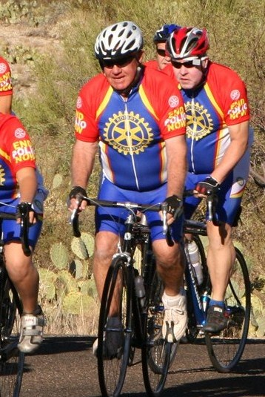
can go to Tucson (they are promising good weather!) and ride in-person or participate in various virtual rides. For more information go to www.polioride.org

Note: This update is going out to those on Bob Roger’s previous list and all Zones
2627 DGs and DPPCs. Let me know if you no longer wish to receive these updates or if you have others that should be added. Shoot me an email marnyeul@me.com
For those of you that send out copies or use this newsletter as a template for sending info to your Polio Warriors, I have added attachments in common formats to this email message.

