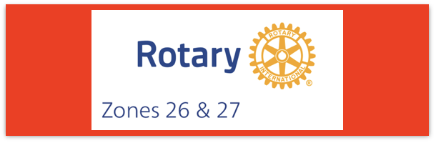

Join us on the “last mile” to end polio!!
End Polio Now Coordinators/Leaders: Mike Crosby & Marny Eulberg
mikePolioPlus@outlook.com and marnyeul@me.com
Almost weekly polio update………….. October 13, 2023
Person confirmed to be paralyzed by Wild Poliovirus Type 1 in Pakistan bringing total cases year-to-date to 9
Wild Poliovirus Cases reported this week: One
Most recent wild poliovirus cases: Afghanistan: 9/04/23 Pakistan: 9/13/23
 | As of 10/10/23 | Total | Total | Total | Total
 | 2023 (2022ytd) | 2022 | 2021 | 2020 | 2019
WPV (Wild Poliovirus) | 9 (28) | 30 | 6 | 140 | 176
WPV-Afghanistan | 6 (2) | 2 | 4 | 56 | 29
WPV-Pakistan | 3 (20) | 20 | 1 | 84 | 147
WPV- Other countries | 0 (6) | 8 | 1 | 0 | 0
cVDPV circulating vaccine-derived | 304 (399) | 87 | 699 | 1117 | 378
Positive Environmental (sewage) samples: This week; 2022 total year in brackets { }
Wild poliovirus= 10; {65} cVDPV (variant) = 14; {506}

News this week:
European Union and the EIB, together with the Bill & Melinda Gates Foundation, are committing more than EUR 1 billion to global health efforts. Half of this EUR 1 billion will go to the GPEI. This will cover polio vaccinations for nearly 370 million children annually. Another financial support agreement for Pakistan was also announced.

Quote of the Day - "Rotary is the organization that had the audacity to take on a global effort to protect children everywhere from disability or even death due to Polio. We must have the tenacity to see it to the finish line." - Barry Rassin, Rotary Foundation Trustee Chair
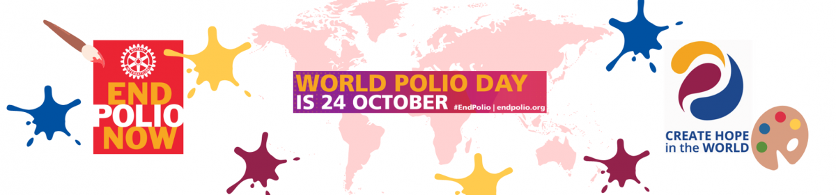

How have you used the videos that were created by Zones2627 These videos don’t mention the year so they could be used in future years giving you plenty of time to plan for next WPD! Here are the links to each individual video:
30 sec English- female voice https://vimeo.com/863283520?share=copy
30 sec English-male voice https://vimeo.com/863283433?share=copy
30 sec Spanish-mail voice https://vimeo.com/863283337?share=copy
60 sec English-mail voice https://vimeo.com/863283209?share=copy
Some World Polio Day events happening in our Zone:
Thurs Oct. 19 at 2 PM (PDT)/3 PM (MDT)
World Polio Day-The Rotary Global Classroom—from Durham College, Toronto World Polio Day 2023 – Updating Rotary’s Efforts to Eradicate Polio Worldwide | The Global Class (durhamcollege.ca)
Sat Oct 21 events: Pints for Polio Bend, OR https://greaterbendrotary.org/pints-for-polio/
Walk across Golden Gate Bridge bdaguio@aol.com
Lincoln, CA Ride to End Polio contact: jscheimer@gmail.com
cell: (916) 955-1378

Tues Oct 24: Let’s Make Polio History at Gates’ Discovery Center-in-person
or virtual RSVP Now

Rick Barry signed basketballs still available—orders need to be approved by your District Polio Plus Committee chair. Questions—contact either Marny or Mike
Sat. Nov.18 Annual Ride to End Polio in Tucson, AZ. https://polioride.org

Let us know about your events and we can help publicize in this update. Please register your event on the www.endpolio.org/register website! One of the metrics that RI uses to measure the impact/effectiveness of the EPNCs is the number of clubs having a WPD event. Historically, our Zones haven’t done well reporting their events.
Note: This update is going out to those on Bob Roger’s lists and all Zones
2627 DGs and DPPCs. Let me know if you no longer wish to receive these updates or if you have others that should be added. Shoot me an email marnyeul@me.com
For those of you that send out copies or use this newsletter as a template for sending info to your Polio Warriors, I have added attachments in common formats to this email message.

