Join us on the “last mile” to end polio!!
End Polio Now Coordinators/Leaders: Mike Crosby & Marny Eulberg
mikePolioPlus@outlook.com and marnyeul@me.com
Almost weekly polio update………….. October 27, 2023
One more child paralyzed by wild Poliovirus in Pakistan this week and 17 positive environmental samples & not in just one small part of the country!
Wild Poliovirus Cases reported this week: One
Most recent wild poliovirus cases: Afghanistan: 9/04/23 Pakistan:10/03/23
 | As of 10/24/23 | Total | Total | Total | Total
 | 2023 (2022ytd) | 2022 | 2021 | 2020 | 2019
WPV (Wild Poliovirus) | 10 (28) | 30 | 6 | 140 | 176
WPV-Afghanistan | 6 (2) | 2 | 4 | 56 | 29
WPV-Pakistan | 4 (20) | 20 | 1 | 84 | 147
WPV- Other countries | 0 (6) | 8 | 1 | 0 | 0
cVDPV circulating vaccine-derived | 325 (449) | 880 | 699 | 1117 | 378
Positive Environmental (sewage) samples: This week; 2022 total year in brackets { }
Wild poliovirus= 17 in Pakistan!; {65} cVDPV (variant) = 10 {508}

nOPV2 rollout: Approximately 820 million doses of nOPV2 have been administered across 35 countries under its WHO Emergency Use Listing (EUL) to date. An additional 16 countries have met the requirements for nOPV2 use in the event of an outbreak. For more information on nOPV2, visit: www.polioeradication.org/nOPV2

Rick Barry signed basketballs still available!
Limited edition Rick Barry signed basketballs that are only available to Rotary clubs in Zones 26& 27 are available now and until limited supply is exhausted—orders need to be approved by your District PolioPlus chair. Need help? Contact Mike Crosby mikePolioPlus@outlook.com

Thank you to all who have registered your WPD event on the www.endpolio.org/register website! As of 10/20, 91 events were registered from our two Zones!! And there will likely be some more registrations coming in. Way to go Polio Warriors!

Ride to End Polio in Tucson Saturday, Nov. 18. You can go to Tucson (they are promising good weather!) and ride in-person or participate in various virtual rides.
For more information go to www.polioride.org
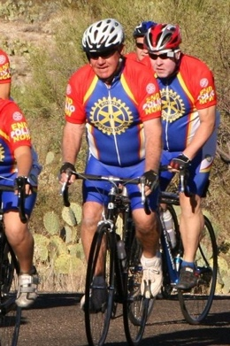

Questions about Post-Polio Syndrome?? Please feel free to contact me, Dr. Marny Eulberg. I’ve cared for polio survivors with and without Post-Polio Syndrome since 1985. As with acute polio there is no cure, but there are things that can help polio survivors manage their symptoms. There are resources available (but they may be getting harder to find).

Note: This update is going out to those on Bob Roger’s previous list and all Zones
2627 DGs and DPPCs. Let me know if you no longer wish to receive these updates or if you have others that should be added. Shoot me an email marnyeul@me.com
For those of you that send out copies or use this newsletter as a template for sending info to your Polio Warriors, I have added attachments in common formats to this email message.

