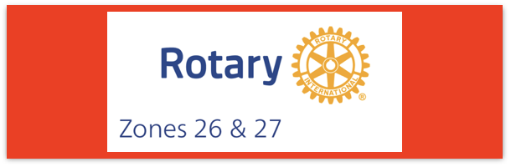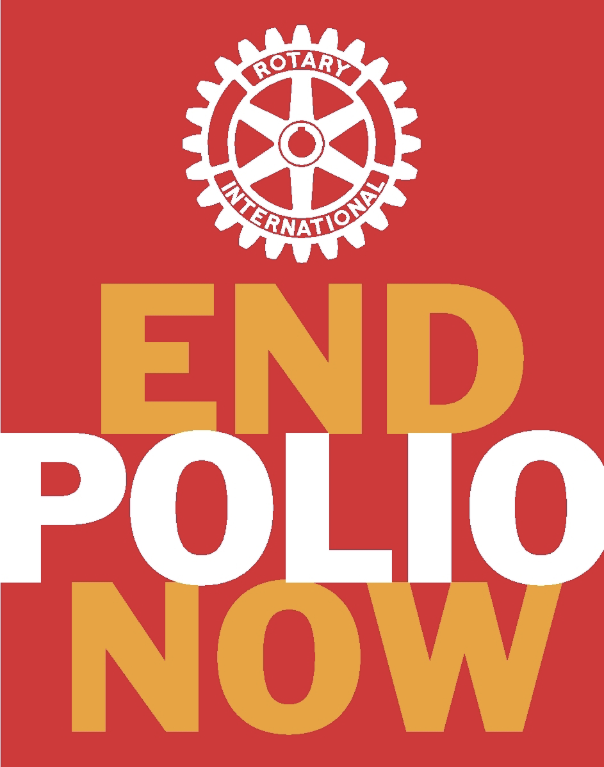

Join us on the “last mile” to end polio!!
End Polio Now Coordinators/Leaders: Mike Crosby & Marny Eulberg
mikePolioPlus@outlook.com and marnyeul@me.com
Almost weekly polio update…… September 28, 2023
Continued Good News—no wild poliovirus cases reported this week but expect to hear about another case in Afghanistan in the next week or two!
Wild Poliovirus Cases reported this week: None
Most recent wild poliovirus cases: Afghanistan: 5/18/23 (but there is a new case reported from Afghanistan in a 12 year old—not yet formally reported by GPEI)
Pakistan: 7/11/23
 | As of 9/26/23 | Total | Total | Total | Total
 | 2023 (2022ytd) | 2022 | 2021 | 2020 | 2019
WPV (Wild Poliovirus) | 7 (27) | 30 | 6 | 140 | 176
WPV-Afghanistan | 5 (2) | 2 | 4 | 56 | 29
WPV-Pakistan | 2 (19) | 20 | 1 | 84 | 147
WPV- Other countries | 0 (6) | 8 | 1 | 0 | 0
cVDPV circulating vaccine-derived | 276 (359) | 876 | 699 | 1117 | 378
Virus detected from other sources (environmental) this week:
Wild poliovirus= 2 cVDPV (variant) Types 1,2,3 = 30
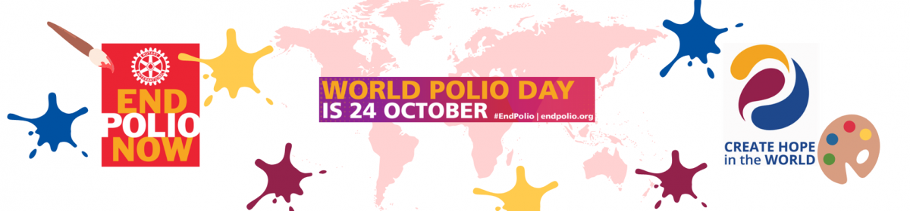
Thanks to Dick Schultz, a Florida Rotarian and Polio Education Warrior for this graphic
Some World Polio Day events happening in our Zones
Please let us know about your successes in getting the World Polio Day Public Service Announcements aired!
See attached .jpg or .pdf for flyers about the limited-edition Rick Barry signed basketballs that can be used to raise money for polio. There also is a video featuring Rick Barry promoting his autographed basketball that will only be sold for this World Polio Day promotion. Contact Mike Crosby for more information.
Clubs in the Long Beach, CA area are planning a walk for polio across their new bridge (ala Walk across the Golden Gate bridge event).
HEADLINES
- The Leona M. and Harry B. Helmsley Charitable Trust announced a US$3 million grant to support the GPEI. The contribution is intended to help vaccinate nearly 370 million children against polio annually for the next 4 years among other programmatic goals
- A high-level meeting on Universal Health Coverage took place on 21 September, at the UN General Assembly in New York. Through a political declaration, governments committed to scaling up efforts to improve immunization capacities and outcomes, including for polio eradication.
- nOPV2 rollout: Approximately 750 million doses of nOPV2 have been administered across 35 countries under its WHO Emergency Use Listing (EUL) to date. An additional 15 countries have met the requirements for nOPV2 use in the event of an outbreak. Visit the nOPV2 webpage for more information.
- The Strategic Advisory Group of Experts on immunization (SAGE) met this week in Geneva, to deliberate on a broad range of immunization issues, including on polio eradication. A summary of the meeting will be published over the coming days on the WHO SAGE website, with the meeting’s full report to be published at a later date in WHO’s Weekly Epidemiological Record.
Let us know about your events and we can help publicize in this update. Please register your event on the www.endpolio.org/register website! One of the metrics that RI uses to measure the impact/effectiveness of the EPNCs is the number of clubs having a WPD event; they get data from the endpolio.org website. For the last 3 Rotary years the highest % of events reported from either of our zones was 6%!! Mike and I would love to see it jump to 10% or more for 2023!
Note: This update is going out to those on Bob Roger’s previous list and all Zones 2627 DGs and DPPCs. Let me know if you no longer wish to receive these updates or if you have others that should be added. Email me: marnyeul@me.com
For those of you that send out copies or use this newsletter as a template for sending info to your Polio Warriors, I have added attachments in common formats to this email message.

