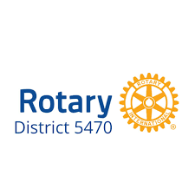
District 5470 Education Group
(501)
Donation Form

The purpose of donations will be to support the learning and training events sponsored by the Education Group (Foundation).

Contact Name: ______________________________________________________________________
Club or Business Name: _______________________________________________________________
Address: ___________________________________________________________________________
City: _______________________________________ State: ________________ Zip: _____________
Phone: ____________________ Email: _________________________________________________
Donation Levels
Rotary Plantinum $2000 - $5,000
- Honored sponsor
Rotary Gold $1,000 - $1,999
- Major sponsor
Rotary Blue $500 - $999
- Sponsor
Paul Harris $250 - $499
- Valued Sponsor

____ I/My club/business would like to make a donation of $______________________________.
____ Please send an invoice to this address:___________________________________________
__________________________________________________________________________.
____ A check is enclosed (Payable to Rotary District 5470 Education Group)
Return this form by Mail to:
MAKE CHECKS PAYABLE TO ROTARY DISTRICT 5470 EDUCATION GROUP

Donna Hood
3115 C. R. 160
Westcliffe, CO 81252

THANK YOU!!

