Rotary District 5470
Global Partnership for Education
Donation Form

Club Name ________________________________________________________________________

Lead Contact Person__________________________________________________________________
Lead Contact Person email_____________________________________________________________
Lead Contact Person phone_____________________________________________________________

Amount of Donation $_________________________________________________________________
The Rotary Club of ___________________________________ agrees to donate these funds to the Rotary District 5470 Global Partnership for Education Initiative. The District will make the donation to Rotary District D9212 for their approved Global Grant # 2120048 on the part of this Rotary Club as part of a collaborative donation from clubs throughout the District.

________________________________ ________________________
Signature Date

Please mail your check to :

Rotary District 5470
GPE Intiative
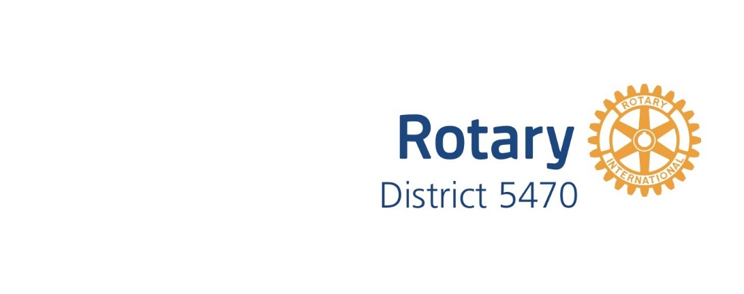
PO Box 963
Montrose, CO 81402

