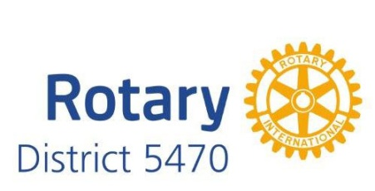
Red Badge Program

The Red Badge Program is designed to get new members involved and active quickly. It is suggested that a new member seek the help of their mentor or another club member in achieving the following goals within the first three months of membership. When the Red Badge requirements are completed, a permanent badge will be presented to the new member.

The Red Badge requirements are:
- 75% attendance at meetings or with meeting make-ups.
- Become familiar with the Rotary Motto and the 4-Way Test
- Attend at least one board meeting.
- Attend a social activity.
- Attend a community service activity.
- Become a member of a club committee.

Encouraged Activities:
- Attend a different area Rotary Club.
- Provide a program speaker.
- Attend one District 5470 function.
- Bring a guest to a Rotary meeting.

Date Red Badge Program Completed___________________

Signature of mentor upon completion____________________________

The mentor is responsible for the success of this member and is strongly encouraged to assist the new member with any activities with which he/she may need assistance.

The mentor will return the completed Red Badge Program form to the membership chair so formal presentation of permanent name badge may be scheduled.

