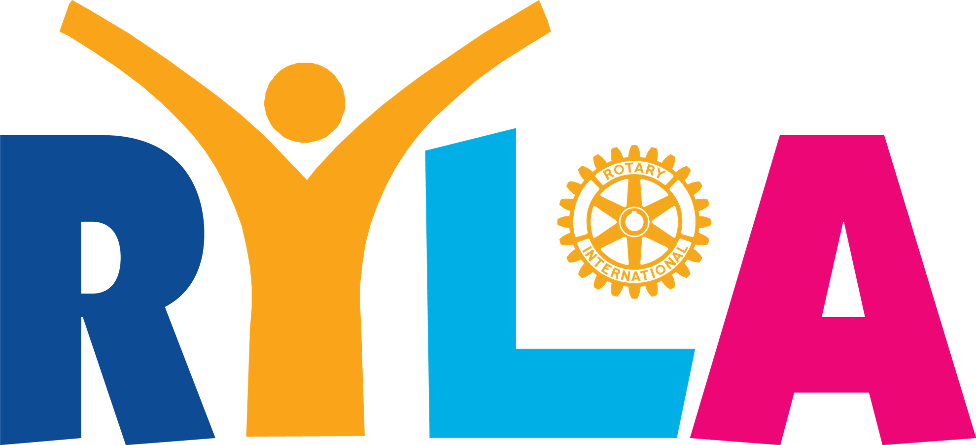
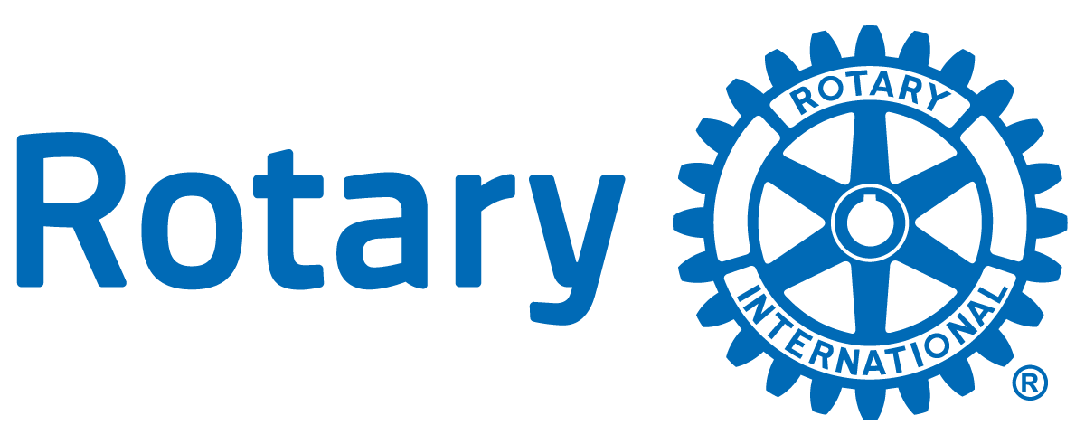

District 5470

Rotary Youth Leadership Academy Application
Dates of RYLA 2023:
- June 2 - June 4, 2023
- Location: Colorado Mountain College, Leadville, Colorado
Transportation: Provided by local Rotary Clubs. Please consult your awarding club.
Attendees: Approximately 60 young leaders from high schools in Southern Colorado. 2 per Club with others on a waiting list until notified on or before May 1, 2023.
Selection process: Participants must be currently in the 10th or 11th grade. Final selection will be made by a committee that may consist of a variety of Rotary Club members, school administrators and teachers by April 28, 2023.

INSTRUCTIONS
Provide the following information and tell us in 100 words or less, entitled "Why I Want To Attend RYLA” (0ptional..each club will determine whether or not to require the essay)

***********************Application deadline is April 14, 2023 *******************************

Student Info

First and Last Name
Street/Mailing Address
City, State, Zip
Phone Number
Email Address (non school email)
Age
Grade
School

Parent/Guardian Name
Parent/Guardian Phone Number
Parent/Guardian Email Address

List Current School Activities (clubs, sports, projects, volunteer, etc)
List Current Off-Campus Activities (work, clubs, volunteer, etc)
Explain in 100 words or less, “Why I want to attend RYLA?” (up to 100 words)

Rotary Club
Rotary Club Contact

Once completed, print this form and deliver to the Rotary Club sponsoring you for RYLA by April 14, 2023.

