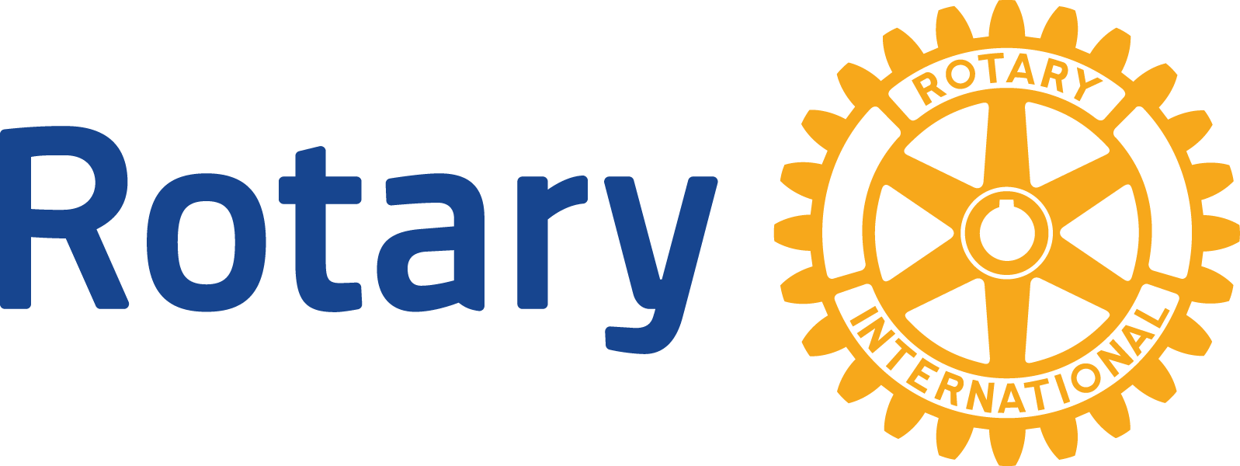 Global Grant Scholar Program

Global Grant Scholarship
2022-23 Application

Rotary District 5470 Global Grants can be used to fund scholarships with sustainable, high-impact outcomes in one of Rotary’s six areas of focus: Peace and Conflict Prevention/Resolution, Disease Prevention and Treatment, Water and Sanitation, Maternal and Child Health, Basic Education and Literacy, Economic and Community Development.

You must submit this completed preliminary scholarship application form to a Rotary club in District 5470. Do not forward this application to The Rotary Foundation.

Only Rotary clubs in Rotary District 5470 will be participating in the District 5470 Global Grant Scholarship program. Please check with the local club to determine the availability of scholarships and application deadlines. A list of clubs in Rotary District 5470 can be found at: http://www.rotary5470.org/

SCHOLAR CONTACT INFORMATION

Family name: __________________________________ First name: _________________________________
Gender: ☐Male ☐Female
Permanent ___________________________________________________________
address: ___________________________________________________________
___________________________________________________________
___________________________________________________________
E-mail address: ___________________________________________________________
Primary phone: ___________________________________________________________
Secondary phone: ____________________________________________________
Country of citizenship: _____________________________________________________

EMERGENCY CONTACT INFORMATION
Family name: __________________________________ First name: _________________________________
Relationship: ___________________________________________________________
Address: ___________________________________________________________
___________________________________________________________
___________________________________________________________
___________________________________________________________
E-mail address: ________________________________________________________
Primary phone: ________________________________________________________
Secondary phone: _________________________________________________

LANGUAGES AND EDUCATION
List the languages you speak (including native language) and your proficiency level.
Language: | Proficiency Level:

List the two educational institutions you have attended most recently.
Name of Educational Institution | Country | Field of Study | Degree Received and Date

Note: Please send in your transcript(s) with your application

ACADEMIC PROGRAM DETAILS
Name of institution: ______________________________________________________
Location (city and country): ________________________________________________
Institution’s website (URL): ________________________________________________
Academic program: ______________________________________________________
Official language(s): _____________________________________________________
Anticipated start date: ____________________________________________________
Anticipated end date: ____________________________________________________

AREA OF FOCUS AND GOALS

With which area(s) of focus is the program of study aligned?
☐ Peace and conflict prevention/resolution | ☐ Maternal and child health
☐ Basic education and literacy | ☐ Disease prevention and treatment
☐ Economic and community development | ☐ Water and sanitation

Please respond to the following questions in 500 words or less (per question).

List the classes you plan to take and provide any relevant links to information about the program.

How does your educational, professional, or volunteer experience align with Rotary's goals in the selected area of
focus?

What are your plans immediately after the scholarship period?

How do your long-term professional goals align with Rotary's goals in the selected area of focus?

Signature ______________________________

Date: __________________________________

