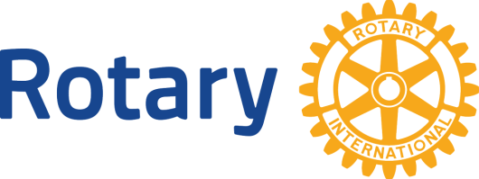 | Rotary International  District 5550  Million Dollar Dinner
A dinner targeting support of USD $1 million dollars to enable the program and project work of our Rotary Foundation for gifts made from 1 July 2015 to 14 May 2016.
May 14 2016 Gimli MB
You are building your district’s legacy of service with your gifts of support to our Rotary Foundation!
This District event is our FIRST! Rotarians and Friends of Rotary will have the opportunity either through new cash donations or a bequest to support Rotary in making the world a better place for years to come! The Celebration Dinner will be held at the Governor’s Gala at District Conference 2016 and is a “Thank You” and recognition of the commitments made in the above time frame. Together we will celebrate our achievements and strengthen our Rotary relationships through a better understanding of our Foundation!
What would my gift to our Rotary Foundation accomplish?
Well that depends on what is most important to you! Your support is invited through an outright Major Donor gift*, Arch Klumph Society Gift* or Bequest Society gift*. You are also invited to consider an increased gift of support to your current Bequest, Benefactor or Major Donor Gift levels. Your own personal named fund may be established within Rotary’s endowment with any outright or gift commitment of USD$25,000**. Gifts may be directed towards:
- Polio Eradication-which includes the Gates 2:1 match and the new Government of Canada 2:1 match (Oct 2015) This makes $1=$5 with the double matches!
- Annual Programs**-shared gift split 50/50 between World Fund and your district-to enable district grant activities and largely local projects.(if endowed, will gift out in perpetuity)
- World Fund**-an unrestricted gift for the greater good of Rotary as determined by the Trustees of the Rotary Foundation.
- Rotary Peace Centers** (endowment) –Rotary’s highest educational priority. Your gift will fund our Peace Fellows at one of our 7 premier global institutions of learning partners.
- Any of the six Global Grants Areas of Focus (endowment) –Water and Sanitation, Maternal and Child Health, Basic Education and Literacy, Peace and Conflict Prevention and Resolution, Disease Prevention and Treatment, and Economic and Community Development.
How can I make a gift of support and be a guest at our Million $ dinner?
You are invited to consider the gift options listed below. For more information and to formalize your gift, please complete the below form and return it to your planning committee or send to:
Carolyn Ferguson, Zone 24 Senior Major Gifts Officer | Polio, Development & Partnerships
(Remote office) 471 Orton Ave, Ancaster, ON. Canada. L9G 4M7
Tel 905.304.6831, Carolyn.Ferguson@rotary.org
____________________________________________________________________________
Yes, I want to be a guest with this gift.
My gift to the Rotary Foundation:
Name (individual or joint as couple): __________________________________________
District: 5550 Club:___________________________________
Address: _____________________________________________
Email + Phone _________________________________________
Gift Designation/Program ___________________________________
I have made or will make a bequest gift to the Rotary Foundation (Canada) in the amount of
USD$______________ and have completed or will complete the required paperwork by May 14, 2016.
I have an existing benefactor or bequest gift commitment that I would like to increase to qualify for attendance at this event for a total of USD$______________
I have a life insurance policy that I would like to name the Rotary Foundation (Canada) as a beneficiary to become a Bequest society member valued at USD $____________________
I would like to make an outright or 3-year pledged Major Donor gift of USD $______________ by cheque, credit card or direct gift of publically traded securities.
I would like more information. Please contact me to discuss the details of my potential gift of support.

