Escuela Oficial Rural Mixta Hector Barillas Orantes
Host Club: Rotary Club of Guatemala Norte International Club: Rotary Club of Kenora
Rotary Club of Guatemala Norte will be responsible for project management and ISF will provide consulting services/ oversight to the project.
Description of the Community
The school is located in Aldea Los Dolores in the Municipality of Villa Canales, Department of Guatemala. It is 46.5 km away from Guatemala City and 24.5 km. from the town of Villa Canales which is the municipality who has jurisdiction over Aldea Dolores. Two years ago, the Cocode did a census with the Municipality and the population in Aldea Los Dolores added up to 6,000.
Description of Project:
The project is the construction of two new classrooms, repairing the perimeter wall and sealing the existing classrooms for pest control It is important to move the kitchen because the smoke from the open fire contaminates the two classrooms next to it. Also, we have to close the separation between the walls and the roof because the pigeon’s nest there and also rats come into the kitchen and the classrooms. The perimeter wall is made of prefab slabs and part of it is broken, therefore thieves come and steal from the school. Repairing the wall will make the school secure.
Impact: This would impact over 450 students and provide much needed classrooms to students who are currently studying in the kitchen. Repairing the perimeter wall will improve security for the children and closing the separation between the walls and the roof will provide pest control and healthier environment for the children.
Estimated Cost: $41,000 US
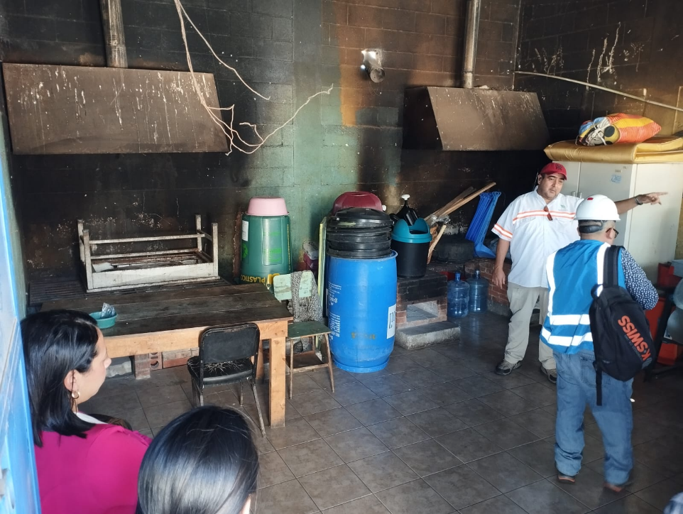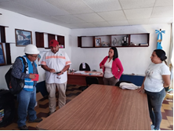
This classroom is being used as a kitchen, Engineer Moises Garcia, from Engineers Without Borders
you can see the soot in the walls and the at the school with RC Guatemala Norte President Gerardo Vera smoke contaminates the classrooms next to it.

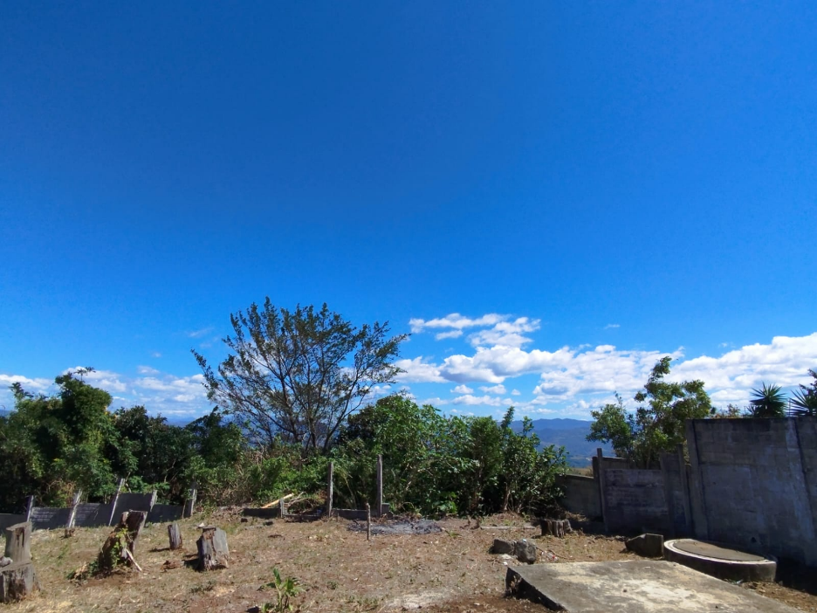
The wall/fence around the school is destroyed in this area the children are facing security issues
What the school needs is identified in red.
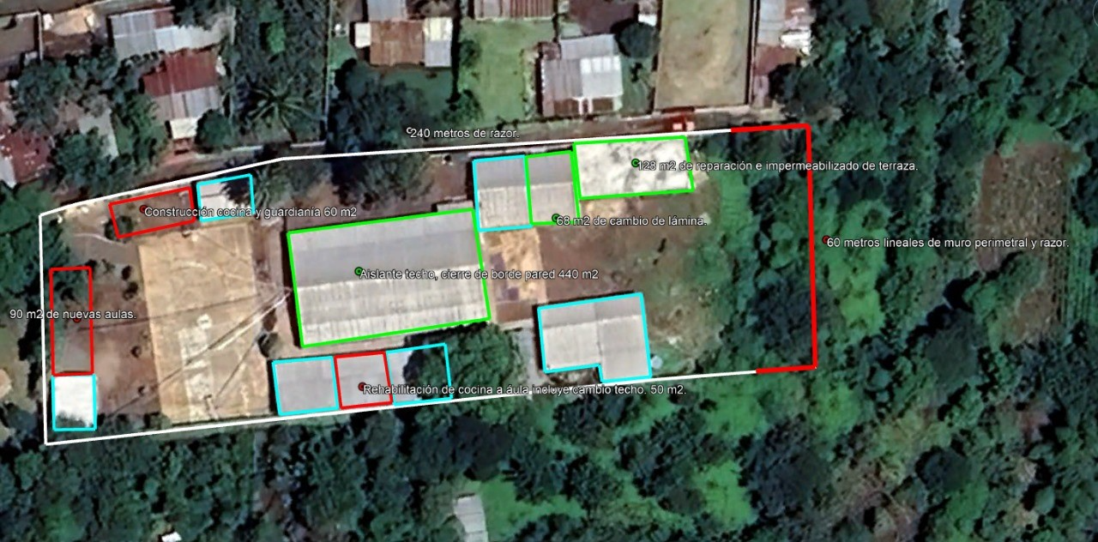
The RC of Guatemala Norte is proposing a project to work on the areas marked with red. The areas marked in light blue are existing areas. The green areas need work, the club is considering for a future project

Average family income and what the people do for a living.
Most of the people work in agriculture. They grow coffee, pineapple, corn and beans. Those that work in agriculture make around Q2000.00 a month. There are some construction workers who make Q100 per day, which amounts to approximately Q2500.00 a month. Approximately 25% of the people come into Guatemala City to work, and they get minimum salary which is Q3634.69 per month. There are some girls and young women who work making tortillas who earn Q700 – Q800 a month

Current Situation and History
This community is surrounded by private land, some years ago, the owners of the land started the school for the people that worked at their plantation, and eventually donated the land to the Municipality of Villa Canales. The school is named after the owner of the finca, Héctor Barillas Orantes.

This is a community where our club would like to replicate what we did in Joya Verde. As in Joya Verde we want to begin with the school. There are approximately 500 children studying at this school, which are about 65% of all the children from the community. The other 35% do not come to school because the parents cannot afford to pay for their uniforms and school supplies, or because the children are sent to work.
The community has a health clinic (from the Ministry of Health), a small clinic from IGSS (Guatemalan Institute for Social Security), and an “Instituto de Básicos y Diversificado” Secondary School.
The community has many other needs which we hope to address in the future. For example, the water that they use has a lot of sulphur, and it is not suitable for human consumption.

What it has: add information
Good support from the Rotary Club of Guatemala Norte the Municipality, the Cocode, Parent Committee, parents and teachers and Principal.

Funding Partners to date:
RC of Milwaukee $20,000 US
RC of Guatemala Norte $1,000 US
RC of Kenora and private donors $5,500 US
RC of Dryden $1,500 US

Contact Gord LeMaistre: glemaistre1@hotmail.com
807-548-5390

