**Minutes of WCS Foundation Retreat Zoom Meeting** **Date:** October 21, 2023

**Meeting Called to Order:** At 9:32 am CDT by Eva Vida

**Attendees:**

**Eva Vida** (Chair); **Asit Sarkar** (Vice Chair); **Brian Cocks** (Treasurer); **Pankaj Bhowmik** (Secretary); **Bob Durston** (Chair, District RF); **Fred Wright** (Past District Governor); **Sonja Suset** (District Governor); **Peter Tonge** (District Governor Elect) **Wayne Jacobsen** (District Governor Nominee); **Jeff Miller** (District Grant Committee Report); **Gord LeMaistre** (Canadian Ripple Effect Committee); **Deb LeMaistre** (Canadian Ripple Effect Committee)

**Regrets:** Grants Sub-Cttee – VTT – **Gailmarie Anderson;** Grants Sub-Cttee – Grants – **Jeff Miller;** Compliance Officer – **Art Beselt**

**Agenda:**

1. **Welcome**
2. **Approval of Agenda** - *Motion:* That agenda be approved as circulated with amendment - district grant, funding of workshop, ranking of clubs are tabled for discussion under item #10- other business. (Bob-Sonja) . *Carried*
3. **Comments from Chair** – Eva; This event would be an in -person event normally with a key-note speaker. Encouraged a bit more introduction from Secretary (Pankaj), District Governor Nominee (Wayne) and others (Sonja, Asit, Alan, Cameron, Christine, Peter)
4. **Message from District Leadership Team**
   * PDG Fred Wright – sent message, attached at the end of the minutes.
   * DG Sonja Suset - every club donated, congratulations; goal is to every club continues to support foundation contribution
   * DGE Peter Tonge -thanked everybody for support
   * DGN Wayne Jacobsen -welcome, will be looking to have message next year
5. **Treasurer’s Report** – Received financial report from PDG Brian Cocks a) Financial Statement *Motion:* Bob moved on behalf of Brian that that Financial Statement be accepted as presented. Cameron seconded. **Carried**  b) *Motion:* Bob D – Gord: That the 2024-25 budget request of $10,000 from District for audit expenses be approved. **Carried**
6. **District Grant Committee Report 2023-24 Rotary Year** - Jeff Miller; discussion was tabled under item 10. What is the implication if a grant is being cancelled? Allocating funds to make sure we don’t have to send money back to Rotary International, allow clubs to apply for other funding
7. **District Foundation Update** - Bob Durston
   * RI mandates spending District DDF by June 30, 2026, will work with Peter and Sonja, all DDF has to be spent by the end of 2026, any remaining DDF at that time can be transferred to PolioPlus, World Fund, or Peace Partners.
   * No second call this year due to minimal unspent funds (only $798.00 unspent).
   * DG Sonja received the Zone 28 Certificate of Achievement for 100% club giving (meeting in Toronto) to the Rotary Foundation in 2022-23 (part of $470M worldwide; membership matter).
   * Emphasis on the need for membership growth in the District. We really want to retain our District. We are one of the largest districts geographically but smallest membership. We are little bit ahead where we are at the contribution to the annual fund compared to last year at this time.
8. **Grant Certification Training 2024-25** - Webinar dates: Nov 16, 18, 21, 29
   * *Motions:*
     1. *Motion:* That the 2024-25 draft District Grant budget be accepted (Bob- Sonja). ***Carried***
     2. *Motion:* That the 2024-25 MOU, and Terms and Conditions for Scholarships, Youth Programs, and Projects be accepted (Bob-Gord). ***Carried***
     3. *Motion:* That the 2024-25 International Project Terms and Conditions be accepted with a budget of $6,000.00 from WCSF surplus funds (Bob-Brian). ***Carried*.**
     4. *Motion:* That the maximum DDF available to current draft Global Grant applications and any new applications in 2023-24 and 2024-25 be increased to matching maximum $20,000.00 DDF and further that D5550 clubs supporting other District’s Global Grants be included in the same matching formula (Bob-Gord. ***Carried*** Rational: To reduce the carryover of DDF to zero by the 2026 Rotary year. We will need committee of expert locally to review district global grant. Will be addressed under item 10.
9. **Canadian Ripple Effect Committee Report** - Gord and Deb LeMaistre, received a call last September from past district governor about the opportunity to match $100,000 US with the RC of Milwaukee. Details of the report attached. The Canadian Ripple Effect Committee has accepted the offer. This will include building classrooms and equipping classrooms with furniture, washrooms and wash stations and health and Hygiene training collaborating with the RC in Guatemala. Looking forward to exciting and productive year ahead. Motion to accept report- Gord- Peter). ***Carried.***
10. **Other Business**

* District grant process; Club applications and ranking, allocation of funds- funding allocation; **Alan**- whole question about sustainability, ranking of clubs on the basis of community projects but not only scholarships; not get a project at all compared the club applying for both. Should we change the approach? **Christine** – RYLA and scholarship as example how do we prioritize; **Asit** – committee was discussing community service project, district membership doing useful work in the community. Given the dollar amount we have here that Alan has described we have to discuss youth and community. Sonja – club applies for both for district grants. The priority is student scholarship and RYLA. If our funding envelops shrinks, how should we prioritize.
* Global Grant discussion on improvements. *Consensus:* To continue as present.

1. **Next Meeting** - Thursday, January 18, 2024
2. **Adjournment** - By Chair at 11:30 am CDT

**Meeting Attendance Record: DISTRICT 5550 WCSF COMMITTEE MEMBERS**

* X Past District Governor – Fred Wright
* X District Governor – Sonja Suset
* X District Governor Elect Peter Tonge
* X District Governor Nominee – Wayne Jacobsen
* X Chair – Eva Vida
* X Vice Chair – Asit Sarkar
* X Treasurer – Brian Cocks
* X Secretary – Pankaj Bhowmik
* X Chair, District RF – Bob Durston
* X CREC Gord & Deb LeMaistre
* X Alan Moulin
* X Christine Hansen
* X Cameron Zywina

**Appendix**

**Copy of the messages from District Leadership Team:**

• **PDG Fred Wright –**

Good morning, All,

Some personal circumstances are causing me to be at least late for the retreat and very possibly absent for all the retreat, so hear is my message for you:  
You, our District 5550 World Community Service Foundation Committee do so much great work in our District. Your contributions through grant administration, Ripple Effect, Polio Plus and Foundation giving and administration are an enormous part of why we are Rotary. One of the key elements in the continued success of this committee is the continuity that you have been able to maintain. Add to this the experience and knowledge of you the committee and we have an extremely functional organization that serves our District members so very well.

Congratulations on working with District Treasurer Jeff Merry to realize significant savings on our audit fees.

Thank you for continuing to put service above self through Rotary.

You are bringing hope to so many.

This is a great time to be part of Rotary and to make Rotary better!

* **Financial statement –**

**WCS financial statement ... up to and including Oct. 20/2023**

**WCS ~ Acct. #130 2612**

$ 22,216.32

**Canadian Dollar Acct. #150 3219**

$ 125,155.69 (Ripple Effect funds)

**U.S. Dollar Acct. #020 0816**

$ 106,913.02 ... (Ripple Effect funds)

**Foundation Acct. #180 4111**

**• District Grant Committee Report –**

**District 5550 World Community Service Foundation**

**District Grant Committee Report**

**1. Summary of Scholarships, RYLA, Local and International Projects approved in May 2023**

**Club Grant Amount**

Scholarships

Winnipeg St. [Bon.-St.Vit](http://Bon.-St.Vit). $1,000.00

Saskatoon Ri[verside](http://Bon.-St.Vit) $500.00

Weyburn $1,000.00

Dauphin $1,000.00

Flin Flon $1,000.00

Portage Rotary Club $1,000.00

Sioux Lookout $1,000.00

Saskatoon Nutana $1,000.00

Kenora $1,000.00

Melfort $1,000.00

Winnipeg-Fort Garry $1,000.00

Neepawa $1,000.00

Winnipeg-Assiniboine $1,000.00

Gimli $1,000.00

Moose Jaw Wakamow $1,000.00

**TOTAL$ 14,500.00**

RYLA & Youth Exchan[ge](http://Bon.-St.Vit)

Winnipeg St. [Bon.-St.Vit](http://Bon.-St.Vit). $500.00

Saskatoon Ri[verside](http://Bon.-St.Vit) $500.00

Saskatoon Nutana $500.00 Cancelled

Winnipeg - Downtown $500.00

Flin Flon $500.00

Portage Rotary Club $500.00

Sioux Lookout $500.00

Kenora $500.00 Cancelled

Melfort $500.00

Winnipeg-Fort Garry $500.00 Revised to $300.00

Dryden $500.00

Winnipeg-Assiniboine $500.00

Neepawa $500.00

South Eastman $500.00

Gimli $500.00

Brandon $500.00

Moose Jaw Wakamow $500.00 Cancelled

**TOTAL $8,500.00 Rev 6,800.00**

Local Projects

Saskatoon North Fairhaven Primary School $1,500.00

Saskatoon Nutana Garden Boxes for Food Security $1,500.00 Saskatoon Meewasin Childcare Kitchen Project $1,500.00

Approved with US exchange

Regina Eastview Chili for Children $1,000.00

Regina Industrial Parks Souls Harbor Rescue Mission $1,390.42   
Melfort Rotary Park Lighting $1,500.00   
Flin Flon Rotary Court Upgrades $1,500.00   
Moose Jaw Wakamow Imagination Library $250.00

Winnipeg-Charleswood Rossbrook House- programming support$1,500.00 Saskatoon Riverside A Full Day Workshop on Post Covid $1,300.00

Mental Health Issues, Challenges

and Coping Mechanisms

South Eastman Summer Education Programs at $1,500.00

Mennonite Heritage Village Museum

Regina Oskaya Kitchener Indigenous Literacy $1,500.00

**TOTAL $15,940.42**

International Projects

Winnipeg - Downtown Wana Johnson Learning Centre $1,500.00 cancelled

Improvement Project

Winnipeg St. [Bon.-St.Vit](http://Bon.-St.Vit). Puerto Vallarta Du Sur Eye $1,000.00

Surgery Program

**TOTAL $2,500.00 Rev 1,000.00**

**2. Item’s for discussion:**

Funding allocation of Scholarships/Youth programs vs Community Projects.

Funding of small international project under district grants.

Funding of workshop for community projects.

Ranking of clubs applying for community projects only and not scholarships/ Youth programs

**Respectfully submitted Jeff Miller**

**October 15, 2023**

**• Canadian Ripple Effect Committee Report –**

**World Community Service Foundation Retreat**

**Ripple Effect Program Report**

**Saturday October 21, 2023**

**Breaking news!!** The Ripple Effect Program has been offered the opportunity to match $100,000 US with the RC of Milwaukee for 5 school construction projects in the period January 1, 2024 to December 31, 2024.This will include building classrooms and equipping classrooms with furniture, washrooms and wash stations and health and Hygiene training. The Canadian Ripple Effect Committee has accepted the offer. It is going to be a busy year of fundraising and school construction!!!

**Fundraising opportunity: Giving Tuesday on November 28**- more information on the campaign is coming soon.

**What has been done**

**1**.District Grant was approved for $1,500 for the Rotary Year 2022/2023 for the Colpech School to upgrade electrical, provide classroom furniture, security and replace the sheets of asbestos on the roof that are leaking, breaking up and falling into the classroom.

**Status: The final report has been approved, payment has been received and the District Grant is now closed**.

**2.Dona Maria School- RC of Kenora/RC of Gualan -** Construction of a new retaining wall behind the school to replace the retaining wall that collapsed recently. This needs to be completed immediately to prevent unstable soil from sliding into the classroom wall and damaging the infrastructure of the school as well as a safety hazard for children.

**Estimated Cost:** $7,015 US**.** Fully funded.

The RC of Gualan provided $500 US, the teachers purchase 155 concrete blocks for the retaining wall and the Municipality provided the labour of one mason to build the concrete block retaining wall.

**Status**: Project is nearing completion

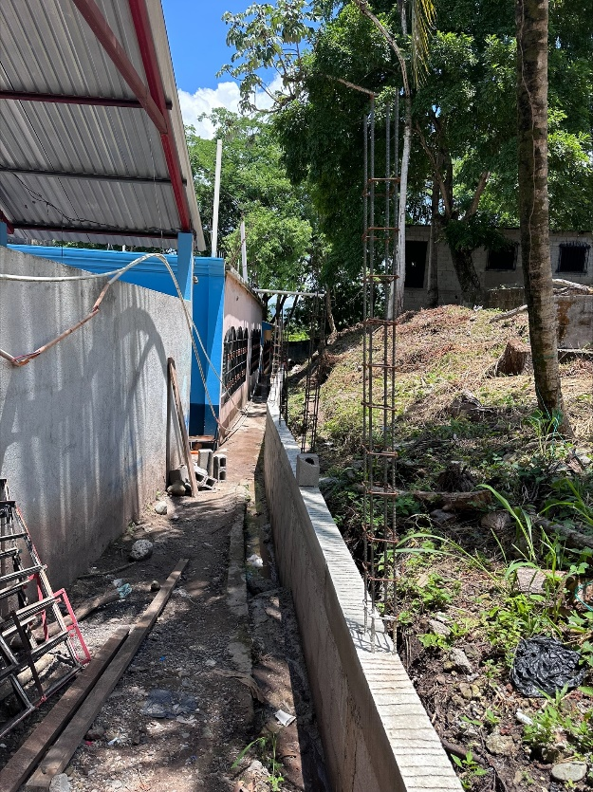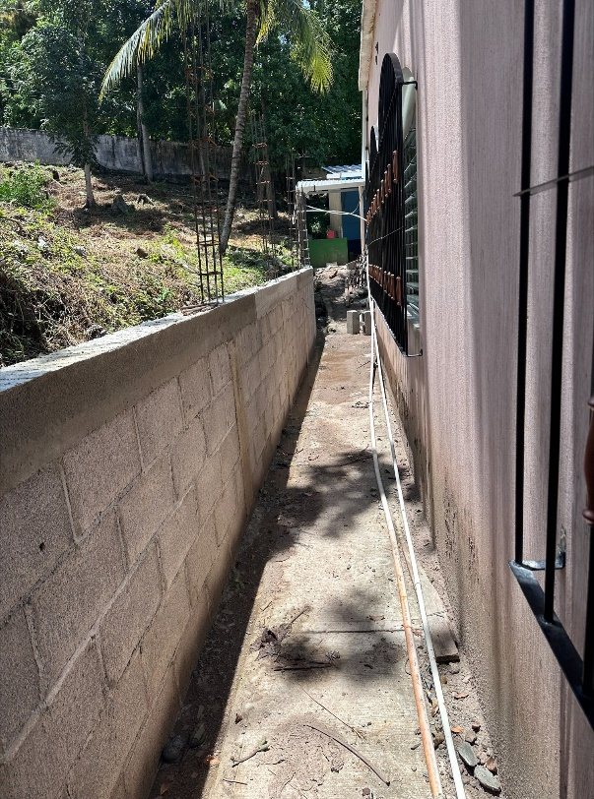

Partially constructed retaining wall.

**3.San Isidro Robles School-RC of Kenora/ RC of Coatepeque**

Construction of a rear perimeter wall on the edge of a deep ravine.The Municipality will build the front perimeter wall and a gate at the front of the school. The school yard borders on a steep slope that drops about 200 ft. to a valley, which poses an extremely dangerous situation for the students. The teachers are also concerned students could be kidnapped or the children can just wander off. There are cows in the nearby farm that often wander into the school yard, and many stray dogs.

**Estimated Cost: $14,700 US**. Fully funded.

**Status**: The Municipality has started construction on the front perimeter wall**.** Next steps is to sign a Club to Club Agreementand receive the drawings for the construction of concrete block rear perimeter wall.

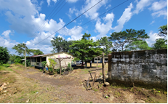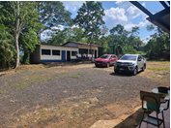

**San Isidro Robles School-front inside the school yard**

4. **Hernaldo Beltran Jr. School- Lead Club is the RC of Burlington Lakeshore in D7080/RC of Gualan D4250**

WASH in Schools GG #2120729 Hernaldo Beltran Jr School- $79,800 US

The project is the construction of new and refurbished washrooms for children and teachers, new septic system, new well and training in Health and Hygiene for teachers, children and parent committee. This school had over 650 children and only three working toilets.

**Status:** Project is complete and final report was submitted May 22, 2023. TRF has requested additional information.

* **In 2023, Ministry of Education started Middle School classes for grades 7,8 and 9 at the Hernaldo Beltran Jr. school with 150 students registered. Another ripple!!**

**Other REP Projects-update**

**5.GG # 2096181 Nuevo San Luis School-** construction of two classrooms, washrooms, and kitchen are complete. RC of Saskatoon Riverside/RC of Coatepeque Colomba.

**Status:** Final report has been approved by TRF and the Global Grant is closed.

**6. Global Grant Water, Sanitation**, Health and Hygiene (WASH) ($317,750 US) in 24 schools-construction is now completed in 24 schools.

RC of Moose Jaw Wakamow/ RC of Nueva Guatemala

**Status:** Progress report accepted 08/23. Next report is due 08/24.

**New REP projects for the 2023/2024 Rotary Year**

**7.GG #2456616 A Goal for Guate III** - 20 school computer project, 320 computers, 20 servers, teacher training and tech support. Budget estimate is $99,000 US

RC of Regina Eastview/RC of Oeste.

**Status:** GG #2456616 will be resubmitted soon. A draft is being reviewed by the RC of Regina Eastview.

**8.GG # 22351655 WASH in Schools**-new or refurbished washrooms in 7 schools as well as Health and Hygiene and sanitation training for students, teachers and Parent Committee.

RC of Regina Eastview/ RC of Retalhuleu. Cost Estimate is $97,000 US

**Status:** the revisions to the GG have been submitted and are under review by the Rotary Foundation.

**9.Xecoxol School-** construction of new washrooms for the teachers, kindergarten and grades 1-6.

**RC of South Eastman/RC of Guatemala Nordeste. Cost Estimate is $19,000 US**

**Status**: Club to Club agreement is signed. Request for wire transfer instructions. Construction will start in November after school is out.

**Ripple Effect Scholarship Programs:**

**Santo Domingo Xenacoj School –** 43 -Middle and High School scholarships will be awarded in the 2024 school year. Club to club Agreement for the 2024 school year has been signed. The REP has been supporting the Xenacoj Scholarship Program at this school for over 16 years.

**Teachers Scholarships: -** 4 Scholarships will be awarded in the 2024 school year.

4 Students are now in 3rd year and 2 will graduate this year. In 2024,2 will enrol in 4th year of the English Program and 2 1st year students will enrol in the program.

The Teacher Scholarship program is co-managed by Warren Thompson and John Saunders of the RC of Winnipeg Assiniboine and the University of Valle del Guatemala.

**Status:** The University provided the 1st semester marks. The students are doing very well. The 2nd semester tuition has been paid for the four students.

**Election Year in Guatemala 2023**

A new government will take office in January 2024 for a four- year term.

**Upcoming Meetings:**

**Wednesday October 25-**Canadian Ripple Effect Committee zoom meeting.

**Wednesday November 15-** Guatemalan Ripple Effect Committee/Canadian Ripple Effect Committee zoom meeting

Respectfully submitted on behalf of the Canadian Ripple Effect Committee

Gord and Deb LeMaistre,

Co-Chairs Canadian Ripple Effect Committee

548-5390