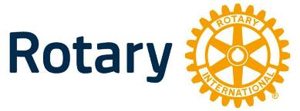
4-Way Test
Essay Contest

Sponsored by
Rotary District 5580

CASH PRIZES
District Winner - $1,100
6 Regional Winners - $150 Each
Local Winner - $

Open to Students in Final Two Years of High School

TOPIC: Any topic may be chosen that will utilize the
Rotary 4-Way Test:

1 1. Is it the truth?
2 2. Is it fair to all concerned?
3 3. Will it build goodwill and better friendships?
4 4. Will it be beneficial to all concerned?

The topic may be specific or general; however, the essay must include all four (4) principles of the Four-Way Test and the way these principles relate to the topic presented.

LENGTH: 500-1000 words.
JUDGING CRITERIA: Judging will be based on utilization and application of the principles of the Four-Way Test, creativity, organization and
language/grammar.

DEADLINE FOR LOCAL ENTRIES IS: , 2023.

