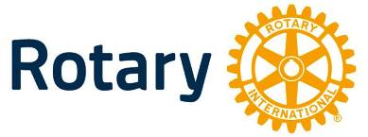
4-Way Test
Essay Contest

Sponsored by
Rotary District 5580

CASH PRIZES
District Winner - $1,100
6 Regional Winners - $150 Each
Local Winner - $

Open to Students in Final Two Years of High School

TOPIC: Any topic may be chosen that will utilize the
Rotary 4-Way Test:

1. Is it the truth?
2. Is it fair to all concerned?
3. Will it build goodwill and better friendships?
4. Will it be beneficial to all concerned?

The topic may be specific or general; however, the essay must include all four (4) principles of the Four-Way Test and the way these principles relate to the topic presented.

LENGTH: 500-1000 words. MUST BE DOUBLE-SPACED

JUDGING CRITERIA: Judging will be based on utilization and application of the principles of the Four-Way Test, creativity, organization and
language/grammar.

DEADLINE FOR LOCAL ENTRIES IS: , 2025.

