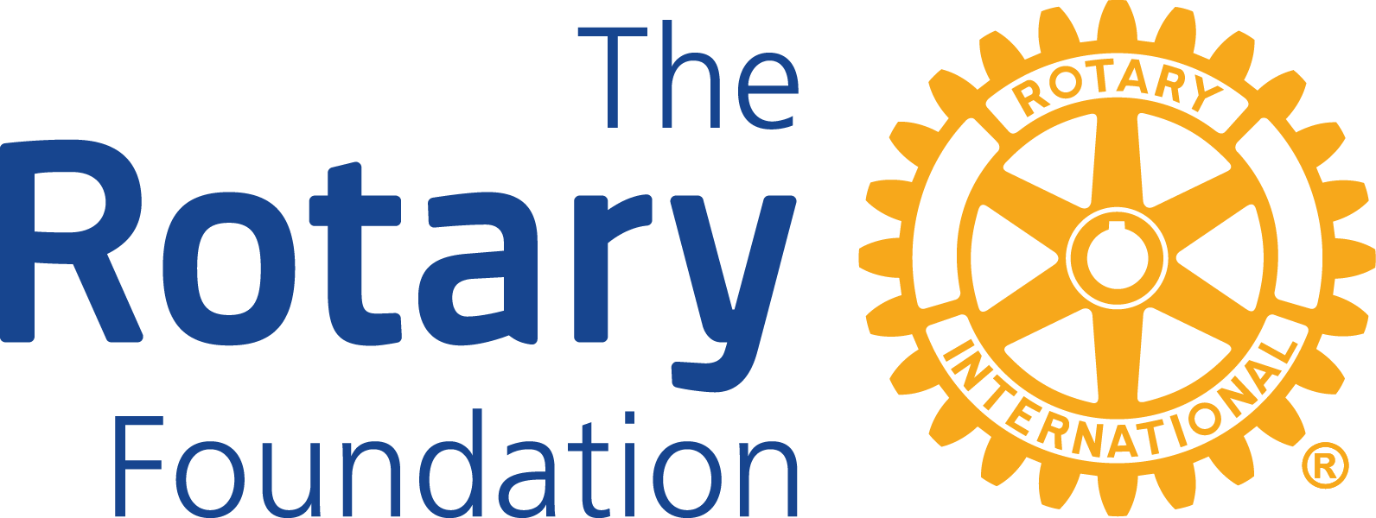


Rotary District 5710 - District Grant Application 2026

Instructions:
Complete all sections of this form. Incomplete applications will be returned and cannot be considered for approval. The submission deadline is August 31, 2026. Funding decisions will be made in September and funds made available as soon as possible thereafter.

Eligibility & Approval Process:
- Projects dependent on these funds cannot be started before this application has been approved and you have been notified of approval by the Grants Subcommittee.
- All grants must include active participation of Rotarians.
- Clubs must be current in their Rotary International and District 5710 dues payments.
- Clubs must be current in all reporting for any open grant for which they are a sponsor or co-sponsor.
- Clubs must have been represented, by at least one club member, at a District Grants Certification Seminar within the last three years prior to the application deadline date.
- Clubs must provide a copy of IRS 990 for the most recent tax year for which filing is due with this application.
- Clubs must provide a signed Club Qualification Memorandum of Understanding (MOU) with this application.
- The Primary Contact of the club’s Project Committee will receive all correspondence from the District Grants Subcommittee, and approved funds will be mailed to the Primary Contact’s address provided.

Grant Applications:
- ALLOCATED: Each eligible club may submit as many grant applications as necessary to receive their maximum Club Allocated Funds.
  - If partnering with another club(s) on the same project, each club involved must submit their own separate signed application if they want to use their Club Allocated Funds.

- DISCRETIONARY: Each eligible club may submit only one grant application for District Discretionary Funds. The same project may request both allocated and discretionary funds, but it requires two applications, one in each category.
  - Any club that sponsors an active Rotaract, Interact, or Satellite club sanctioned under Rotary International, may submit one Discretionary Fund application for a project that entity is leading. This may be in addition to the sponsoring club’s own discretionary grant request.

Grant Applicant Rotary Club Name:
Project Title:
Grant Category Applying for: (Only check ONE; each grant request type must be made by a separate application)
☐ Club Allocated Funds
☐ Check here if funds are earmarked for a Global Grant
Global Grant Number, if known: _______________
Location of Global Grant: ____________________
-OR-
☐ District Discretionary Funds
☐ Check here if funds are going to a sponsored Rotaract, Interact, or Satellite Club Name of Sponsored Club: ____________________

Project Description:
- Briefly describe the project and how it will meet the needs of the target community.

- Estimate the number of people impacted by this project, both directly and indirectly.

- All grants must include active participation of Rotarians. How will the sponsoring club or clubs work to implement the project?

- Which one or more of the Rotary Foundation seven areas of focus will this project address?
☐ Peace and conflict prevention/resolution
☐ Disease prevention and treatment
☐ Water and sanitation
☐ Maternal and child health
☐ Basic education and literacy
☐ Economic and community development
☐ Environment
☐ or Scholarship
Briefly explain how:

Conflicts of Interest Statement:
Are there any conflicts of interest with Rotarians? ☐ Yes ☐ No (Must check one)
If YES, please describe how they are being mitigated:

Training Requirement Statement:
The Rotary club applying for funds has been represented by at least one current club member, in the last 3 years, at a District Grants Seminar held prior to the application date. This member will be included in the oversight of this grant.
☐ Yes ☐ No (Must be checked ‘Yes’, or application will not be considered.)
Trained Rotarian:
Trained Rotarian’s Signature:

Grant Project Bank Account Required:
The Rotary club applying for funds has established a separate ‘Grant’ bank account used exclusively to receive and disburse all funds related to this project. ☐ Yes ☐ No (Must check one)
If NO, please explain corrective action to be taken:

Project Budget & Financing:
Include a complete itemized budget for the entire project equal to the total financing below.

Project Budget Item | Amount $
Total Project Budget $ (Budget total and Financing total must equal)

Project Financing Source | Amount $
Sponsoring Rotary Club:
Partnering Rotary Club:
Partnering Rotary Club:
Additional Funding Sources (list):
Amount Requested from District:
Total Project Financing $(Financing total and Budget total must equal)

Project Committee: A committee of at least two Rotarians must be established in the sponsoring club. It is the committee's responsibility to coordinate the project locally, monitor funds, and provide financial accounting to the District Stewardship Chair in accordance with the Terms and Conditions of this agreement for the duration of the project. The Primary Contact of the club’s Project Committee will receive all correspondence from the District Grants Subcommittee, and approved funds will be mailed to the Primary Contact’s address provided.

Primary Contact and Rotary Member ID Number:
Rotary Position/Title:
Email address: Phone number:
Mailing address:

Alternate Contact and Rotary Member ID Number:
Rotary Position/Title:
Email address: Phone number:
Mailing address:

Coordinating with Other Clubs: If multiple clubs are participating in the same project, and those clubs are requesting Club Allocated Funds, they will need to also submit a separate grant application. Name the club that assumes primary responsibility for the project (the Project Sponsor), and list each participating club:
Project Sponsor - Club Name:
Project Sponsor - Club Number:
Project Sponsor - Club President:
Participating Clubs:

Grant Reporting with Participating Clubs: Although all co-sponsors are also ultimately responsible for completing grant reports, the Grants Subcommittee requires that one club must take primary responsibility for submitting the detailed required reports to the District Stewardship Chair.
The Sponsoring club accepts the primary responsibility of submitting the detail grant reports (including invoices, receipts, etc.). Participating clubs, that are using District Allocated Funds, must submit grant reports documenting their specific project financing sources and their transfers to the Sponsoring club.

Cooperating Organization: Is another organization directly involved in the implementation of the project?
☐ Yes ☐ No (Must check one)
If YES, please provide a letter from the organization indicating how they will work with Rotarians in the implementation of the project and agreement to cooperate in any reporting and financial review of activities associated with the project.

NOTE: The expectation is that joint projects with cooperating organizations will be new projects or that are geared towards expanding existing capacity. Grants cannot fund operating, administrative, or indirect program expenses of another organization. All funding provided to cooperating organizations must be used solely for specific Rotary project expenses.
Clubs should pay directly for all items related to projects; however, when club checks are written directly to a cooperating organization, the club must provide a letter from the club to the organization restricting funds to the purchase of project supplies and must obtain from the organization a copy of invoice(s) from the organization’s vendor for at least the amount submitted. A copy of the letter and invoice(s) are required in the grant reporting.

Terms and Conditions: The Rotary Foundation Terms and Conditions for Rotary Foundation District Grants prohibits the use of funds for specific activities, including, but not limited to:
- Continuous or excessive support of any one person, entity, or community
  - Rotary should not be the majority of support received by an entity
- Fundraising activities
  - Includes ALL fundraising activities of any type by a club or another entity
- Public relations initiatives, unless they are essential to completing the project
- The operating, administrative, or indirect program expenses of another organization
  - Example: Rotary cannot pay for a teacher’s salary at a school
- Unrestricted cash donations to a person, entity, or cooperating organization
  - Rotary cannot give money to a charity to add to their revenues and/or pay their expenses. Example: Rotary cannot give money to Water.org as they go about their plans to drill wells; however, it is acceptable for a club to hire a vendor such as Water.org to drill a well for Rotary.
  - All student scholarship disbursement checks must be written to the educational institutions, and not directly to students. This restricts the use of funds to only educational expenses.
- Activities for which the expense has already been incurred
  - Example: Rotary cannot reimburse a municipality for having already fixed up a park shelter.

Agreement: This Application and Agreement are entered into between the project sponsor, on behalf of itself and any partnering Rotary clubs, identified herein, and the District 5710 Grants Subcommittee. In applying for and accepting Project Funding, the project sponsor agrees:
- To utilize the Project Funds to support a humanitarian and/or educational project as outlined in the application, within one of seven areas of focus identified by The Rotary Foundation or scholarships. Funds provided by the District will not be used for any purpose other than those considered eligible and not restricted in the Terms and Conditions for Rotary Foundation District Grants (linked and enclosed).
- To defend, indemnify, and hold harmless Rotary International (RI) and the Foundation of Rotary International (TRF) from any and all damages, losses, judgments, costs, fines, awards, liabilities, and or, expenses, including without limitation reasonable attorney fees and costs of litigation, asserted or recovered from RI/TRF, that result or arise directly or indirectly, from the implementation of this project.
- That this agreement may be cancelled by District 5710 for any reason without notice upon the failure of the sponsors to abide by the terms set forth herein.
- The sponsors agree to return any grant funds, in their entirety, including any interest earned, should funds be misused or used for ineligible purposes.
- This agreement is governed by all applicable laws of the State of Illinois, U.S.A.

I have read and understand the “2026 District Grants Policy” and will abide by all stipulations set forth therein _______. (initials required)

I have read and understand the “Terms & Conditions for Rotary Foundation District Grants” and will abide by all stipulations set forth therein _______. (initials required)

Acknowledgement: By signing below, I certify that the sponsors acknowledge and accept the terms of this agreement and agree to abide by the stipulations set forth herein, including the grant reporting requirements.
Rotary Club Name:
Rotary Club President:
Email address: Phone number:
Club President Signature: Date:
(Actual written signature required)

Submitting Completed Application:
Emailed applications are preferred to the address below. You must include:
- This completed and signed application
- A signed copy of the Club Qualification Memorandum of Understanding (MOU); and,
- The club’s most recently filed IRS Form 990

District Grants Subcommittee Chair
Greg Shondell
3905 Delmar Dr.
Shawnee Mission, KS 66208
(c) 913-956-1764
greg@HeathwoodOil.com

