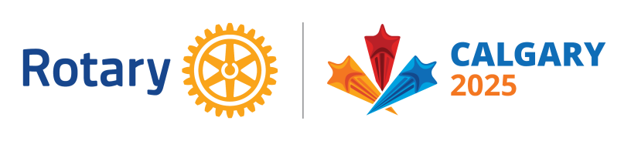
District 5710 Global Grant
Preliminary Evaluation

Host Club: ______________________________________
International Club: ________________________________
Has your Club’s GG Project Committee carefully read the documents listed below? (Please check to indicate “Yes”)
___ Guide to Global Grants
___ Terms and Conditions for Global Grants
___ Area of Focus Policy Statements

- What area of focus does this project fall under?
___ Peacebuilding and Conflict Prevention
___ Disease Prevention and Treatment
___ Water, Sanitation, and Hygiene
___ Maternal and Child Health
___ Basic Education and Literacy
___ Community Economic Development
___ Environment
- Referencing the Area of Focus Policy Statement, please state below which “Purpose and Goals” and “Parameters for Eligibility” your project complies with.

- In 150 words or less, please give us a brief description of your project.
(Please refer to the Terms and Conditions document, especially part 2 “Ineligible Activities” and part 3 “Application Requirements” before answering.)

Intended location for the project (city, country):___________________________

4. Intended duration of the project: ________________________________________

Note: While the TRF does not specifically require a particular length of time for the project, Global Grant service projects typically are scheduled for 12-36 months.

Proposed start date: ________ End date: ___________ # of months ______________

5. Name of Cooperating Organization: _____________________________________

Why? ________________________________________________________________

6. Who are the beneficiaries of your project? Approximately how many people?

7. List members of your project committee:

 | Name | Club | Phone | EMail
Primary Contact
Member
Member
Member

International Partner Club:
If you have an International Club partner identified, please list their committee/contact names.
 | Name | Club | Phone | EMail
Primary Contact
Member
Member

8. Budget. Please list funding you have secured so far:

Domestic sponsorship:(In US Dollars)
Club: ____________________________ Amount: ___________________
Club: ____________________________ Amount: __________________
District: __________________________ DDF Amount: ______________
District: __________________________ DDF Amount: ______________
Other Non-Rotarian Donations: ____________________
Subtotal: ____________________ (A)
International sponsorship:(In US Dollars)
Club: ___________________________ Amount: ___________________
Club: ___________________________ Amount: __________________
District: _________________________ DDF Amount: _______________
District: _________________________ DDF Amount: _______________
Other Non-Rotarian Donations: ___________________
Subtotal: __________________ (B)
A minimum of 15% of your funding must come from the International partner.

How much funding is expected from the RI World Fund? $______________________
Available grant funding from the World Fund is the sum of all DDF contributions above X 0.8.

What is your total project budget? The minimum Rotary Global Grant project is $30,000. $________________________

9. Have you completed a community assessment in the community where the project will take place? Please describe below:

