Alan Mallory
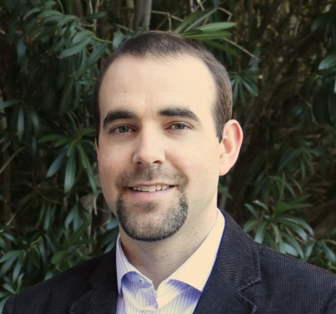
Alan is an international speaker, author and professional development trainer who is passionate about leadership and human performance. He studied engineering at Queen’s University and has worked all over the world as a mechanical engineer and project manager but his true passion is in working with people to reach new heights in the way we think and the actions we take. Alan has always had a keen interest in discovering what drives us to do what we do and how we can use this knowledge to improve our lives and the lives of those around us.
As a keynote speaker and leadership coach, Alan delivers a number of exciting presentations and training programs that are all about embracing and working through challenges as well as exploring the skills and mindsets that allow great leaders and committed teams to achieve breakthrough performance. Alan integrates his many years of innovative leadership experience with captivating mountaineering and adventure stories to create a powerful and unforgettable journey for his audiences.
Alan is also a college professor, avid adventurer and outdoor enthusiast. He enjoys many different activities but his favorite activities are those spent out in the wilderness and those that involve strategy and problem solving. He speaks English and Spanish and loves to travel the world and explore new places.
In the spring of 2008, Alan and his family set a world record as the first family of four to reach the summit of Mt. Everest. It was a two-month expedition through some of the most terrifying and arduous conditions imaginable but to finally reach the end goal was an incredible feeling. Alan offers a number of exciting keynotes and interactive sessions focused on building leadership capacity and strengthening teams by reinforcing the professional development skills that are essential for conquering one’s own Everest, whatever that may be.
Alan’s presentations are a stunning visual and emotional journey that bring the audience along on the amazing venture. They are supported by many of the vivid photos and short video clips captured along the grueling quest to the top. The Mallory family’s story is as exciting as it is terrifying as they fought their way through the many perils that the world’s highest peak had in store for them.

