Larry Dimmitt

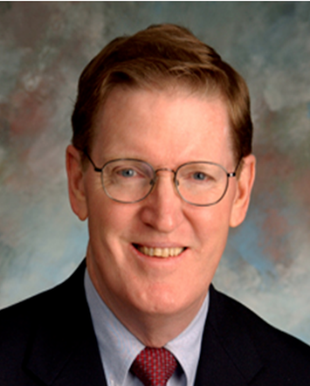

Larry Dimmitt has been a member of the Topeka, Kansas USA Rotary Club since 1983. He served as District Governor of District 5710 in 2006-07. He was District Foundation Chair and also served as Zone 27 Rotary Foundation Alumni Coordinator, Assistant Regional Rotary Foundation Coordinator and Paul Harris Society Coordinator.

He currently serves as Regional Rotary Foundation Coordinator for Zone 27. He also served as General Chair of the 2014 Zones 21B/27 Institute. He was on the 2015-16 Rotary Joint Committee on Alumni Relations, and currently is a member of the 2016-17 Joint Young Leader and Alumni Engagement Committee. He has been elected to serve as Rotary International Director for Zones 21 and 27 in 2018-20.

Larry has been on four service missions to Panama, and has prepared numerous international grant applications, including those for India, Bangladesh and Pakistan. He is a Paul Harris Fellow, a Benefactor, a member of the Bequest Society, a member of the Paul Harris Society, a Major Donor and actively supports the Topeka Rotary Foundation. He has been awarded the Rotary Foundation Citation for Meritorious Service and the Distinguished Service Award.

