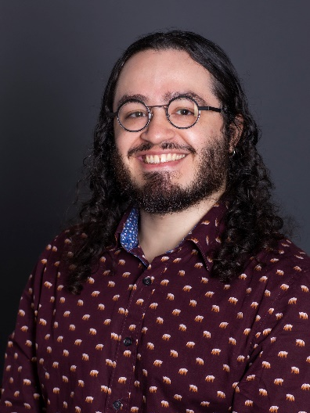
Andrez Perez
Officer, Zones 29 and 31 | Club and District Support
Andrez.Perez@rotary.org | 1.847.424.5368
Andrez Perez is the Club and District Support Officer for Zone 29. In this role, Andrez works directly with Rotary leaders to help them understand Rotary’s policies and procedures, guides members through club and district processes, and assists in addressing adult harassment. He is a graduate of the Savannah College of Art and Design where he received a B.F.A in Film and Television before moving to Chicago. In his spare time, he likes to cook, go to music venues, and work on short, experimental films.

