Log int RI and go to Club Central Site
Log into Rotary International at www.rotary.org
Click My Rotary in the menu bar.
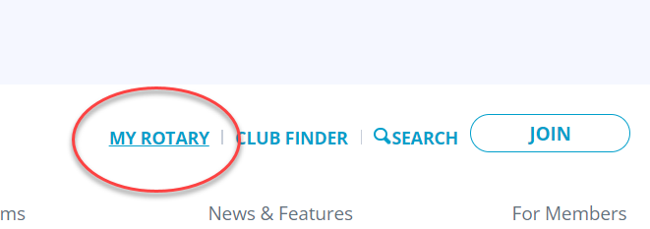
Click the Sign In To My Rotary button.
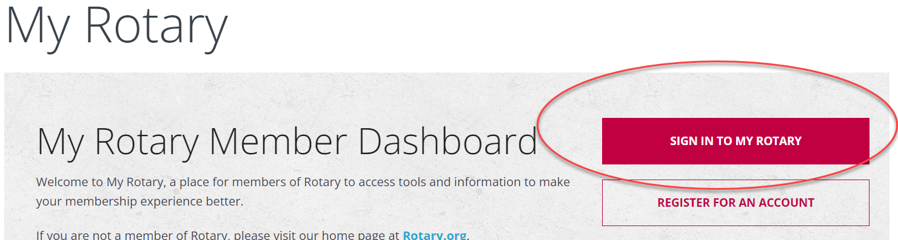
Enter your user name which is your e-mail address and password. Then click sign in.
Hover over Manage then Club & District Administration.
Click Rotary Club Central
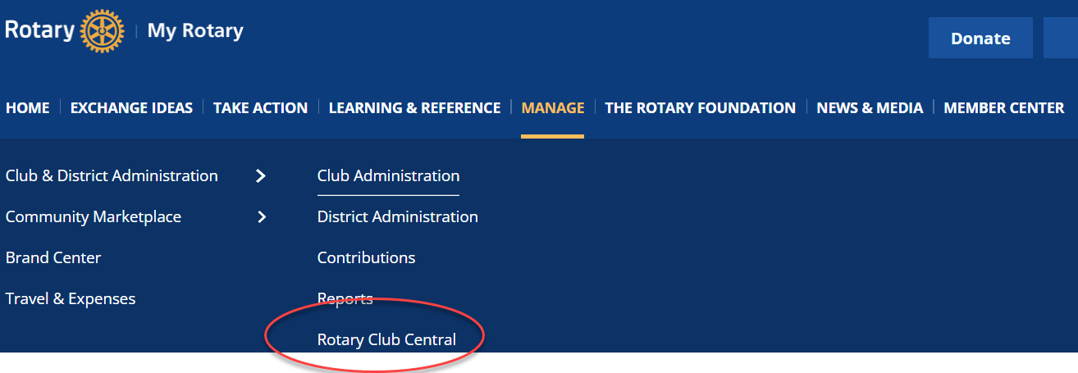

Here’s an easier method:
At the top of the page, click Rotary.org
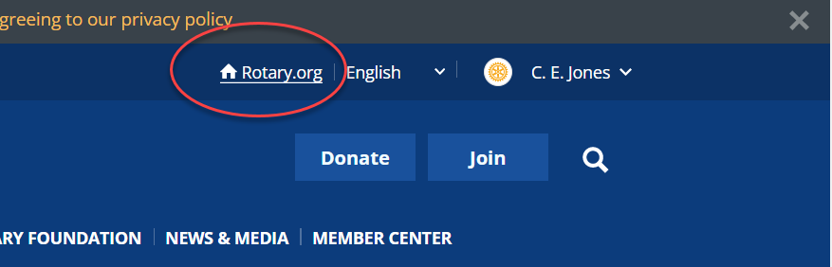
Hover over the menu item For Members
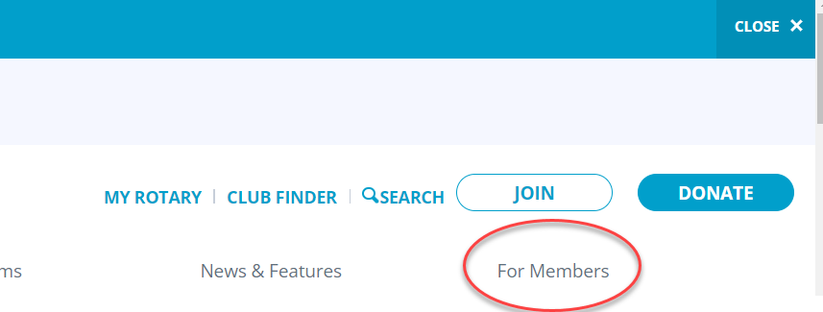
Click on Rotary Club Central
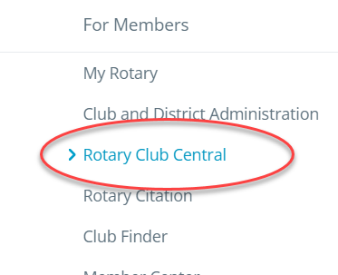

Select and enter goals for the next year.
In the left panel, click Goal Central.
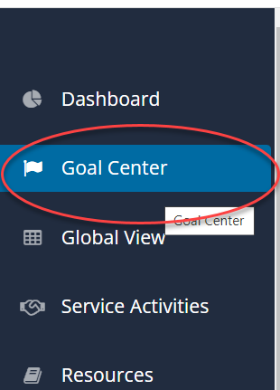
Click the right arrow to view the next Rotary Year.
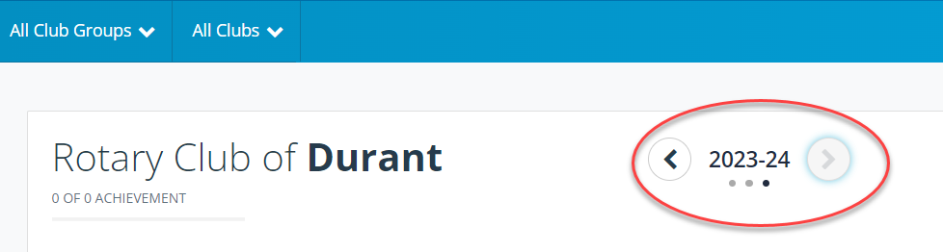
NOTE: Only Club Officers can select, enter and edit goals.
It’s recommended that other members using the site use the printed worksheet. Submit the goals to your club’s officers (President, Secretary or Executive Secretary) and let them enter and edit the goals.
Click the Edit button to view all goals.
Use the check marks next to each goal to select the goals you wish to achieve.
Enter the goal number for each goal.
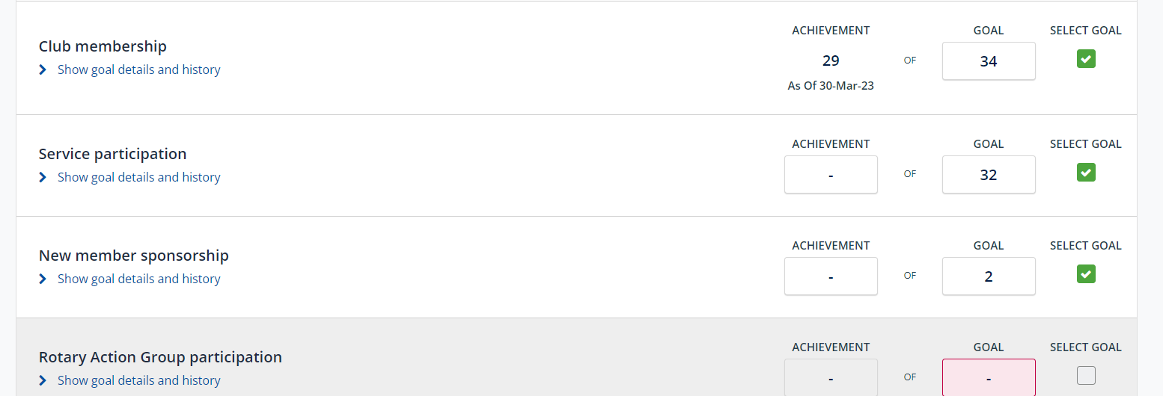
Return to this page to update your achievements.
Be sure to click Save at the top of the goals page before leaving the page.
