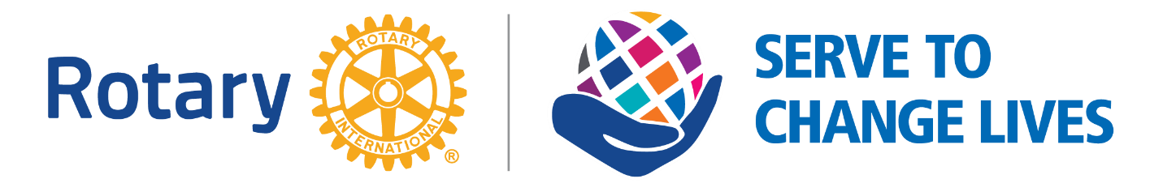

Rotary District 5830 Polio Posse
Paul Harris Fellow (“PHF”) Contest
District 5830 will award a PHF to the president of the clubs (by size) who raise the most funds per capita for Polio Plus in Rotary year 2021/2022. Each person who contributes $25.00 will become a member of the District 5830 Polio Posse and receive a complimentary Polio Posse badge. See image attached.
Clubs will be divided into three groups:
1. Small – up to twenty (20) members.
2. Medium – twenty-one (21) to fifty (50) members.
3. Large – Over fifty (50) members.
Club size will be based on membership reported to Rotary International on July 1, 2021. The president in each group who raises the most per capita in 2021/2022 will be awarded a PHF. Our goal is to have 100% participation by all District 5830 members.
How many more lives will we save by this? How many more people will be able to reach their full potential because of this? Interesting fact – the plus in Polio Plus includes vitamin A drops which have prevented 1.25 million deaths by decreasing susceptibility to infectious diseases.

