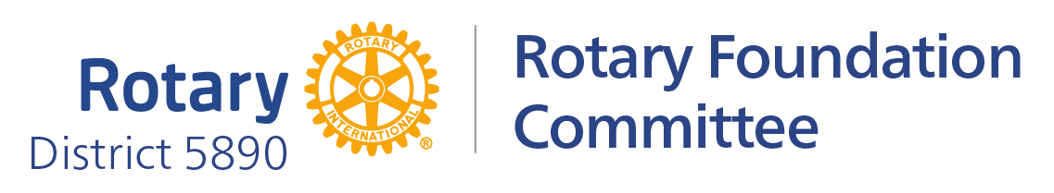
2025-2026 District Grant Qualifiers and Requirements

The maximum matching for 2025-2026 is $2,500.00

- If club has Foundation giving in the Rotary year 2022-2023, 2023-2024, 2024-2025, the club will receive $1,00.00.

- Each year of the 2022-2025 years you have $100.00 per capita, club will receive $500.00 per year achieved.

PDG Eric Liu
District 5890 Rotary Foundation Chair 2024-2027
(713)594-3370
ericliu5890@gmail.com

