Contact | (Insert Your Name)
Telephone | Your Cell and/or Work Phone
Email | Your email address
Website | Your club’s web address
 | Keep it Short & Only 1-Page!
(Insert your club’s logo here)

FOR IMMEDIATE RELEASE

Add Date

In Celebration of nelson mandela day

The Rotary Club of ???? along with

The International Office of the University of Texas proudly presents:

The 2nd Annual Evening with the
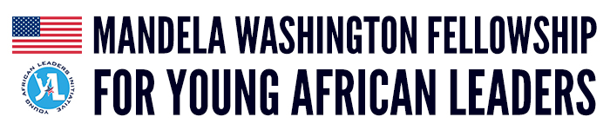
Please join us on Wednesday July 19th, from 6-9pm at the University of Texas Club.
The evening will include a series of short talks on the areas of Ethics, Equality and Opportunity Young African Entrepreneurs and an open panel Q&A with all 25 of the YALI (Young African Leaders Initiative) participants. The evening will close with fellowship and networking so that the ideas shared can continue to build bridges from Austin to Africa.

This event will include a Heavy Hors d’oeuvres and Cash Bar.
Tickets are $20 each and Seating is Limited, it is very important that you register early.
Location: The UT Club – Private Dining Room – 2108 Robert Dedman Drive Austin, TX 78712
More Information and Registration can be found at http://www.southaustinrotary.com
The University of Texas at Austin is proud to announce that it has been selected as a partner with The Mandela Washington Fellowship for Young African Leaders for the 4th consecutive year. This is an intensive 6-week program sponsored by the U.S. Department of State that empowers young leaders (age 25-35) from Sub-Saharan Africa through academic coursework, leadership training, and networking. This summer, UT Austin will host 25 entrepreneurs for our Business & Entrepreneurship Institute who run businesses in tech, fashion, marketing, finance, media, and communications.
These Mandela Washington Fellows belong to a generation of young African leaders who feel a great responsibility to decide the direction their countries will take over the coming decades. They are seeking to take advantage of the new economic opportunities unfolding across the continent, while also maintaining a positive social impact through their business endeavors. This program presents a wonderful opportunity for them to expand their field of impact and hone their skills for bringing change to their countries.

Example – Please insert short description similar to this one: “After spending an evening with these amazing Young African Leaders, you truly walk away feeling connected to something special in the world… knowing that with all of us working together to support humanity this world will continue to transform into a peace filled place to call home.”
–President’s name, President Rotary Club of ?????

Rotary is 1.4 million passionate individuals in 35,000+ clubs worldwide. We are both an international organization and a local community leader. Together we lead change in our own backyards and across the world. Our greater Houston area Rotary District 5890 has 60+ clubs and over 2,850 members serving their communities right here in Harris and the surrounding counties.
# # #
If you would like more information about this topic, please contact (Insert Your Name) at Your Cell and/or Work Phone email at Your email address

