A Guide to the Learning Topic: District 5890 Expanding Our Reach

Basics
What is a Learning Topic?
Learning Topics allow Learning Center users to share new ideas and useful resources, including links, documents, presentations, and more with fellow members. Rotary staff and members monitor content to ensure it is relevant. In this case, it’s a one-stop shop for anything related to membership and public image training in your district.
How do I get the most out of a Learning Topic?
Take the course Getting Started with Learning Topics for an overview of the purposes of social learning, how to access Learning Topics, how to ask questions, how to contribute, how to create a list of favorites, and how to download an asset.
Then add your own discussions and feedback to the resources. The Learning Topic is yours to manage – it will improve and expand based on how you use it and the work you put into it.
What other Learning Topics can I explore?
The learning doesn’t stop at District 5890. You can find many other useful topics like 2020 Virtual Convention Breakout Presentations, Meeting Online, Membership, Foundation Giving, DEI, District Trainer Best Practices, and more.
How do I find the Learning Topic District 5890 Expanding Our Reach?
If you are already signed into your My Rotary account or the Learning Center, you can click on this direct link.
Otherwise, follow the steps in the pages below.

STEP 1: Go to Rotary’s Learning Center – either via My Rotary (see screenshot below) or directly using the URL rotary.org/learn.
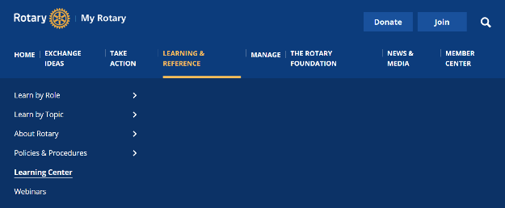

STEP 2: On the Learning Center homepage, click on the User Menu – the three horizontal lines at the top left, next to the Rotary logo.
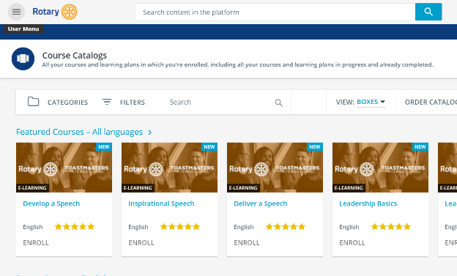

STEP 3: Click on Learning Topics.
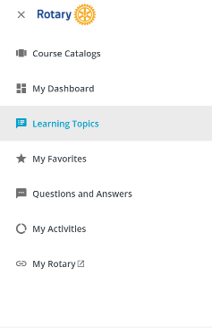

STEP 4: Scroll down to District 5890 Expanding Our Reach (topics lower on the page may take a couple of seconds to load) and click on the title.
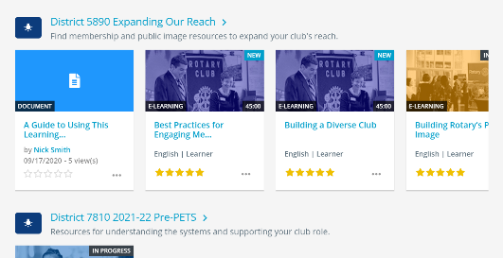

What can I find in the Learning Topic?
The District 5890 Expanding Our Reach Learning Topic is meant to provide you with a one-stop shop for enhancing your knowledge about membership topics, public image, and building engagement. It will help you find the resources you need to communicate who you are and what you do. You can:
- Take courses and learning plans on Rotary’s Learning Center  - Enroll with one click and start expanding your knowledge  - Take individual courses or take a number of courses in the learning plan | 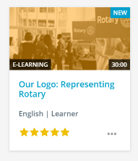
- Find links to helpful resources for your district  - Your district’s home page – and the public image resources subpage  - ClubRunner and DACdb technical support | 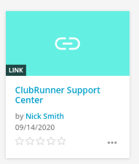
- View helpful presentations and webinars  - How to manage your social media account  - District training webinars | 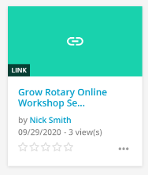

How else can I use the Learning Topic?
This Learning Topic is yours to develop and manage, and can become a robust site for knowledge and skill-building. Some of the other features of a Learning Topic include:
- Contribute your own resources. As a member of the Learning Topic, you can upload files, record your own demonstrations and tutorials, and link to other helpful websites. | 
- Ask a question and get your question answered by an expert from your district or on Rotary staff. | 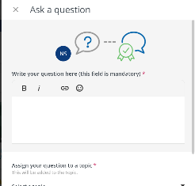
- Make individual resources more meaningful. Rate, leave questions and comments, like or dislike answers, answer someone else’s question, and create a Favorites list. | 
- Invite others to view items that you think are important. | 

What if I want to add resources created by someone outside of Rotary?
If you want to include third party content:
- Confirm you have permission to use and share the content
- Rather than uploading the content to the Learning Topic, include a link to its source. That way, users will be accessing the most up-to-date versions and you will not have to manage versions. (That’s why we linked to ClubRunner Support instead of embedding one of their videos, for example.)
- Before you add third-party content, review or have someone else review it, to ensure that it is clear and easier for your members to understand.

