The Kingwood Rotary Club would like to thank our following EAFK community partners:

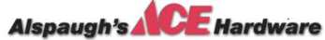

The 10 virtues of the EAFK curriculum:
Tolerance Responsibility Confidence Service
Perseverance Friendliness Respect Discipline
Compassion Honesty

What is the Kingwood Rotary Club? We are business, professional and community leaders connecting to make a difference in our community, and beyond! We're a "family friendly" Rotary club which was chartered in December 2004. As Rotarians we share our time, our talents, our resources, and we are at our best when we use Rotary for the purpose of sharing our individual passions for the betterment of our community, and our world.
We invite you to find out how Rotary shares your passion and commitment. Spouses and children are always welcomed at meetings which are held every Thursday evening from 6:45 PM until 7:45 PM at Skeeter's Mesquite Grill in Kingwood. We invite you to attend a weekly meeting!
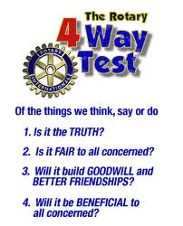
Rotary's 4-Way Test - One of the most widely printed and quoted statements of business ethics in the world is Rotary’s 4-Way Test. Rotarian Herbert J. Taylor created the 4-Way Test in 1932 when he was asked to take charge of a Chicago-based Club Aluminum Company, which had over 250 employees. With $400,000 in debt, and facing bankruptcy, Taylor looked for a way to save the struggling company mired in depression-caused financial difficulties. He drew up a 24-word code of ethics for all employees to follow in their business and professional lives. The 4-Way Test became the guide for sales, production, advertising, and all relations with vendors and customers, and the survival of the company was credited to this simple philosophy. In 5 years, Taylor paid off the $400,000 of debt, with interest, and distributed one million dollars in dividends to stockholders, in spite of the continuing Great Depression. Bear Branch Elementary students can recite it from memory! Encourage them to share it with you.

Please visit WWW.KWROTARY.ORG for more about Kingwood Rotary Club.
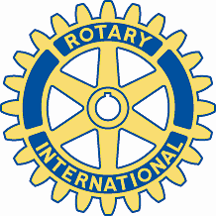
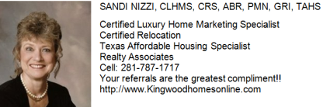
The Rotary Club of Kingwood
proudly sponsors and presents the
EarlyAct FirstKnight Character Education
Program Knighting Ceremony

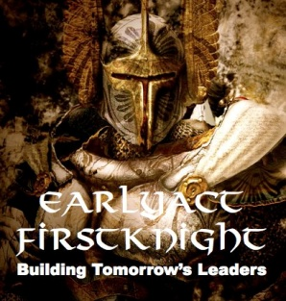

Celebrating This Month's Virtue of "Confidence"
at
Bear Branch Elementary School

May 2, 2012
Our 5th Knighting Ceremony of this school year

CONFIDENCE. Confidence is being content with who you are without comparing yourself to others. It is believing in yourself and your abilities, and having the assurance that you can fulfill your life's dreams. Remember, inaction breeds fear and doubt. Action breeds confidence and courage. If a knight wants to conquer fear, do not sit at home and think about it; go out and get busy. Seek great stature of character by holding to the virtues and duties of a knight.

Congratulations.....
The Rotary Club of Kingwood congratulates you for having a student selected to be honored at this month's EarlyAct FirstKnight Character Education Program's Knighting Ceremony. Our Kingwood Rotarians are very proud to sponsor this outstanding character education program at Bear Branch Elementary which is currently only one of nine campuses in Harris, and the surrounding eight counties, which have EAFK at their school. The children and grandchildren of several of our Kingwood Rotarians have either attended, or are currently attending Bear Branch Elementary, so we are very excited about continuing a tradition of service here at Bear Branch Elementary. Please visit our website at www.kwrotary.org or call Charlie Buscemi at 281.359.7193.

EAFK IS BUILDING TOMORROWʼS LEADERS TODAY DURING THE MOST FORMATIVE YEARS OF THEIR LIVES.

Based on the theme of gallant knights and Rotarian values, EarlyAct FirstKnight is a curriculum-based character education program for elementary and middle schools that teaches students how to become noble, service-oriented people along with why it is important for them to do so. EAFK can only be sponsored by a Rotary club, and the Rotary Club of Kingwood is very proud to be sponsoring it at Bear Branch Elementary School.

Each month, the students will focus on one EAFK character virtue, and at the monthly Knighting Ceremony, one student from each classroom will be selected to be honored. EAFK is amazingly effective, with 100% of participating schools crediting the program with significantly increased academic scores, decreased behavioral issues, more teaching time and happier faculties and parents.

36 out of 50 states in America have now enacted legislation that either mandates or strongly encourages character education in public schools. This is because people are beginning to realize that the traditional values, ethics and civility that define a great society are increasingly eroding among children today. Our future, therefore, depends upon reversing this trend on a broad scale. EAFK provides Kingwood Rotary Club with an effective solution to the problem by bringing excellent character, morals and ethics to the forefront of public school classrooms, right alongside math, science and social studies. Combining strong academics, Rotarian mentorship, and live-action motivational support, EAFK is building tomorrow's leaders today during the most formative years of their lives.

EarlyAct FirstKnight Knighting Ceremony - May 2, 2012

Introduction: Principal Kakie Palmer
Kingwood Rotary Welcome: Charlie Buscemi

Knighting Ceremony at 1:15 PM
Gallery of Champions:

Kindergarten
Brinley Birkhead, Rylee Bush, Nolan Krueger, Abby Vandiver

First Grade
Madysen Crutchfield, Marissa Mazzaferro, Bethany Stewart,
Connor Price, Camille McWhorter

Third Grade
Savannah Moore, Michelle Perri, Ian Graham, William Van Dyke

Knighting Ceremony at 2:25 PM
Gallery of Champions:

Second Grade
Suzanne Durand, Kaitlyn Brand, Hassan Hashemian,
Jordan Hoyt, Cali Burningham

Fourth Grade
Brian Bleier, Lindsey Cochran, Katherine Whittaker,
Brianna Rodriguez, Nathan Murray

Fifth Grade
Elizabeth Campbell, Luis Fernandez, Genevieve Sheppard, Tyrus Krueger

