As the 2022 Rotary International Convention approaches and the spotlight on Rotary in Houston intensifies, we have a prime opportunity to expand our reach. We encourage you to use these new marketing materials that have been developed for Rotary members in District 5890. On the district Dropbox site you’ll find photos, videos and ads featuring Houston Rotary club members as people of action.

Rotary in Houston photos
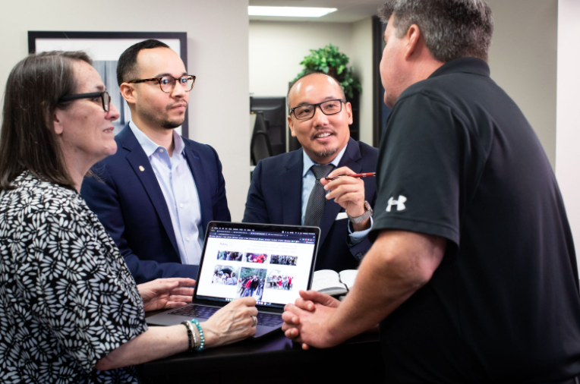

Find scores of photos that show District 5890 members in action for use in in your marketing materials and on your social media channels. Or, be inspired and take your own photos!
Digital banner ads
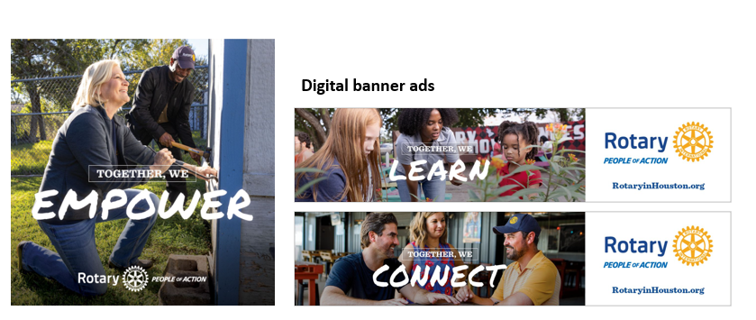
Use these digital banners on club websites and in other online applications to promote your club as people of action.
Videos
Videos showing District 5890 members in action are available in three lengths — 0:15 seconds, 0:30 seconds, 0:60 seconds — with and without subtitles and in formats optimized for your social media channels. Download and share these new videos on social media. Find links (embed codes) to add these videos to your club website in Rotary in Houston Videos.

Videos
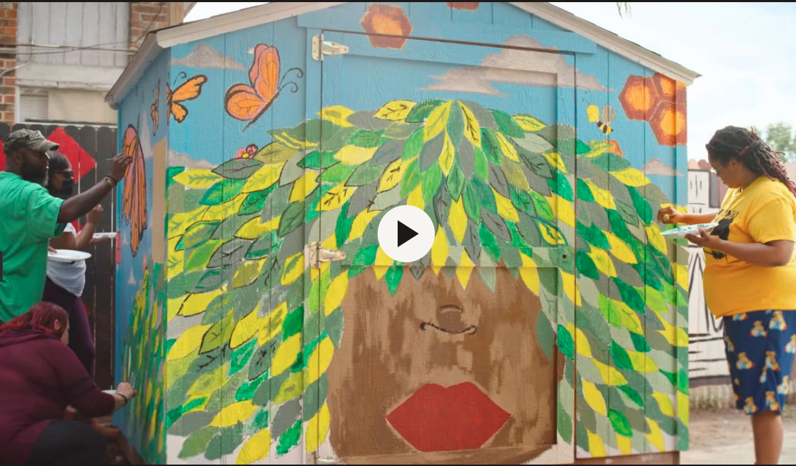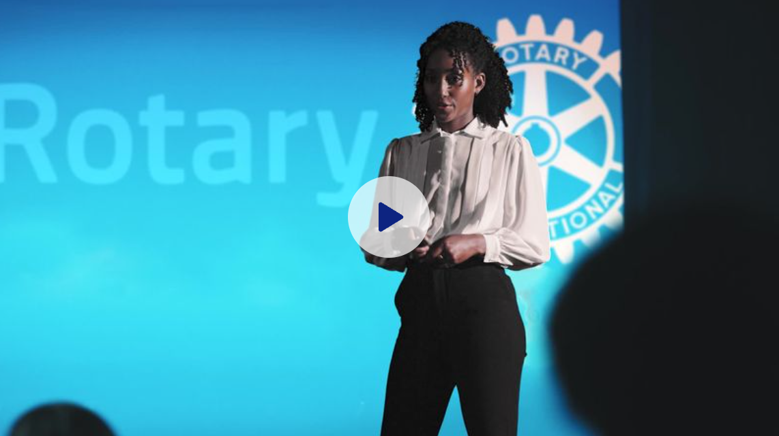
People of Action-Houston We are Rotary–Houston.
Please note videos can be used for non-commercial Rotary-related purposes. Videos must be used in their entirety.

Rotary in the news
ABC H-Town Spotlight ​
Learn how Rotary is inspiring change around the world!​
Houstonia
Rotary: People of Action Who Take Action to Change Lives​
A happy new year to you. There’s so much to gain when you give back to your community. ​
Community Impact News​
Rotary helping Houstonians find avenues to make the world a better place​

Create customized materials in the Brand Center
The photos and ads in the District 5890 Dropbox can be customized with your club’s logo to let your communities know you’re people of action. Visit the Rotary Brand Center to find templates for creating ads for digital, print and social media and more.

In the new Our brand section, you will find guidance on using Rotary’s logos, colors, fonts, and voice to design flyers, brochures, presentations, and other materials that look and sound unmistakably like Rotary.

Resources for D5890 members
Visit Rotary’s Learning Center to access Learning Topic District 5890 Expanding Our Reach for self-paced courses, webinars and more. You’ll need a My Rotary account to access the Learning Center and the Brand Center.

Three easy actions to promote your club
- Ensure your club’s website is up to date with current information and correct logos.
- Use Rotary's templates in the Brand Center to create a new brochure and promotional materials for your club.
- Share stories that show how your club makes a difference in your community. And, invite others to join you!

We would love to hear about your promotion efforts – please let us know how you are using these materials to promote your club. If you have questions about the assets or how to use them, please contact PR@Rotary.org

