As the 2022 Rotary International Convention approaches and the spotlight on Rotary in Houston intensifies, we have a prime opportunity to expand our reach. We encourage you to use these new marketing materials that have been developed for Rotary members in District 5890. On the district Dropbox site you’ll find photos, videos and ads featuring Houston Rotary club members as people of action.
We would love to hear about your promotion efforts – please let us know how you are using these materials to promote your club. If you have questions about the assets or how to use them, please contact PR@Rotary.org

People of Action-Houston
This video is available in three lengths — 0:15 seconds, 0:30 seconds, 0:60 seconds — with and without subtitles and in three formats:
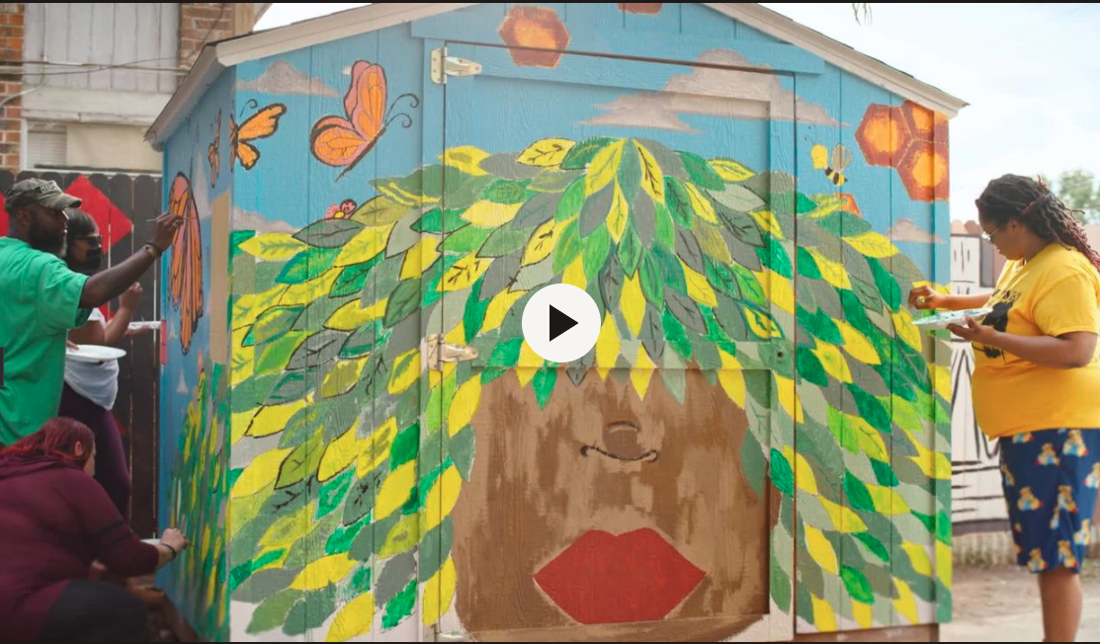 | 16:9 — for use on your website and social platforms, for horizontal video players such as YouTube, or for paid ads on Facebook, Google Ads, or Twitter. See page 2 for embed codes to add these videos to your club’s website.
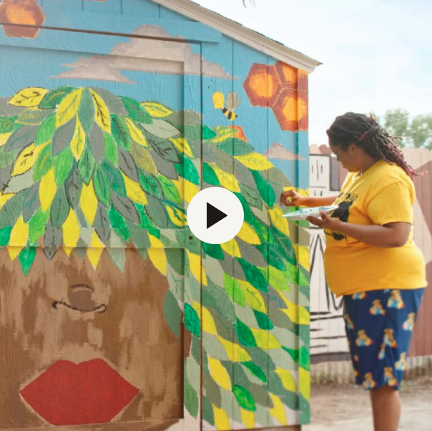 | 1:1 — for use on social platforms with square formats, including Facebook, Instagram, LinkedIn, and Twitter.
Please note videos can be used for non-commercial Rotary-related purposes. Videos must be used in their entirety.

To add the new videos to your club website, you will need to use an embed code. Select the People of Action-Houston video you want to include and use the corresponding embed code.
Length | Format | Embed Code
0:30  view video | 16:9, no subtitles | <div class="2021143poah3016x9enmp4-1647026251599"></div><script type="text/javascript" src="https://rotary.webdamdb.com/js/modules/embeddables/display.webdam.js" data-embeddableid="Y2iKwa_knGoBRZpVNM" data-width="550" data-class="2021143poah3016x9enmp4-1647026251599" data-displaytype="3" data-mediatype="4" data-webid="792sPLeiBL82kL39" data-labeltext="Download" data-autoplay="0"></script>
0:30  view video | 16:9, with subtitles | <div class="2021143poah3016x9ensubsmp4-1647026282827"></div><script type="text/javascript" src="https://rotary.webdamdb.com/js/modules/embeddables/display.webdam.js" data-embeddableid="hgkC_0okT5nGFYZVNm" data-width="550" data-class="2021143poah3016x9ensubsmp4-1647026282827" data-displaytype="3" data-mediatype="4" data-webid="s81wkEpZX8f63koR" data-labeltext="Download" data-autoplay="0"></script>
0:60  view video | 16:9, no subtitles | <div class="2021143poah6016x9enmp4-1647025954435"></div><script type="text/javascript" src="https://rotary.webdamdb.com/js/modules/embeddables/display.webdam.js" data-embeddableid="UkCZryh0TtpZsEMTkz" data-width="550" data-class="2021143poah6016x9enmp4-1647025954435" data-displaytype="3" data-mediatype="4" data-webid="6TPrNGCV7R11cyR7" data-labeltext="Download" data-autoplay="0"></script>
0:60  view video | 16:9, with subtitles | <div class="2021143poah6016x9ensubsmp4-1647026125377"></div><script type="text/javascript" src="https://rotary.webdamdb.com/js/modules/embeddables/display.webdam.js" data-embeddableid="oAiQQiJ0dyh38Os238" data-width="550" data-class="2021143poah6016x9ensubsmp4-1647026125377" data-displaytype="3" data-mediatype="4" data-webid="ghCwrsbXPy93Yqdg" data-labeltext="Download" data-autoplay="0"></script>

We are Rotary–Houston
This video is available in three lengths — 0:15 seconds, 0:30 seconds, 0:60 seconds — with and without subtitles and in three formats:
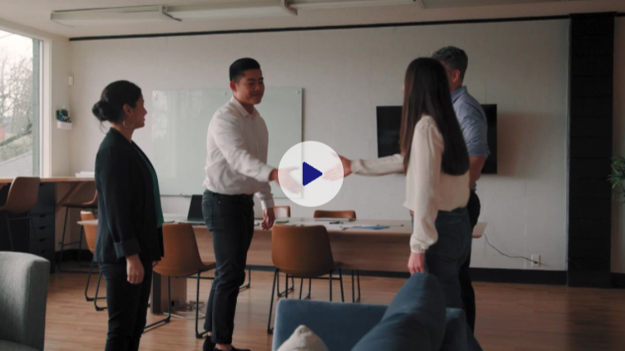 | 16:9 — for use on your website and social platforms, for horizontal video players such as YouTube, or for paid ads on Facebook, Google Ads, or Twitter. See page 2 for embed codes to add these videos to your club’s website.
 | 1:1 — for use on social platforms with square formats, including Facebook, Instagram, LinkedIn, and Twitter.
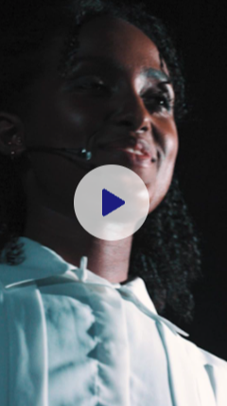 | 9:16 — for use on social platforms with vertical formats, such as Snapchat or Instagram Stories.
Please note videos can be used for non-commercial Rotary-related purposes. Videos must be used in their entirety.

Use these embed codes to add We are Rotary–Houston videos to your club’s website.
Length | Format | Embed Code
0:60  view video | 16:9, no subtitles | <div class="2021108houston60en16x9mp4-1633658695818"></div><script type="text/javascript" src="https://rotary.webdamdb.com/js/modules/embeddables/display.webdam.js" data-embeddableid="PSBt76XUYGvQQ-e2_v" data-width="550" data-class="2021108houston60en16x9mp4-1633658695818" data-displaytype="3" data-mediatype="4" data-webid="AupJXSpDwoi11Unn" data-labeltext="Download" data-autoplay="0"></script>
0:60  view video | 16:9, with subtitles | <div class="2021108houston60en16x9subtitlesmp4-1633658766610"></div><script type="text/javascript" src="https://rotary.webdamdb.com/js/modules/embeddables/display.webdam.js" data-embeddableid="03iS6wvUvmjlqR_KDc" data-width="550" data-class="2021108houston60en16x9subtitlesmp4-1633658766610" data-displaytype="3" data-mediatype="4" data-webid="2fQU30y9ny055Isc" data-labeltext="Download" data-autoplay="0"></script>
0:30  view video | 16:9, no subtitles | <div class="2021108houston30en16x9mp4-1633658810125"></div><script type="text/javascript" src="https://rotary.webdamdb.com/js/modules/embeddables/display.webdam.js" data-embeddableid="NkRcayJE6aj5DbEjlm" data-width="550" data-class="2021108houston30en16x9mp4-1633658810125" data-displaytype="3" data-mediatype="4" data-webid="Iv0nOoFBZYW12sqS" data-labeltext="Download" data-autoplay="0"></script>
0:30  view video | 16:9, with subtitles | <div class="2021108houston30en16x9subtitlesmp4-1633658832661"></div><script type="text/javascript" src="https://rotary.webdamdb.com/js/modules/embeddables/display.webdam.js" data-embeddableid="WfZW9oe0X0iHcoTJZh" data-width="550" data-class="2021108houston30en16x9subtitlesmp4-1633658832661" data-displaytype="3" data-mediatype="4" data-webid="kCbkPz5RIq323kaL" data-labeltext="Download" data-autoplay="0"></script>

