Polio Eradication Update
For The Week Ending 07/30/16
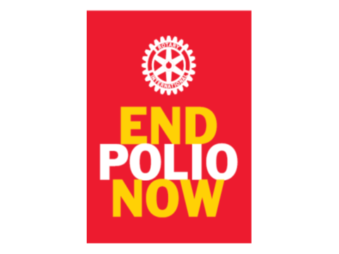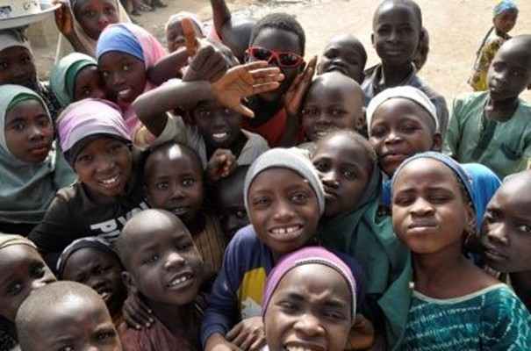

The Gates Foundation is currently matching all Rotarian Raised Polio Donations $2 for each $1 Contributed (Up to $35Mil/Yr.)
Our Goal is Global Polio Eradication!
PolioPlus: “This Close” ls Not Close Enough
Advocate, Donate & Educate to END POLIO NOW & FOREVER!
15,250,000 Children Saved from the Paralysis of Polio Since 1988
Total paralysis cases | Year-to-date 2016 | LY to D 2015 | Total  2015 | Total  2014 | Total  2013
Globally | 19 | 33 | 74 | 359 | 416
- in endemic countries: | 19 | 33 | 74 | 340 | 160
- in non-endemic countries: | 0 | 0 | 0 | 19 | 256

Polio cases reported this week:
Pakistan 0, Afghanistan 0

2016 Polio Case Breakdown by Country (Green Numbers are 2015 Totals)
Endemic Countries –13 Pakistan (2015-54), 6 Afghanistan (2015-20)
Post Endemic 0 Nigeria (2015-0)

Terry Ziegler, bigzlumber@aol.com District 5890 Polio Eradication Chair & Zone 21/B/27 PHS Coordinator

