Nick Giannone, MD District 5890 Governor 2015-16
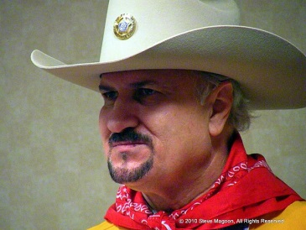
Nick Giannone is an Emergency Physician working in the Greater Houston Area. He received his undergraduate degree from Gonzaga University in Spokane, Washington and his medical degree from the Autonomous University in Guadalajara. Nick did his post graduate education at Tulane University, New Orleans and the University of Texas Medical Branch.

Nick opened a private practice of Family Medicine in Freeport, TX in 1987 moving it to Lake Jackson, TX in 1990. He started Coastal Physician Associates in Lake Jackson in 1992 specializing in Family and Industrial Medicine where he practiced until 2002. He then made a career change to Emergency Medicine and has since been an active E.R. Physician.

Nick formed the Brazoria County Chapter of the Texas Academy of Family Practice and served on the board of the Texas Academy of Family Practice as well as the board of the Brazosport Chamber of Commerce, the Brazosport Junior Achievement and the Riverside Country Club. He’s been the Health Officer for the City of Lake Jackson and Freeport and has been Chief of Medicine (1992) and Chief of Staff (1994) of Brazosport Regional Health System.

In 1990 Nick was invited to join the Rotary Club of Brazosport. He served as President in 2001-2002 tying for best large club in the District. He helped form the After 5 Rotary Club in 2008 and has been honored as Rotarian of the Year in both clubs. Nick is also active at the District Level of District 5890. Nick has served as Chairman of New Generations, Youth Exchange Officer, Assistant Governor, Lieutenant Governor and on multiple committees as Chair or a member. He has also served Rotary at the multi-District and International level as a Ranger/Sergeant at Arms.

Nick is a Major Donor, a Benefactor, a charter member of the Paul Harris Society and the Polio Plus Society. Nick also has had perfect attendance since 1990.

Nick has been married to Fabiola Sanchez for 32 years. They have 2 daughters, Isabel (a Charter member of the Dallas TX Uptown Club) and Stephanie. Nick is an active member of the Catholic Church serving as a 3rd Degree Knight.

