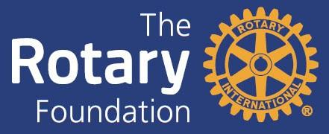

District 5890 2025-26 Grants Qualification Package
DEADLINE FOR SUBMISSION: June 3, 2025
PLEASE RETURN THIS PAGE AND THE FOLLOWING 14 PAGES OF THIS DOCUMENT BY SCAN AND E-MAIL to: Carlo Sosa at RotaryDistrict5890Grants@gmail.com

The Rotary Foundation returns District Designated Funds to District 5890 in the form of District and Global Grants. In order to be eligible to receive applicable portions of these grants, clubs must have at least two members (with one member being the President-Elect) attend an annual Grant Management Seminar and after Board approval, sign the Club Memorandum of Understanding and related documents and return the signed documents by e-mail to Rotary District 5890 no later than June 3, 2025.

As part of the club qualification process for receiving District Designated Funds (DDF) for District Grants and Global Grants, the Board of Directors of the Rotary Club of _______________________________ has approved the attached Club Memorandum of Understanding (MOU), District Addendum to the MOU, Club Financial Management Plan, and Club Misuse or Mismanagement Plan.

The following club members have attended all required District 5890 Grants Training Sessions:

Name:
Name:
District 5890 Requirements For
District and Global Grants Qualifications

For any club in D5890 to receive District Designated Funds (DDF) for District and/or Global Grants, the club must be qualified. To qualify, a club must:
- Designate at least two club members (with one member being the President-Elect) to attend a Grant Management Seminar. Several seminars will be offered during the year prior to the start of the next Rotary year.
- Execute the following documents: a Memorandum of Understanding (MOU), a D5890
Addendum to the MOU, a Club Financial Management Plan, and a Club Misuse or Mismanagement Plan, and submit them to the District Grant Stewardship Chair no later than June 3, 2025. These documents are contained in this document.
- Be current on its Rotary International and District 5890 dues, and be in good standing with the District 5890, Rotary International, and The Rotary Foundation.
- Be current on all tax returns for the Rotary Club and any associated Club Foundation.
- Have established and reported an Annual Giving Goal for the current year.
- Be current on all Rotary Grant reporting requirements.

Clubs are encouraged to appoint a Club Rotary Foundation Chair to a two-year term. Club qualification must be renewed annually.
In the following pages there are:
- Club Memorandum of Understanding (MOU) to be executed by the club;
- Addendum to the MOU to be executed by the club;
- Club Financial Management Plan to be executed by the club; and
- Club Misuse or Mismanagement Plan to be executed by the club.
District 5890 2025-26
Club Memorandum of Understanding

This document is the official Memorandum of Understanding (MOU) provided by The Rotary Foundation (TRF). It is an agreement between the club and its district to implement the financial and stewardship requirements in this MOU and to ensure proper implementation and management of Rotary Foundation Global Grant Funds and District Grant Funds. By executing this document, the club agrees that it will comply with all Foundation and District requirements.

District 5890 has directed that clubs must be “qualified” to receive grant funds from the Rotary Foundation District Block Grant and each “qualified” club will be held responsible for implementing this club MOU. The sections of this MOU are:
  - Club Qualification
  - Club Officer Responsibilities
  - Financial Management Plan
  - Bank Account Requirements
  - Report on Use of Grant Funds
  - Document Retention

- Club Qualification
To participate in Rotary Foundation global and packaged grants, the club must agree to implement the financial and stewardship requirements in this memorandum of understanding (MOU) provided by The Rotary Foundation (TRF) and to send at least one club member to the district’s grant management seminar each year. The district may also establish additional requirements for club qualification and/or require its clubs to be qualified in order to participate in Rotary Foundation district grants. By completing these requirements, the club becomes qualified and eligible to participate in the TRF grant program.
  - Upon successful completion of the qualification requirements, the club will be qualified for one Rotary year.
  - To maintain qualified status, the club must comply with this MOU, any additional district requirements, and all applicable TRF policies.
  - The club is responsible for the use of funds for club-sponsored grants, regardless of who controls the funds.
  - Qualification may be suspended or revoked for misuse or mismanagement of grant funds involving, but not limited to: fraud; forgery; membership falsification; gross negligence; endangerment of health, welfare, or safety of beneficiaries; ineligible contributions; use of funds for personal gain; undisclosed conflicts of interest; monopolization of grant funds by individuals; report falsification; overpricing; acceptance of payments from beneficiaries; illegal activities; use of grant funds for ineligible purposes.
  - The club must cooperate with any financial, grant, or operational audits.

- Club Officer Responsibilities
The club officers hold primary responsibility for club qualification and the proper implementation of TRF grants. Club officer responsibilities include:
  - Appointing at least one club member to implement, manage, and maintain club qualification.
  - Ensuring that all TRF grants adhere to stewardship measures and proper grant management practices.
  - Ensuring that all individuals involved in a grant conduct their activities in a way that avoids any actual or perceived conflict of interest.

- Financial Management Plan
The club must have a written financial management plan to provide consistent administration of grant funds. The financial management plan must include procedures to:
  - Maintain a standard set of accounts, which includes a complete record of all receipts and disbursements of grant funds
  - Disburse grant funds, as appropriate
  - Maintain segregation of duties for handling funds
  - Establish an inventory system for equipment and other assets purchased with grant funds, and maintain records for items that are purchased, produced, or distributed through grant activities
  - Ensure that all grant activities, including the conversion of funds, comply with local law

- Bank Account Requirements
In order to receive grant funds, the club must have a dedicated bank account that is used solely for receiving and disbursing TRF grant funds.
  - The club bank account must:
    - Have a minimum of two Rotarian signatories from the club for disbursements
    - Be a low- or non-interest bearing account
  - Any interest earned must be documented and used for eligible, approved grant activities, or returned to TRF.
  - A separate account should be opened for each club-sponsored grant, and the name of the account should clearly identify its use for grant funds.
  - Grant funds may not be deposited in investment accounts including, but not limited to, mutual funds, certificates of deposit, bonds, and stocks.
  - Bank statements must be available to support receipt and use of TRF grant funds.
The club must maintain a written plan for transferring custody of the bank accounts in the event of a change in signatories.

- Report on Use of Grant Funds
The club must adhere to all TRF reporting requirements. Grant reporting is a key aspect of grant management and stewardship, as it informs TRF of the grant’s progress and how funds are spent.

- Document Retention
The club must establish and maintain appropriate record keeping systems to preserve important documents related to qualification and TRF grants. Retaining these documents supports transparency in grant management and assists in the preparation for audits or financial assessments.

  - Documents that must be maintained include, but are not limited to:
    - Bank information, including copies of past statements
    - Club qualification documents including a copy of the signed club MOU
    - Documented plans and procedures, including:
      - Financial management plan;
      - Procedure for storing documents and archives;
      - Succession plan for bank account signatories and retention of information and documentation.
    - Information related to grants, including receipts and invoices for all purchases.
  - Club records must be accessible and available to Rotarians in the club and at the request of the district.
  - Documents must be maintained for a minimum of five years, or longer if required by local law.

- Method for Reporting and Resolving Misuse of Grant Funds
The club must report any potential and real misuse or mismanagement of grant funds to the district. This reporting fosters an environment in the club that does not tolerate the misuse of grant funds.

Authorization and Agreement
This memorandum of understanding is an agreement between the club and the district and acknowledges that the club will undertake measures to ensure the proper implementation of grant activities and proper management of Foundation grant funds. By authorizing this document, the club agrees to comply with all of the conditions and requirements of the MOU.

On behalf of the Rotary Club of , the undersigned agree to comply with all of the conditions and requirements of the MOU for Rotary year and will notify Rotary International District 5890 of any changes or revisions to club policies and procedures related to these requirements.
2025-26 Club President 2025-26 Club President-Elect

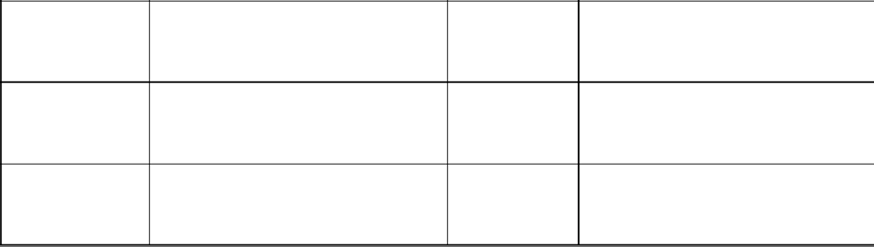



Name
(Printed)
Name
(Printed)
Signature
Signature
Date
Date
DEADLINE FOR SUBMISSION: June 3, 2025
2025-26 CLUB MEMORANDUM
OF UNDERSTANDING ADDENDUM
District Requirements. Clubs submitting applications for District or Global Grants must be qualified by District 5890 that has established requirements in addition to those established by The Rotary Foundation. To be eligible to receive grant funding for District Grants or Global Grants program, Rotary Clubs in District 5890 must also:

- Appoint a Club Rotary Foundation Chair to a 2-year term or request a waiver with a proposed alternative that will assure continuity of information and supervision related to grants.
- Have at least two members of the Club attend a District 5890 Foundation Grants Qualification Seminar annually. (The Club President-Elect (incoming President) must be one of the members).
- Be current on its Rotary International and District 5890 dues, and be in good standing with District 5890, Rotary International, and The Rotary Foundation.
- Be current on all tax returns required for the Rotary Club.
- Have established and reported an annual giving goal to the District Foundation Chair for the 2025-26 Rotary year by June 3, 2025. This must be accomplished by using Rotary Club Central.
- Agree to publicize any District Grant and Global Grants project using Rotary Showcase.
- Be current on all Rotary District and Global Grant reporting requirements.
- Have the Club's President (2025-26) and 2025-26 President-Elect (will be President for 2026-27) sign the Club MOU and this Addendum.

Bank Account Waiver. The District will waive Rotary International MOU requirement to create and maintain a separate bank account for participation in a District Grant. This waiver does not apply to Global Grants. Compliance with the Club’s financial plan is required as per TRF terms and conditions.

Addendum to MOU Agreement: By signature below, clubs will adopt the District 5890 Addendum to the MOU for District and Global Grants.

2025-26 Club President 2025-26 Club President-Elect




Name
(Printed)
Name
(Printed)
Signature
Signature
Date
Date
DEADLINE FOR SUBMISSION: June 3, 2025
District 5890 Club Financial Management Plan

Club Name:

Club Number:

Date Management Plan Adopted:

Our Rotary Club agrees to adhere to all Rotary Foundation bank account requirements, including the opening of a new bank account, with two signatories, for each new Global Grant.
- Our Club agrees to maintain a standard set of accounts, including: a record of all income and disbursements and receipts for all expenditures of $75 or more.
- Our Club agrees to disburse grant funds directly to the Rotarians, vendors, and beneficiaries as approved in the grant application.
- Our Club agrees to maintain separate statements of income and expenses, noting any interest earned and recoveries, so that such incremental dollars earned will be returned to TRF.
- If we have more than one grant in progress at any one time, our Club agrees to maintain a general ledger which separates funds according to each project.
- Our Club agrees to maintain an inventory system for control of any equipment or other assets purchased with grant funds and to maintain records of items purchased, produced, or distributed through grant activities in accordance with RI terms and conditions.
- Original invoices, budgets, written correspondence, competitive bid proposals, RI project reports, bank statements, monthly bank reconciliations, grant application, emails, etc., will be retained in accordance with TRF policies and procedures for a period of five years from the final report date, and as required by local, state, and/or federal laws.
- Such supporting financial and other documentation shall be accessible for review by club members and audits as required by TRF, the District 5890 Rotary Foundation Audit Committee, and any bona fide regulatory governmental agency.
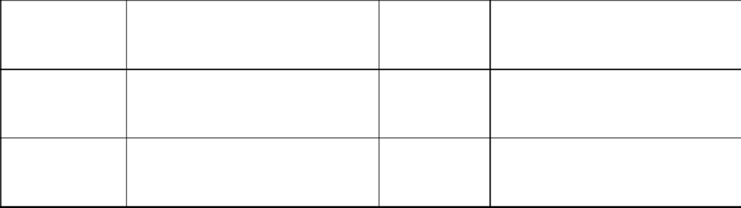

2025-26 Club President 2025-26 Club President- Elect

Name
(Printed)
Name
(Printed)
Signature
Signature
Date
Date

DEADLINE FOR SUBMISSION: June 3, 2025
District 5890 Club Misuse or Mismanagement Plan

Club Name:_____________________________________________

Club Number:

Date Management Plan Adopted:

An allegation of misuse or mismanagement of The Rotary Foundation (TRF) grant funds whether such funds were received directly from the Foundation, via this District, or another District may be made by a Rotarian, beneficiary, cooperating organization, or any other individual involved in or aware of grant activities. Such an allegation should be made in writing and sent to the District 5890 Rotary Foundation Committee Chair (DRFCC) as soon as possible. Assistance in communicating with the DRFCC can be obtained by utilizing the Rotary District 5890 website (www.Rotaryd5890.org) to obtain the DRFCC email address, physical address, and/or telephone number(s).

Upon receipt of an allegation, the DRFCC shall promptly inform the District Governor (DG) and the appropriate District Sub-committee Chair which may include the District Rotary Foundation Global Grants Committee Chair, District Rotary Foundation Global Scholar Committee Chair, or District Rotary Foundation District Grant Committee Chair as applicable of the alleged misuse or mismanagement. The DRFCC will also notify the District Stewardship Management Team Committee Chair, and TRF as necessary.
As directed by the DG, either the DRFCC or an investigative District leadership committee member shall be appointed by the DG to investigate the allegation and to report findings of fact, opinions, and recommendations to the DG and DRFCC within 30 days of appointment, unless such period is extended by the DG. The DRFCC shall consult with the DG regarding the report and shall then determine the appropriate corrective actions, if any, to be taken. The DRFCC shall report on the matter to TRF, indicating how the District has acted to resolve the allegation.
The DRFCC shall be responsible for tracking, reporting, and retaining all supporting documentation for any and all such allegations, including the status of reporting to the DG and TRF.
Reports of investigations and actions taken as reported to TRF shall be maintained in the District Office for a period of five years from the date such information is forwarded to TRF. Access to such reports shall be limited to the current DG, DRFCC, and RI unless the DG directs otherwise.
This policy shall be posted on the District Website and included as a topic at all Grant Management Seminars.

2025-26 Club President 2025-26 Club President-Elect

Name
(Printed)
Name
(Printed)
Signature
Signature
Date
Date
DEADLINE FOR SUBMISSION: June 3, 2025

