**EarlyAct FirstKnight Founder**

[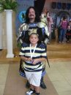](http://www.facebook.com/photo.php?pid=114759&op=1&o=global&view=global&subj=140270324943&id=100000091832191)

**EAFK was founded by Dr. Randall Parr, KTJ. A member of the Boerne Rotary Club, Dr. Parr is somewhat of a renaissance man. He has traveled much of the world and earned acclaim in multiple fields, ranging from the entertainment industry as a musical virtuoso and producer to the military ministry as an officer in the United States Naval chaplaincy.**

**Dr. Parr is an internationally published writer, consultant, and a frequent guest lecturer on character education at Universities and professional conferences.**

**A life-long student of history’s most influential leaders with over twenty years of experience in creating effective ethics development programs for young people, his service to others has won accolades from many, including all branches of our military, the Washington Times, and members of the U.S. Senate and Congress.**

**[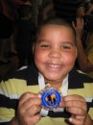](http://www.facebook.com/photo.php?pid=114756&op=1&o=global&view=global&subj=140270324943&id=100000091832191)** 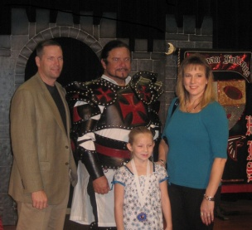

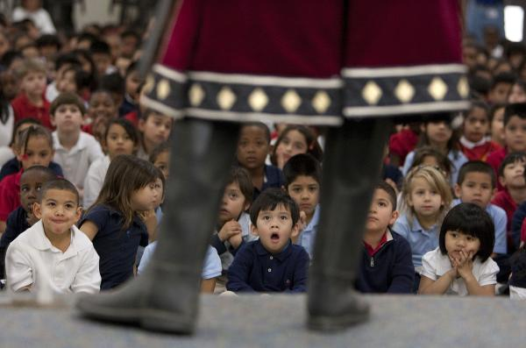

*(Houston Chronicle photo - Eiland Elementary EAFK Ceremony)*

**Quotes from educators in District 5890**

“*This program instructs, motivates, and equips students to seek the highest standards and personal excellence so that* *they can serve their communities with knowledge, wisdom, and compassion.” -* **Eiland Elementary (Klein ISD) Principal Greg Jones**

[](https://joustforfun.com/wp-content/uploads/2010/08/Header-EAFK.jpg) **Dr. Randall Parr**

**Founder, EarlyAct FirstKnight**

**(210) 288-6140 www.eafk.org**

**Email: randall.parr@mac.com**

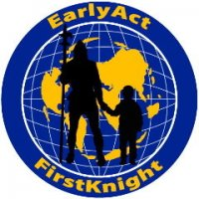 [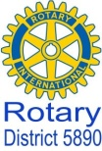](http://www.facebook.com/media/set/fbx/?set=a.440390764961.237385.131665964961)

**District 5890 EarlyAct FirstKnight**

**Tommie & Charlie Buscemi (281) 359-7193**

**Email: tommie5890@suddenlink.net**

**Email: cjsb@suddenlink.net**

**EarlyAct FirstKnight Program**



**Sponsored by Rotary Clubs, EarlyAct FirstKnight is a year-round character and service education program for elementary and middle schools that, for the first time ever, puts Rotary into mainstream public education every day.**

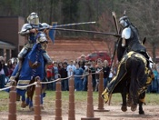

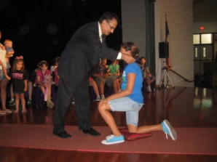

***(DG Sunny Sharma at Huffman ISD Knighting Ceremony)***

EAFK's daily character education teaches the importance of Service, Responsibility, Honesty,

Confidence, Tolerance, Compassion, Respect, Perseverance, Discipline, & Friendliness. ***EVERY* school day, *EVERY* student recites Rotary's 4-Way Test!**

**The Need For Character Education**

**Ethical impairment reveals itself through symptoms like dishonesty, irresponsibility, disrespect, hatred, jealousy, greed, and indifference to others. Studies show these attributes are afflicting young people today more than ever before. Ethical impairment also leads to antisocial behaviors and conditions such as crime, poverty, substance abuse, deception, ignorance, dependency, and immorality. EarlyAct FirstKnight (EAFK) program is a proactive strategy that endeavors to prevent many of these potential outcomes before they occur.**

**Why EarlyAct FirstKnight?**

**EAFK’s unique approach of teaching ethics to young people creatively integrates the live-action theme of noble knights and chivalry with Rotarian service ideals. Highlighting the exciting theme of knightly champions, EAFK instructs, motivates and equips students to seek high knightly standards and personal excellence, through which they can better serve their communities through knowledge, wisdom and compassion.**

**Of added benefit to Rotary Clubs, thousands of young parents are discovering Rotary every month at student knighting ceremonies and parent education events. Entire campuses recite the Four Way Test daily by memory, students begin learning who Paul Harris is in the 3rd grade. 5th graders can provide the latest news on Polio Plus, and local communities are benefitting from the Rotarian-led service initiatives of 5 to 12 year-old students.**

*Parents participate in monthly Knighting Ceremonies*

[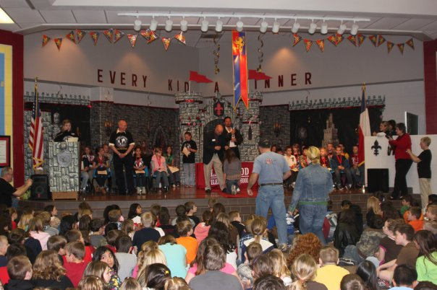](http://www.facebook.com/photo.php?op=1&view=global&subj=140270324943&pid=114759&id=100000091832191&oid=140270324943)

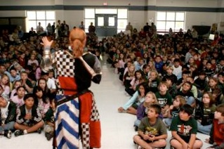

**EAFK Program in District 5890**

**District 5890 has over 6,400 students using the EAFK Program in the following school districts: El Campo ISD (El Campo Rotary), Galena Park ISD (North Shore Rotary), Houston ISD (Houston Heights Rotary), Humble ISD (Kingwood Rotary), Klein ISD (Champions Sunrise, Houston NW Sunset, and Willowbrook Rotary), and Pasadena ISD (Pasadena ISD). Their sponsoring Rotarians are excited about this unique service opportunity to work with the students to understand the importance of values like honesty, tolerance, service, responsibility, self-discipline, compassion, plus "Service Above Self" in the classroom.**

**More than a student service club participated in by a few, EAFK is a daily, mandatory course of study for each child, starting with the first day of Kindergarten and continuing through the last day of 8th grade.**

**EAFK is research-based, which means that each facet of the program is scientifically evaluated annually to validate its effectiveness upon student behavior and academic performance at each participating campus.**

[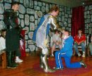](http://www.facebook.com/photo.php?pid=1045128&op=1&o=global&view=global&subj=140270324943&id=1066481889) 

Students being knighted during ceremony. One student per classroom is selected by their teachers based upon how they have exemplified the month's EAFK curriculum's ethical principle or life skill.

Objectives

* **Rotary's code of ethics integrated into daily classroom curriculum**
* **Students learn about the life of Paul Harris, PolioPlus, and all other Rotary programs**
* **Daily, students recite Rotary's Four-Way Test**
* **Rotarians serve as mentors to the students**
* **Each teacher selects one student each month to be honored for their exceptional deeds. Secretly, their parents are notified to attend the knighting ceremony where the student is knighted & receives a special EAFK medallion**

Activities

* **Jousting "Tournament of Champions"**
* **Daily Classroom Curriculum for teachers**
* **Monthly Knighting Ceremonies**
* **Student Service Clubs**
* **Parent Education**
* **Meet and honor parents for their student's success**
* **Opportunity to share Rotary with community**