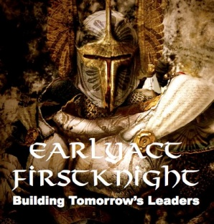

Rotary Club of Kingwood - EarlyAct FirstKnight
Character Education Program Certificate of Merit
is presented to
Anna Early

In recognition of you exemplifying the virtue of "Tolerance", outstanding morals and ethics, and "Service Above Self" at Bear Branch Elementary School, you are hereby a member of the EAFK Gallery of Champions. We know you will continue to expand your efforts of building friendships in your school, community, and beyond, while connecting the hearts of people.
The Kingwood Rotary Club is very proud to honor you as a student with excellent personal character.
Dated: May 6, 2015

Sandi Nizzi Sir James
President, Kingwood Rotary Club Knights of the Guild
2014-2015 2014-2015

