**MCj04130940000[1]The Kingwood Rotary Club would like to thank our following EAFK Community Partners:**

C:\Tommie\My Pictures\Alspaugh's.png

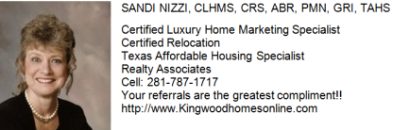

**The 10 virtues of the EAFK curriculum:**

*Tolerance Responsibility Confidence Service*

*Perseverance Friendliness Respect Discipline*

*Compassion Honesty*

***What is the Kingwood Rotary Club?*** *We are business, professional and community leaders connecting to make a difference in our community, and beyond! We're a "family friendly" Rotary club which was chartered in December 2004. As Rotarians we share our time, our talents, our resources, and we are at our best when we use Rotary for the purpose of sharing our individual passions for the betterment of our community, and our world.*

*We invite you to find out how Rotary shares your passion and commitment. Spouses and children are always welcomed at meetings which are held every Thursday evening from 6:15 PM until 7:30 PM at Skeeter's Mesquite Grill in Kingwood. We invite you to attend a weekly meeting!*

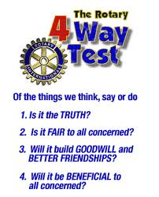

***Rotary's 4-Way Test*** - One of the most widely printed and quoted statements of business ethics in the world is Rotary’s 4-Way Test. Rotarian Herbert J. Taylor created the 4-Way Test in 1932 when he was asked to take charge of a Chicago-based Club Aluminum Company, which had over 250 employees. With $400,000 in debt, and facing bankruptcy with $400,000, Taylor looked for a way to save the struggling company mired in depression-caused financial difficulties. He drew up a 24-word code of ethics for all employees to follow in their business and professional lives. The 4-Way Test became the guide for sales, production, advertising, and all relations with vendors and customers, and the survival of the company was credited to this simple philosophy. In 5 years, Taylor paid off the $400,000 of debt, with interest, and distributed one million dollars in dividends to stockholders, in spite of the continuing Great Depression. ***Bear Branch Elementary students can recite it from memory! Encourage them to share it with you.***

***Please visit WWW.KWROTARY.ORG for more about Kingwood Rotary Club.***

*C:\Users\Tommie\AppData\Local\Microsoft\Windows\Temporary Internet Files\Content.IE5\N3RFD1KE\MC900438273[1].wmf*

*MCj04130940000[1]C:\Users\Tommie\AppData\Local\Microsoft\Windows\Temporary Internet Files\OLK80F5\BBE First Knight final (2).tif*

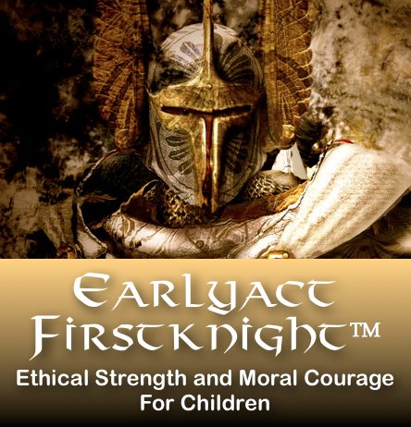

**

*Proud Sponsor of the*

*EarlyAct FirstKnight Character Education*

*Program for the 4th School Year at*

*Bear Branch Elementary School*

*🙟🙝*

*May 6, 2015*

*Our Sixth Knighting Ceremony of the*

*2014-15 School Year*

*Celebrating The Virtue of "Tolerance"*

🙟🙝

***Tolerance*** *is allowing others to express different beliefs that are from your own, and respecting persons who are different from us. Knights with tolerance are open to new ideas and have a willingness to accept feelings, habits, or beliefs that are different from their own. "It is a good thing to demand liberty for ourselves and for those who agree with us, but it is a better thing and a rarer thing to give the liberty to others who do not agree with us.” -* Franklin Delano Roosevelt

*d. It is still true that those who embrace this rule always earn the highest honors.*

***Congratulations.....***

***C:\Users\Tommie\AppData\Local\Microsoft\Windows\Temporary Internet Files\Content.IE5\HSSS759N\MC900013045[1].wmfThe Rotary Club of Kingwood congratulates you for having a student selected to be honored at this month's EarlyAct FirstKnight Character Education Program's Knighting Ceremony.***

***Our Kingwood Rotarians are very proud to sponsor this outstanding character education program for the 4th year at Bear Branch Elementary which is currently only one of sixteen campuses in Harris, and the surrounding eight counties, which have EAFK at their school. Bear Branch Elementary School is the only campus in Humble ISD with this curriculum, and we are very excited about continuing a tradition of service at this outstanding school. Please visit our website at www.kwrotary.org or call Charlie Buscemi at 281.359.7193.***

**EAFK IS BUILDING TOMORROWʼS LEADERS TODAY DURING THE MOST FORMATIVE YEARS OF THEIR LIVES.**

**Based on the theme of gallant knights and Rotarian values, EarlyAct FirstKnight is a curriculum-based character education program for elementary and middle schools that teaches students how to become noble, service-oriented people along with why it is important for them to do so. EAFK can only be sponsored by a Rotary club, and the Rotary Club of Kingwood is very proud of sponsoring EAFK at Bear Branch Elementary School.**

**Each month, the students will focus on one EAFK character virtue, and at the monthly Knighting Ceremony, one student from each classroom will be selected to be honored. EAFK is amazingly effective, with 95% of participating schools crediting the program with significantly increased academic scores, decreased behavioral issues, more teaching time and happier faculties and parents.**

**36 out of 50 states in America have now enacted legislation that either mandates or strongly encourages character education in public schools. This is because people are beginning to realize that the traditional values, ethics and civility that define a great society are increasingly eroding among children today. Our future, therefore, depends upon reversing this trend on a broad scale. EAFK provides Kingwood Rotary Club with an effective solution to the problem by bringing excellent character, morals and ethics to the forefront of public school classrooms, right alongside math, science and social studies. Combining strong academics, Rotarian mentorship, and live-action motivational support, EAFK is building tomorrow's leaders today during the most formative years of their lives.**

**C:\Users\Tommie\AppData\Local\Microsoft\Windows\Temporary Internet Files\Content.IE5\HSSS759N\MC900437976[1].wmf**

***EarlyAct FirstKnight Knighting Ceremony***

Introduction: Principal Kakie Palmer

Rotary Club of Kingwood: Charlie Buscemi

**Kindergarten - Second Grade Knighting Ceremony**

Honoring Our Newest Members of the EAFK "Gallery of Champions" :

**Kindergarten - Title of "Page"**

Teagan Kelly, Elliott Warren, Anna Early, Connor Maple

**First Grade - Title of "Page"**

Katie Tims, Megan Riley, Mailey Nevitt,

Maddie Kirkpatrick Isabella Mendoza

**Second Grade - Title of "Squire"**

Brady Boros, Colton Anderson, Isidora Braun,

Harmoni Ottoline, Sebastian Chaccara,

**C:\Users\Tommie\AppData\Local\Microsoft\Windows\Temporary Internet Files\Content.IE5\N3RFD1KE\MC900438273[1].wmf**

**Third Grade - Fifth Grade Knighting Ceremony**

Honoring Our Newest Members of the EAFK "Gallery of Champions" :

**Third Grade- Title of "Squire"**

Addison Gray, John Michael Ward, Elijah Erwin,

Aidan Coschigano, Callie Maple, Rylee Bush

**Fourth Grade - Title of "Knight"**

Anastasia Leigh Small, Alyssa Dobricka, Molly Moynahan,

Pamela Velasquez, Soloman Karash

**Fifth Grade - Title of " Order of The Black Prince"**

Emma Hood, Lynnsey Young, Alicia Brizuela,

Susanne Durand, Abigail Romero

C:\Users\Tommie\AppData\Local\Microsoft\Windows\Temporary Internet Files\Content.IE5\HSSS759N\MC900437976[1].wmf