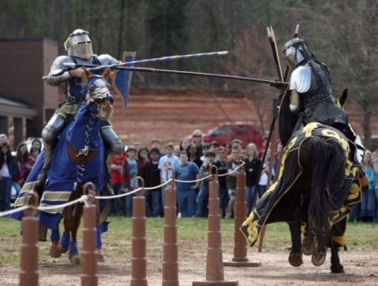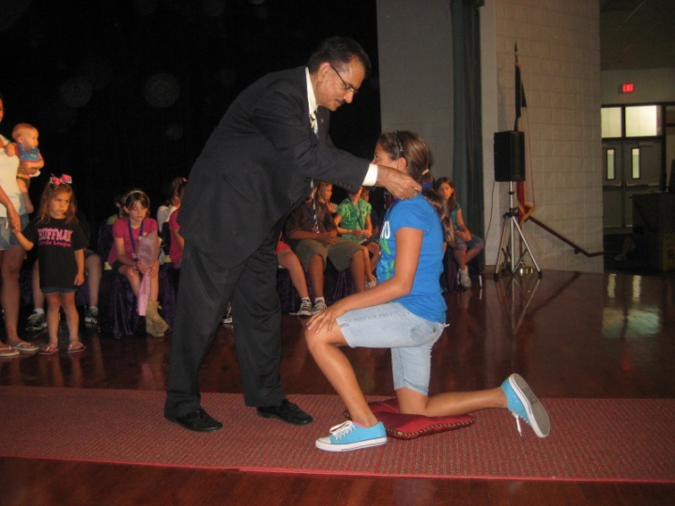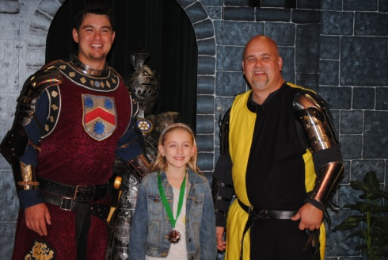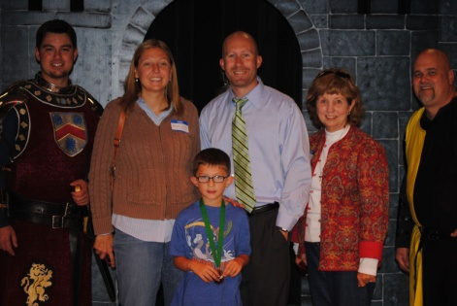

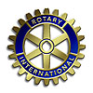Rotary District 5890 EarlyAct FirstKnight Character Education Program 

***[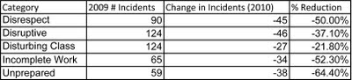](http://3.bp.blogspot.com/-GK08xbREcJI/TezkN47GsiI/AAAAAAAAAOs/0FbJzX5Ohp8/s1600/chart.jpg)***

***The data on the left appeared in the Clemson University "Rutland Institute for Ethics" Newsletter in June 2011. The data was provided by Principal Todd Binnicker at Powdersville Middle School, SC comparing behavior/discipline at his school in 2009 (Pre-EAFK), and 2010 (With EAFK).***

**What are educators saying about EAFK?*****"WOW! Where do I even begin?!? That ceremony was so special! I just wanted to take the time to say thanks so much for honoring students for outstanding character!*  *I have been a part of character education as a counselor for several years, but I have never seen anything like that! The kids were so excited and you could tell by looking at each of their faces, they felt truly honored and special! I hope this program continues for years to come at Bear Branch as well as spreads throughout the district!* *Thank you for supporting such a touching program! Thanks for all you do and for making a difference DAILY in the lives of the students and families at Bear Branch!" Quote from an Humble ISD 7th Grade Counselor whose kindergarten daughter was honored at her school's February 2012 Knighting Ceremony in Kingwood.***

**WISDOM FROM THE KNIGHTLY CODE:**

***Service.*** *True knights lived to serve others. In fact, even the word "knight" derives from an old English term, "cniht", which literally means "servant". While knights were powerful people who could have easily used their strength to serve themselves, the best of them learned early in life that to become great, one must first become the servant of all.*

***Respect.*** *One of the ways true knights were distinguished from armored wannabes was the respect they showed to others. Engrained young through the oversight of cultured mentors, respect was taught as the art of putting others before yourself and treating them as you would want to be treated. It is still true that those who embrace this rule always earn the highest honors.d. It is still true that those who embrace this rule always earn the highest honors.*

***Compassion.*** *Deeds of kindness are never wasted on anyone. Charles Spurgeon once said, "A good character is the best tombstone. Those who loved you and were helped by you will remember you when forget-me-nots have withered. Carve your name on hearts, not on marble."*

***Honesty.*** *In a world where trust and integrity are rare, honesty is a refreshing and welcome virtue. A pillar of the knightly code, honesty could never be compromised and was the mortar which bound knights together with those they served. The greatest knights refused to lie, steal or deceive in any way and modern day knights should live accordingly.*

**WWW.EAFK.ORG ♦ Contact Charlie and Tommie Buscemi ♦ 281-359-7193 ♦ tommie5890@suddenlink.net ♦ www.kwrotary.org**