Outbound Global Grant Scholar, 2013-14
Michelle Heard
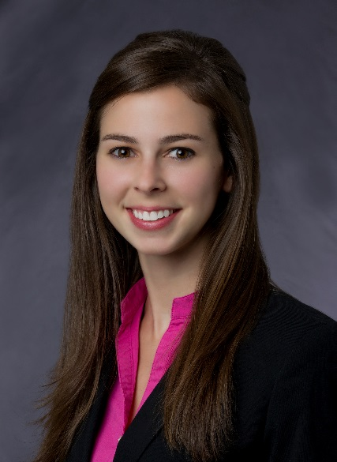
Study Institution: The University of Melbourne, Melbourne, Australia.
Hosted by District 9800, Sponsored by The Rotary Club of Houston Skyline.
Michelle Heard was awarded a Rotary Global Grant Scholarship in the focus area of Peace and Conflict Resolution by District 5890 and is sponsored by The Rotary Club of Houston Skyline. She is currently undertaking studies in global justice, human rights, and ethics through her Executive Master of Arts program. Michelle graduated from Texas A&M University in 2009 with a Bachelor of Business Administration and Master of Science in Accounting. She worked as a Federal Tax Manager for KPMG, LLP before deciding to forego her promising career as a CPA and change paths to study within the field of peace and conflict resolution.
Through her upbringing in a military family, Michelle learned of the ripple effects of violent conflict from an early age. During her undergraduate studies she spent a summer working for the U.S. Army’s Morale, Welfare and Recreation office in Seoul, Korea. There she helped organize developmental activities and cultural events to support soldiers and families stationed far from their homes to fortify the constantly-strained armistice in place between North and South Korea. She spent time at the de facto border between the two countries where, surrounded by live minefields and armed soldiers heavily guarding each side, she was struck by the realization that this border epitomizes the failure of true conflict resolution. Regarding her experience there Michelle said “I could feel the hostility in a way that was hugely formative and influential in my decision to get involved working and volunteering to support individuals and families affected by violent conflict”.
Michelle also spent time at Fort Sam Houston in San Antonio, Texas, home to the Army’s premier burn treatment center, the Brooke Army Medical Center, where she had the privilege of meeting wounded soldiers returning from war. Through her involvement with the San Antonio community she witnessed firsthand the shattering mental, physical, and economic effects that conflict has reaching far beyond the individuals who volunteer for military service.
Michelle plans to use her current studies to work with refugees, one of the largest casualties of violent conflict, to aid their resettlement and employment opportunities, and raise awareness regarding social issues they face.

“Not all of us can do great things. But we can do small things with great love” – Mother Teresa

