Outbound Global Grant Scholar, 2014-15
Jesús Sotelo Jr.
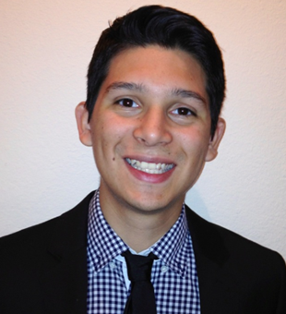
Study Institution: London School of Hygiene & Tropical Medicine, London, United Kingdom
Hosted by District 9800, Sponsored by The University Area Rotary Club in Houston.
Jesús Sotelo was awarded a Rotary Global Grant Scholarship in the focus area of Disease Prevention and Treatment by District 5890 and is sponsored by The Rotary Club of University Area, Houston. Jesús is currently preparing for his studies in London by taking a summer course in Tropical Medicine at Baylor College of Medicine. Jesús graduated from Baylor University in May of 2014 with a Bachelor of Science in Biology.

Through an upbringing in the inner city of Houston and rural Mexico, Jesús saw the importance of public health and its impact on large populations. Public health and later epidemiology became alive in the context of growing up in these communities and also working in western rural Kenya. During his undergraduate career, he sought to learn more about making an impact in the community by taking courses like epidemiology and volunteering in clinics that served the poor or uninsured. In addition, Jesús had the opportunity to serve in Kenya with the non-profit Straw-to-Bread. While in Kenya, Jesús developed a passion for parasitic diseases. As a result, he was able to determine the prevalence of helminthic infections in children in the region. In addition, he found that there were several children co-infected with malaria as well, which increased their risk for anaemia. Jesús hopes that his work in Kenya will one day be transformed into a tangible effort to reduce the number of children with helminthic infections.
In the United States, Jesús worked closely with the staff and physicians at the Family Health Center in Waco, a clinic that serves the poor and uninsured. To him, volunteering there was a privilege. Throughout his time there, Jesús learned to appreciate the role socioeconomic and psychological status play in determining and propagating disease.
With the long term goal of becoming a physician, Jesús seeks to synergize public health and epidemiological research into his medical practice.

“I slept and dreamt that life was joy. I awoke and saw that life was service. I acted and behold, service was joy.”
― Rabindranath Tagore

