Outbound Global Grant Scholar, 2015-2016
Jennifer Gueler

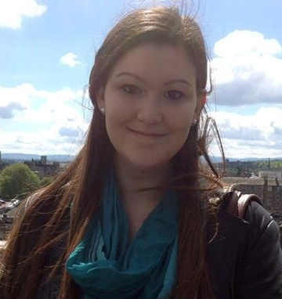
Jennifer Gueler was awarded a Rotary Global Grant Scholarship in the Area of Focus of Maternal and Child Health by District 5890, so that she may pursue a Master of Science in Child and Adolescent Mental Health at the University College London. Jennifer is sponsored by The Rotary Club of River Oaks, and will be hosted in London, England by The Rotary Club of Westminster East (District 1130). Jennifer is excited to serve as an ambassador and to engage in London’s diverse and historic culture, not just academically, but socially and professionally, to invest herself emotionally in the community, and to broaden the horizons of her identity.

Jennifer grew up in Houston and attended Rice University, where she graduated in three years with a Bachelor of Arts, Cum Laude in Psychology. During her grant year, Jennifer will study at University College London’s Institute of Child Health which, in conjunction with the nearby Great Ormond Street Hospital, is Europe’s largest center for postgraduate teaching and research in the field of children’s health. Jennifer’s research experience working with individuals suffering from depression and post-traumatic stress disorder in The Baylor College of Medicine’s Mood Disorder Program has given an awareness of the importance of developing our understanding of mental health, while reducing associated stigma. Her volunteer work with Texas Children’s Hospital and the Peaceable Kingdom Retreat for Children has fueled Jennifer’s passion for working with children, particularly those with serious medical conditions and special needs. Jennifer’s personal and academic experiences have encouraged her to combine these passions by seeking to further understand children’s health from both medical and psychosocial perspectives.

Jennifer hopes that the insight she gains in London will allow her to help in implementing a system where pediatricians are able to recognize mental health concerns, developmental delays, and special needs in children in the initial stages of care, and where specialists and primary care physicians are able to work together to incorporate each child’s individual psychological and socio-cultural background into long-term treatment plans. Her goal is to ultimately be a pioneer in the field of pediatric medicine and an advocate for the biopsychosocial model, thereby revolutionizing the way we understand and treat children worldwide.

