Outbound Global Grant Scholar, 2015-16
Sean Smith

Study Institution: Pontifical Catholic University of Valparaíso, Valparaíso, Chile

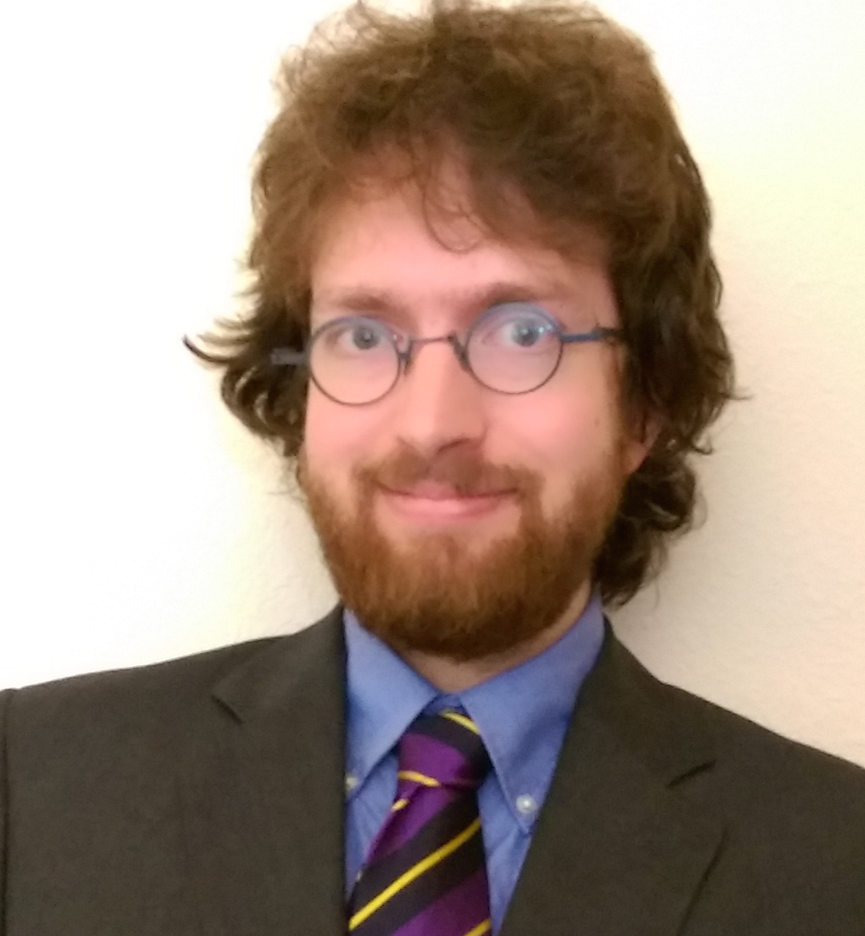
Hosted by Rotary Club of Quilpué, District 4320; Sponsored by Rotary Club of Memorial-Spring Branch
Sean Smith was born in Colombia, Missouri to a surgeon father and artist mother. He grew up in Missouri, Texas, Ontario, Ireland, and coastal Mississippi, in a household very encouraging of curiosity and education. After his hometown in Mississippi was destroyed by Hurricane Katrina, his family relocated permanently to Texas. Witnessing the devastation wreaked by the most powerful storm to strike the country in generations caused Sean to recognize the fragility of human structures within the environment. Much of the Gulf Coast between New Orleans and Mobile was without power for weeks, and the damage was far beyond the region’s capacity to clear. The conditions in this area were, for a short time, similar to that in a developing country: no electricity, scarce water, and poor sanitation. The Gulf Coast was able to recover from the storm relatively quickly, but the difficulty of life during those days impressed upon Sean a strong desire to improve water infrastructure, so that people in the developing world (and in exceptional circumstances in the developed world) would always have access to water and energy.

In Texas, Sean studied Physics at Southwestern University, and after graduation enrolled in the University of Houston’s Cullen College of Engineering, where he is pursuing a PhD in Environmental Engineering. Another student in the program, Isis Mejias, was awarded a Rotary Global Grant Scholarship and studied wastewater treatment in São Paulo, Brazil. After she returned and described the state of water treatment in South America, and the difference she was able to make there through Rotary, Sean was inspired to do the same. Water and wastewater treatment are considered solved problems in the United States, but economic realities in the developing world demand innovation to find solutions that are less capital intensive and require less energy – i.e., that are more sustainable. Sean’s service project in Valparaiso will focus on bringing an affordable and sustainable water treatment system to an impoverished neighborhood in the city, and he intends to use the knowledge and experience gained in this project to improve water treatment methods back home in Texas, as well as in future service in the developing world.

Sean’s research involves growing microalgae in wastewater for simultaneous wastewater treatment and biodiesel production. His mentor at U of H, Prof. Debora Rodrigues, has extensive experience with water treatment processes, but little in the field of algae cultivation; in Valparaiso, Sean will study at the Pontifical Catholic University of Valparaiso (UCV), under Dr. Gonzalo Ruiz, who has lengthy experience growing algae for biofuel production, and who is interested in learning more about their use for contaminant removal in wastewater. The School of Biochemical Engineering at UCV focuses on innovative bioreactor technology, especially relating to water treatment problems. While these methods are familiar on paper to researchers in the US, full-scale plants using them are currently scarce; instruction in these methods from researchers who have firsthand experience will be invaluable for Sean’s career in sustainable, low-energy water treatment.

