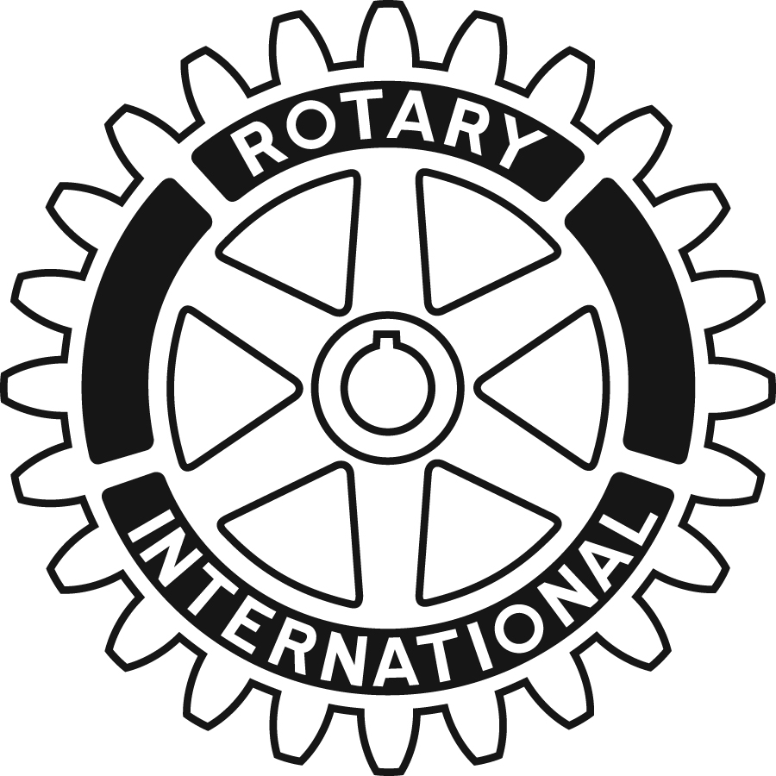
The Children of the Dump
Beads for Hope – Fundraiser in a Box
Order Form – Wholesale / Clubs
Your purchase of these one-of-a-kind hand crafted items helps Rotarians provide thousands of children with water, food, education, and opportunities for sustained economic development.

Item Code | Item | Color scheme | Wholesale Price each | Quantity order | Total
JKIT | Instant fundraiser kit. Includes: 100 bracelets, one 8x10 poster, one DVD, order forms. Shipping is included in the USA and Canada | Assorted | 375.00
Each bead has been hand-crafted using recycled wall paper. Because of the limited color selection the shades of color that we can offer are reds, blues, greens, browns, blacks, beiges and multi-color. Some colors are limited so each box will be assorted according to the colors available. |  |  |  | Sub-total
 |  |  |  | Shipping and handling
 |  |  |  | Total

Please make checks payable to:
Hope and Relief International Foundation
or
Charge my credit card – check one

Amex | Credit card #: ____________________________________________  Expiration date: ___________________Security code: ___________  Signature: _______________________________Date:____________
MasterCard
Visa
Discover

Name on credit card:___________________________________________________

CC billing address:________________________________ email:________________

City__________________________ State_____________ Zip code____________

