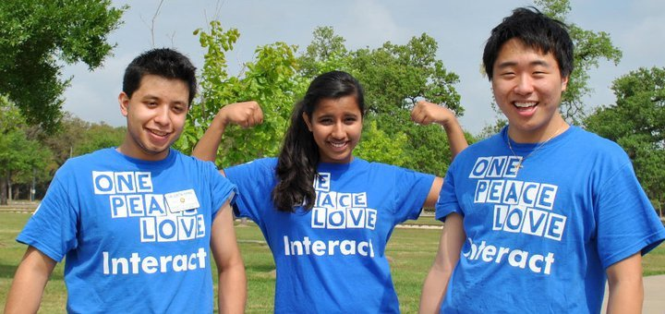
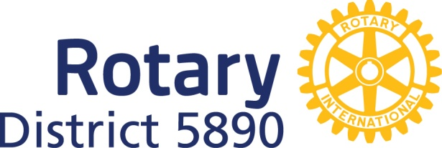

Interact is...
Interact is…495,880 Interactors in 21,560 Interact clubs in over 143 countries & geographical areas!
INTERnational ACTion! Service! Serious Fun! Literacy Projects! Helping Eradicate Polio!
International Service Projects! Helping Provide Clean Water! Improving the Environment!
Developing Your Leadership Skills! Making A Difference In The World!
Making New Friends Around The Globe!
Making A Positive Difference In MY Community...In YOUR Community...and in THEIR Community!!!
INTERACT IS..."THE" SOCIAL ACTION PLAN and Interactors are “PEOPLE OF ACTION”
Interact is...for remarkable young leaders ages 12-18!
DO YOU INTERACT?

Interact….your chance to have some SERIOUS FUN!
▪ Make new friends ▪ Improve your community through service projects
   ▪ Make a difference in the world ▪ Develop leadership skills and personal integrity

Interact is a service and social club for young people ages 12-18. Each club is sponsored by a Rotary club, which guides the Interactors in developing local and international service projects. Interact derives its name from the words “international” and “action,” reflecting the nature of an organization that exists in 143 countries and promotes active service at home and abroad. With over 495,880 members in 21,560 clubs worldwide, Interact provides a powerful force of youthful enthusiasm and energetic service.
Interact clubs are self-governing and self-supporting, offering many opportunities for members to develop valuable leadership and teamwork skills. Each club carries out local service projects that benefit its community or school, such as fundraisers for a variety of causes, blood drives, benefit concerts, and visits to nursing homes, orphanages, and homeless shelters. Interactors also develop international service projects that expand their understanding of the world and promote goodwill.
Interact is a great way to meet people and make new friends. Interactors organize dances, sporting events, and other activities as a way to raise funds and have fun at the same time. Working together on car washes, food drives, or clean-up campaigns, club members get to know each other better and build many lasting friendships. At Interact conferences for clubs in a specific area, members have a chance to expand their network of Interact friendships and share ideas for projects and other club activities.
Interact also offers a chance to make friends across borders and oceans. Through service projects with Interact clubs in other countries, Interactors learn about different cultures, promote goodwill between nations, and sometimes even travel abroad to work with their international service partners.

In addition to the rewards gained from helping others through service, Interactors have the opportunity to:
▪ Begin preparing for their future by speaking at a Rotary club meeting ▪
▪ Attending events sponsored by Rotary clubs ▪
▪ Shadowing a Rotarian to learn more about a specific profession ▪
▪ Develop a strong work ethic and sense of individual responsibility by organizing projects to improve the environment ▪
▪ Eradicate polio, promote drug awareness, and address other community problems ▪
▪ Learn more about other cultures by communicating and working with Interactors abroad ▪
▪Broaden their horizons by getting to know the variety of people they serve…the elderly, children with disabilities, the homeless, and many others throughout your local community, and beyond ▪
What do you want to do to change the world? Ok…let’s start today! Join Interact!

“I was very selfish when I found out I had to do service. I thought ‘I don’t have time for this.’ I dance and I have schoolwork. When I helped at my first Interact project, on my way home I was like, okay it wasn’t what I really thought...It actually changed me. I don’t know if it was that first time, but it definitely changed me. What was that feeling? It’s not about me... it’s about other people. How can I help? Initially I just went in for the credit; that is what pulled me into the program. But then when we started working with the kids, and helping others...it’s the feeling you get helping somebody. "I" made a difference..."I" was needed!” Anonymous Interactor
Visit the Interact The Interact Club of ----------- High School is sponsored
District 5890 Site Page by the Rotary Club of ----.
Visit their website: www.?????
Interact Club Adviser: (Rotarian's name, Email: ---- Cell #:
"Rotary Club of ?"

