INTERACT DISTRICT 5890 SERVICE PROJECT...HELP END HUNGER!
Food will be donated to COMMUNITY FOOD BANKS
For the 7th year, we are encouraging all our District 5890 Interactors, Rotarians, and Rotaractors to "Trick-or-Treat To End Hunger" this Halloween.
Since 2012, our Interactors collected over 125,000 non-perishable food items
for their local community food banks.
Our 2018 goal is 30,000 cans!
Special thanks to the Robert E. Lee HS Interact Club in Baytown since they started this project and they've issued a challenge to all D5890 Interact clubs to do this project. They have also contact other Interact clubs in the USA, so they've helped this project expand to high schools in several states!

Here's what you do! On October 31st, or during Halloween week, instead of
"Trick-or Treating" for candy, you'll "Trick-or-Treat" for non-perishable food which your Interact club will donate to local food banks or organizations serving the hungry, or housing facilities for the elderly.

INTERACT DISTRICT 5890 "TRICK-OR-TREAT TO END HUNGER" PROJECT
Please help us to help the hungry in your community.
This is a great partnership project between the Interact, Rotaract & Rotary clubs.
Interactors: Visit local Rotary club meetings to talk to the Rotarians. Notify your local media so they can let the community know what you are doing.
Rotarians/Rotaractors: Help the Interactors by asking your members to bring non-perishable food items to meetings during October. Help the Interactors with transportation collecting donations, then assist them with transportation and logistics of bringing the food to YOUR LOCAL COMMUNITY FOOD BANK.
More information will be posted on the D5890 website at www.rotary5890.org

"Service Above Self"
Jonathan Yuan, 2018-2019 Interact District Governor jonjonyuan2010@gmail.com
Brittni Staff, District 5890 Interact Committee bstaff@cityofelcampo.org
(979) 578-6347

"TRICK-OR-TREAT TO END HUNGER 2018"
HOW-TO FOR INTERACT, ROTARACT AND ROTARY CLUBS:
- Two weeks PRIOR to Halloween, flag your local neighborhoods and businesses with information about "7th Annual Interact District 5890 Trick-or-Treat To End Hunger 2018"....and send articles to local media.
- Get your club excited! (Have collection boxes at meetings)
- Interactors...Involve your school! Have a home-room or class competition, or lunch drive.
- Partner with other clubs at your school: the more the merrier!
- Interactors...Offer service hours for donations. (i.e.: 5 cans=1 hour.)
- Involve your Rotary club with this project. You need their help. (Vehicles, transportation, publicity, etc.)
- Have an accurate count in the end to report to 5890 the total amount your club collected. (send info to Brittni Staff via email to bstaff@cityofelcampo.org)
- Your Interact club selects where they donate the food.
- HAVE FUN! Make this a membership-strengthening experience for ALL Interact, Rotaract, and Rotary clubs.

"Service Above Self"
Jonathan Yuan, 2018-2019 Interact District Governor jonjonyuan2010@gmail.com
Brittni Staff, District 5890 Interact Committee bstaff@cityofelcampo.org
(979) 578-6347

Interact Clubs: Develop your own business card, or use this as a handout at each home
(Two should fit on one piece of paper, then all you need to do it cut)

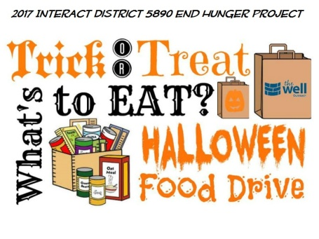

"Trick-or-Treat To Help End Hunger - Interact District 5890 Hungry Harvest 2018" Project

Who are we?: Members of the _________ High School Interact Club and we are sponsored by the Rotary club of ____________ .
What are we?: Interact is the world’s largest student-based service organization
Our Project: We are collecting non-perishable food items in our neighborhood this Halloween which we'll donate to our local food bank.

ALL THE FOOD ITEMS COLLECTED WILL BE DONATED TO (Insert food bank name here)
Our 2018 goal is (insert your goal) non-perishable food items, so donate as much you like!
For more information, please contact our sponsoring Rotary club which is the Rotary Club of ___________, (insert website, insert phone #, insert Rotarian's name)
Rotary and Interact Motto: "Service Above Self"

