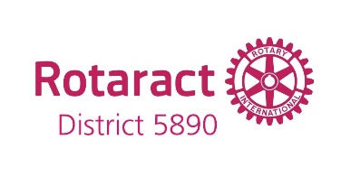
ROTARACT CLUB NEW MEMBER INSTALLATION CEREMONY

Today is a special day because we are installing a new member to our Rotaract Club of ____________, __________________________________________________(Name of New Member).

______________(First Name) this is an indication of the esteem and confidence that your fellow Rotaractors have in you. We also believe you will uphold the high moral and ethical standards of your club, and that you will give the best of your ability to the furtherance of the interest of your Rotaract club, and the carrying forward the morals and ethics of Rotary.

Membership in Rotaract is an honor and a privilege with corresponding duties and obligations, including service to your club, community, and beyond. You will be expected to participate in multiple levels of service, and to attend this club's meetings regularly.

With 203,298 Rotaractors in 10,698 Rotaract clubs in 180 countries and geographical area, you are members of a worldwide elite group of young leaders that represent the best individuals in their respective communities, and countries.

Your community, will know and judge Rotaract by your actions. Rotaract is like everything else - you get out of it what you put into it.

As a member of the “Family of Rotary, Rotaractors are encouraged to foster the ideal of service as a basis of worthy enterprise:
-The development of acquaintances as an opportunity for service;
- High ethical standards in your daily life, using your Rotaract club as opportunity to serve society;
-The application of the ideal of service by every Rotaractor in their personal, family, and community life.
-The advancement of international understanding, goodwill, and peace through a world fellowship of Rotaractors united in the ideal of service.

I charge each of you to judge yourself by Rotary’s motto, “Service Above Self” and the Rotary Four-Way Test: Of the things you think, say or do:
First…Is it the Truth?
Second…Is it fair to all concerned?
Third…Will it build goodwill and better friendships?
Fourth…Will it be beneficial to all concerned?

“_____________________________ (First Name) You have been chosen for membership in the Rotaract Club of____________________________ because we believe you to be a leader, and because you display those characteristics which will enable you to enjoy Rotaract, and Rotaract's message of service and goodwill. Do you accept these responsibilities, and do you agree to uphold the constitution and bylaws of this Rotaract club?"

Answer: I will.

It is my pleasure on behalf of the board of directors and the members of the Rotaract Club of ________________ to welcome you as a member.

