Alphabetical List of Rotaract Clubs in Texas
(College/University and Community Based) (See Page 10 for maps)

Alamo Dominion Rotaract Club - San Antonio, TX
Can't find Facebook or website
Located in Rotary District 5840 - "Rotary 5840" Facebook: https://www.facebook.com/Rotary5840

Angelina College Rotaract Club - Lufkin TX
Facebook: " The rotoract Club of Angelina College" https://www.facebook.com/pages/The-rotoract-Club-of-Angelina-College/364719204920
Located in Rotary District 5910 -
"Rotary District 5910" Facebook: https://www.facebook.com/pages/Rotary-District-5910/194465020603636

Art Institute of San Antonio Rotaract Club - San Antonio, TX
Facebook: "Rotaract Club Art Institute-SA" https://www.facebook.com/RotaractAI
Email: rotaractaisa@yahoo.com
Located in Rotary District 5840 - "Rotary 5840" Facebook: https://www.facebook.com/Rotary5840

Beaumont Rotaract Club - Beaumont, TX
Facebook: "Beaumont Rotaract" https://www.facebook.com/BeaumontRotaract
Located in Rotary District 5910 -
"Rotary District 5910" Facebook: https://www.facebook.com/pages/Rotary-District-5910/194465020603636

Brookhaven College Rotaract Club - Farmers Branch Texas
Facebook: "Brookhaven College Rotaract Club: https://www.facebook.com/BCRotaract
Email:
Websites: http://www.brookhavencollege.edu/studentsvcs/spar/service-learning/rotaract.aspx or http://144.162.92.131/studentsvcs/spar/service-learning/rotaract.aspx
Located in Rotary District 5810 -
"Rotary District 5810" Facebook: https://www.facebook.com/RotaryDistrict5810?ref=br_tf
"Rotaract5810" Facebook Page:https://www.facebook.com/groups/1426845337528100/

Cameron University Rotaract Club - Lawton, Oklahoma
Facebook: Cameron Rotaract Club https://www.facebook.com/CURotaractClub
Website: http://cameronrotaract.org/home/
Located in Rotary District 5770 - "Rotary District 5770" Facebook: https://www.facebook.com/pages/Rotary-District-5770/113933318634894

Continued on next page...
Central Texas College Rotaract Club - Killeen, TX
Facebook: "Central Texas College Rotaract Club" https://www.facebook.com/CTCRotaractClub
Website: http://www.ctcd.edu/locations/central-campus/student-life/clubs-organizations/rotaract/
Email: ctcrotaract@gmail.com
Located in Rotary District 5870 - "District 5870 Rotary" Facebook: https://www.facebook.com/groups/97015990701/

Collin College Rotaract Club, Plano, TX
Facebook: "Collin College Rotaract [Spring Creek Campus]" https://www.facebook.com/CollinRotaractSCC
Website: http://www.collinrotaract.org
Emails: collinrotaract@gmail.com or collinrotaract@collin.edu
Located in Rotary District 5810 -
"Rotary District 5810" Facebook: https://www.facebook.com/RotaryDistrict5810?ref=br_tf
"Rotaract5810" Facebook Page:https://www.facebook.com/groups/1426845337528100/

East Central University Rotaract Club - Ada, Oklahoma
Facebook: "ECU Rotaract Club" https://www.facebook.com/EcuRotaractClub
Website: https://www.ecok.edu/ECURotaract
Located in Rotary District 5770 - "Rotary District 5770" Facebook: https://www.facebook.com/pages/Rotary-District-5770/113933318634894

Galleria Area Rotaract Club (Community Based located in the Galleria Area) - Houston, TX
Facebook: "Galleria Rotaract" https://www.facebook.com/GalleriaRotaract
Email: GalleriaRotaract@gmail.com
Meetings: The Galleria Tennis & Athletic Club. 6:30-7:30 every other Wednesday
Located in Rotary District 5890 -
"Rotary District 5890" Facebook: https://www.facebook.com/rotarydistrict5890
"Rotaract District 5890" Facebook: https://www.facebook.com/Rotaract5890

Galveston Rotaract Club - Galveston TX
Facebook: "Galveston Rotaract" https://www.facebook.com/groups/galvestonrotaract/
Located in Rotary District 5910 -
"Rotary District 5910" Facebook: https://www.facebook.com/pages/Rotary-District-5910/194465020603636

Hillsdale Freewill Baptist College Rotaract Club - Moore, Oklahoma
Website: http://www.hc.edu/365469.ihtml?eventid=7605169
Located in Rotary District 5770 - "Rotary District 5770" Facebook: https://www.facebook.com/pages/Rotary-District-5770/113933318634894

Continued on next page...
Houston Rotaract Club (Community/University Based near the University of Houston and Texas Southern University) Houston, TX
Facebook: "Rotaract Club of Houston" http://www.facebook.com/pages/Rotaract-Club-of-Houston/254872901219845?ref=hl
President: Karen Huynh - k.huynh09@yahoo.com
Located in Rotary District 5890 -
"Rotary District 5890" Facebook: https://www.facebook.com/rotarydistrict5890
"Rotaract District 5890" Facebook: https://www.facebook.com/Rotaract5890

Incarnate Word College Rotaract Club - San Antonio, TX
Can't find Facebook or website
Located in Rotary District 5840 - "Rotary 5840" Facebook: https://www.facebook.com/Rotary5840

Lamar University Rotaract Club - Beaumont TX
Facebook: "LU Rotaract" https://www.facebook.com/LURotaract
Website: http://lamar.orgsync.com/org/rotaractcluboflamaruniversity or https://orgsync.com/24236/chapter
Located in Rotary District 5910 -
"Rotary District 5910" Facebook: https://www.facebook.com/pages/Rotary-District-5910/194465020603636

Lee College Rotaract Club, Baytown (College Based) - Baytown, TX
Faculty Adviser: Dr. Gregory Lattier Email: glattier@lee.edu
Facebook: "Lee College Rotaract/Service Learning Club" https://www.facebook.com/pages/Lee-College-RotaractService-Learning-Club/120343434737714?ref=br_tf
Located in Rotary District 5890 -
"Rotary District 5890" Facebook: https://www.facebook.com/rotarydistrict5890
"Rotaract District 5890" Facebook: https://www.facebook.com/Rotaract5890

Lone Star College Rotaract Club - Montgomery (The Woodlands) - The Woodlands, TX
Facebook: " Rotaract Club of Lone Star College - Montgomery" https://www.facebook.com/LoneStarRotaract
Website: http://www.lonestar.edu/montgomery-rotaract.htm
Faculty Adviser: Steve Scheffler, Email:: steve.j.scheffler@lonestar.edu
Located in Rotary District 5910 -
"Rotary District 5910" Facebook: https://www.facebook.com/pages/Rotary-District-5910/194465020603636

Continued on next page...

Navaro College Rotaract Club - Corsicana, TX
Facebook: "Rotaract Club of Navaro College: https://www.facebook.com/pages/Rotaract-Club-of-Navarro-College/114700001874815
Located in Rotary District 5870 - "District 5870 Rotary" Facebook: https://www.facebook.com/groups/97015990701/

River Oaks Rotaract Club (Community Based)
Web: www.RotaractofRiverOaks.org
Facebook: "Rotaract Club of River Oaks" www.facebook.com/groups/8204377138/
Emails: club@rotaractofriveroaks.org
Meetings: Every 1st and 3rd Thursday of the month
Located in Rotary District 5890 -
"Rotary District 5890" Facebook: https://www.facebook.com/rotarydistrict5890
"Rotaract District 5890" Facebook: https://www.facebook.com/Rotaract5890

San Jacinto College Rotaract Club - North Campus (College Based) - Houston, TX
Facebook: "San Jacinto College North Rotaract" https://www.facebook.com/SanJacintoCollegeNorthRotaract
Located in Rotary District 5890 -
"Rotary District 5890" Facebook: https://www.facebook.com/rotarydistrict5890
"Rotaract District 5890" Facebook: https://www.facebook.com/Rotaract5890

SMU (Southern Methodist University) Rotaract Club - Dallas, TX
Facebook: "SMU Rotaract | Rotary Club of Dallas" https://www.facebook.com/SMURotaractClub
Email: smurotaract@dallasrotary.org
Website: http://www.dallasrotary.com/smu-rotaract
Located in Rotary District 5810 -
"Rotary District 5810" Facebook: https://www.facebook.com/RotaryDistrict5810?ref=br_tf
"Rotaract5810" Facebook Page:https://www.facebook.com/groups/1426845337528100/

Southeast Oklahoma State University Rotaract Club - Durant, Oklahoma
Faculty Adviser: Dr. Gleny Beach
Email: gbeach@se.edu
Located in Rotary District 5770 - "Rotary District 5770" Facebook: https://www.facebook.com/pages/Rotary-District-5770/113933318634894

St. Edwards University Rotaract Club, Austin - Austin, TX
Facebook: "Rotaract Club of St. Edward's University" https://www.facebook.com/RotoractSEU
Website: https://stedwards.collegiatelink.net/organization/rotaract
Email: https://stedwards.collegiatelink.net/organization/rotaract
Located in Rotary District 5870 - "District 5870 Rotary" Facebook: https://www.facebook.com/groups/97015990701/

St. Philipps College Rotaract Club - San Antonio, TX
Can't find Facebook or website
Located in Rotary District 5840 - "Rotary 5840" Facebook: https://www.facebook.com/Rotary5840

Texas A&M International University Rotaract Club - Laredo TX
Facebook: "Tamiu Rotaract" https://www.facebook.com/pages/Tamiu-Rotaract/324431814319901
Website: https://tamiu.collegiatelink.net/organization/Rotaract
Faculty Adviser: Oralia Roach (956) 326-2183
Located in Rotary District 5930 -
"Rotary District 5930" Facebook: https://www.facebook.com/RotaryDistrict5930

Texas A&M University Rotaract Club - College Station, TX
Facebook: "Aggie Rotaract" https://www.facebook.com/groups/234312133288111/
Website: http://rotaract.tamu.edu/
Meetings: Sunday, 7 PM, Rudder Tower
Located in Rotary District 5910 -
"Rotary District 5910" Facebook: https://www.facebook.com/pages/Rotary-District-5910/194465020603636

Texas A&M University-Central Texas Rotaract Club - Killeen, TX
Facebook: "Texas A&M University-Central Texas" https://www.facebook.com/tamuct
Website: http://www.tamuct.edu
Email: info@ct.tamus.edu
Located in Rotary District 5870 - "District 5870 Rotary" Facebook: https://www.facebook.com/groups/97015990701/

Texas A&M University Corpus Christi Rotaract Club - Corpus Christi, TX
Meetings: Wednesday, 7 PM
Facebook: "Rotaract TAMUCC" https://www.facebook.com/TamuccRotaract

Texas A&M University Corpus Christi Rotaract Club - Corpus Christi, TX (continued)
Email: rotaract.tamucc@gmail.com
Located in Rotary District 5930 -
"Rotary District 5930" Facebook: https://www.facebook.com/RotaryDistrict5930

Texas A&M University Kingsville Rotaract Club - Kingsville TX
Facebook: "Tamuk Rotaract" https://www.facebook.com/tamuk.rotaract?fref=ts
Web: https://tamuk.collegiatelink.net/organization/rotaract
Meetings: Memorial Student Union Building
Located in Rotary District 5930 -
"Rotary District 5930" Facebook: https://www.facebook.com/RotaryDistrict5930

Texas Lutheran University Rotaract Club in Seguin, TX
Can't find Facebook or website
Located in Rotary District 5840 - "Rotary 5840" Facebook: https://www.facebook.com/Rotary5840

Texas State University Rotaract Club - San Marcos, TX
Facebook: "Texas State Rotaract Club" https://www.facebook.com/TexasStateRotaract
Email: jl1679@txstate.edu
Located in Rotary District 5840 - "Rotary 5840" Facebook: https://www.facebook.com/Rotary5840

Trinity University Rotaract Club - San Antonio, TX
Rotary Adviser: Joan Kearl, Email: jkearl@satx.rr.com
Located in Rotary District 5840 - "Rotary 5840" Facebook: https://www.facebook.com/Rotary5840

University Area Rotaract Club - Houston
Located in Rotary District 5890 and will be chartered in October 2016
Email for the sponsoring Rotary Club of University Area Houston: sheath@heathesq.com

University of Dallas Rotaract Club - Irving TX
Email: lsandoval@udallas.edu
Located in Rotary District 5810 -
"Rotary District 5810" Facebook: https://www.facebook.com/RotaryDistrict5810?ref=br_tf
"Rotaract5810" Facebook Page:https://www.facebook.com/groups/1426845337528100/

University of Mary Hardin-Baylor Rotaract Club - Belton TX
Facebook: "Rotaract Club of UMHB" https://www.facebook.com/groups/mabeysiri/
Website: http://studentorgs.umhb.edu/rotaract-club-umhb

University of Mary Hardin-Baylor Rotaract Club - Belton TX
Email: umhbrotaract@gmail.com
Located in Rotary District 5870 - "District 5870 Rotary" Facebook: https://www.facebook.com/groups/97015990701/

University of Houston Rotaract Club (University Based)
Facebook Group: https://www.facebook.com/groups/293195727709547/
Rotaract club's website: https://uh.collegiatelink.net/organization/rotaract
Email: lcervantes15@yahoo.com
Located in Rotary District 5890 -
"Rotary District 5890" Facebook: https://www.facebook.com/rotarydistrict5890
"Rotaract District 5890" Facebook: https://www.facebook.com/Rotaract5890

Continued on next page...
University of North Texas Rotaract Club - Denton, TX
Facebook: "UNT Rotaract Club" https://www.facebook.com/untrotaract
Email: untrotaract@gmail.com
Website: https://orgsync.com/60120/chapter
Located in Rotary District 5790 - "Rotary District 5790" Facebook: https://www.facebook.com/groups/339990962767309/?ref=br_tf

University of Oklahoma Rotaract Club - Norman, Oklahoma
Website: http://www.ou.edu/rotaract/
Facebook: "OU Rotaract" https://www.facebook.com/RotaractOU
Email: rotaract@ou.edu
Rotary Adviser: Dennis Brigham, Email: dennis.brigham@bentleyturffarms.com
Located in Rotary District 5770 - "Rotary District 5770" Facebook: https://www.facebook.com/pages/Rotary-District-5770/113933318634894

University of Texas at Arlington Rotaract Club - Arlington, TX
Facebook: "Rotaract Arlington" https://www.facebook.com/RotaractUTA
Website: https://mavorgs.collegiatelink.net/organization/rotaract
Located in Rotary District 5790 - "Rotary District 5790" Facebook: https://www.facebook.com/groups/339990962767309/?ref=br_tf

University of Texas at Austin Rotaract Club - Austin, TX
(Home Rotaract Club of Houston area Interactors and RYLA Coaches: Eduardo Belalcazar, Anusha Hasan, and Carolina Medina)
Facebook: "UT Rotaract Club" https://www.facebook.com/groups/UTAustinRotaractClub/?ref=br_tfhttps://www.facebook.com/groups/UTAustinRotaractClub/?ref=br_tf
Website: http://rotaractutaustin.webs.com/
Email: utarotaract@gmail.com
Located in Rotary District 5870 - "District 5870 Rotary" Facebook: https://www.facebook.com/groups/97015990701/

University of Texas at Brownsville Rotaract Club - Brownsville, TX
Facebook: "Rotaract Brownsville" https://www.facebook.com/rotaract.brownsville
Located in Rotary District 5930 -
"Rotary District 5930" Facebook: https://www.facebook.com/RotaryDistrict5930

University of Texas at Dallas Rotaract Club - Richardson, TX
Facebook: "Rotaract at UT Dallas" https://www.facebook.com/utdrotaract
Email: rotaract.utd@gmail.com Located in Rotary District 5810 -
"Rotary District 5810" Facebook: https://www.facebook.com/RotaryDistrict5810?ref=br_tf
"Rotaract5810" Facebook Page:https://www.facebook.com/groups/1426845337528100/
University of Texas at El Paso Rotaract Club - El Paso, TX
Facebook: "UTEP-Rotaract Club" https://www.facebook.com/pages/UTEP-Rotaract-Club/162671433791631
Email: rotaract@listserv.edu
Located in Rotary District 5520 -
"Rotary District 5520" Facebook: https://www.facebook.com/rotary5520/?fref=ts

University of Texas at San Antonio Rotaract Club - San Antonio, TX
(Home Rotaract Club of our 2012-2013 Interact District Governor & RYLA Coach - Garrett Kneese)
Website: http://utsarotaract.org/
Facebook: "Rotaract Club at UTSA" https://www.facebook.com/Rotaract.UTSA
Former D5890 Interact District Governor Garrett Kneese is a member of this Rotaract Club
Located in Rotary District 5840 - "Rotary 5840" Facebook: https://www.facebook.com/Rotary5840

University of Texas Pan American Rotaract Club - Edinburg, TX
Facebook: "Rotaract Club at The University of Texas - Pan American" https://www.facebook.com/RotaractClubAtTheUniversityOfTexasPanAmerican
Email: rotaract_utpa@hotmail.com
Located in Rotary District 5930 -
"Rotary District 5930" Facebook: https://www.facebook.com/RotaryDistrict5930

West Houston/Katy Rotaract Club (Community Based) - Katy, TX
Website: www.rotaractclubofwesthoustonkaty.weebly.com/
Facebook: "West Houston/Katy Rotaract" https://www.facebook.com/groups/WhkRotaract/
Email: aafranco19@gmail.com
Located in Rotary District 5890 -
Rotary Contact: Brendan Scott, Email: Brendan.Scott@edwardjones.com

West Texas A&M University Rotaract Club - Canyon, TX
Faculty Adviser: Bonnie Pendelton, Email: bpendleton@wtamu.edu
Located in Rotary District 5730 - Facebook: https://www.facebook.com/WestTexasRotary

Western Oklahoma Rotaract Club - Altus, Oklahoma
Rotary Contact: Phil Moss 405-990-7750
Email: pmoss@cox.net
Located in Rotary District 5770 - "Rotary District 5770" Facebook: https://www.facebook.com/pages/Rotary-District-5770/113933318634894

See next page for maps of the State of Texas and the State of Oklahoma:

Map below shows where Rotary District in the State of Texas are located:

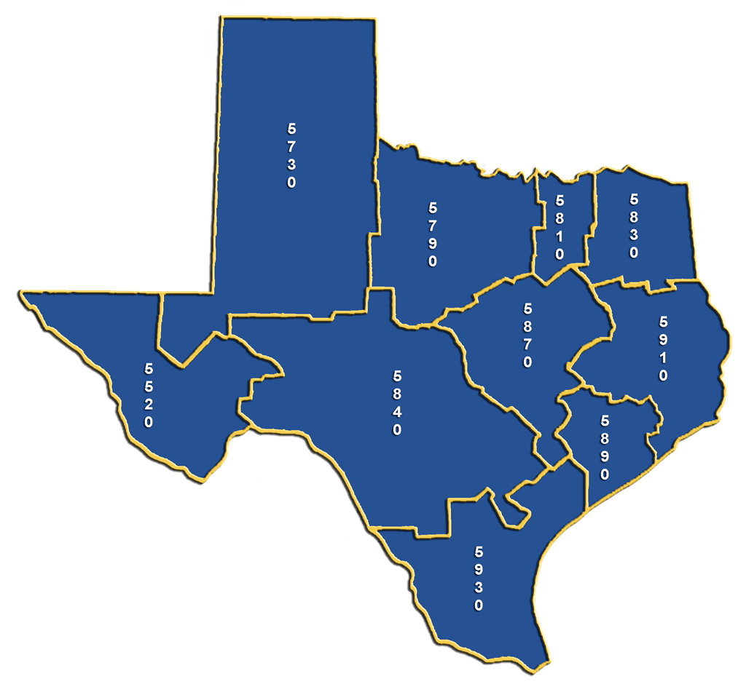

Map below shows where Rotary District 5770 in the lower southwest Oklahoma is located:

