Rotaract Clubs in Texas- Listed by Rotary District

ROTARY DISTRICT 5730 (see Texas map on page 8)
"Rotary District 5730" Facebook: https://www.facebook.com/WestTexasRotary
"Rotary District 5730" Facebook: https://www.facebook.com/pages/Rotary-District-5730/160438914339
Could not find Rotaract District 5730 Facebook Page
Rotaract Club West Texas A&M University - Canyon, TX
Faculty Adviser: Bonnie Pendelton, Email: bpendleton@wtamu.edu

ROTARY DISTRICT 5770(see Oklahoma map on page 8)
"Rotary District 5770" Facebook: https://www.facebook.com/pages/Rotary-District-5770/113933318634894
Could not find a Rotaract District 5770 Facebook Page
Rotaract Club of Cameron University - Lawton, Oklahoma
Facebook: Cameron Rotaract Club https://www.facebook.com/CURotaractClub
Website: http://cameronrotaract.org/home/

Rotaract Club of East Central University - Ada, Oklahoma
Facebook: "ECU Rotaract Club" https://www.facebook.com/EcuRotaractClub
Website: https://www.ecok.edu/ECURotaract

Rotaract Club of Hillsdale Freewill Baptist College - Moore, Oklahoma
Website: http://www.hc.edu/365469.ihtml?eventid=7605169

Rotaract Club of Southeast Oklahoma State University - Durant, Oklahoma
Faculty Adviser: Dr. Gleny Beach
Email: gbeach@se.edu

Rotaract Club of University of Oklahoma - Norman, Oklahoma
Website: http://www.ou.edu/rotaract/
Facebook: "OU Rotaract" https://www.facebook.com/RotaractOU
Email: rotaract@ou.edu
Rotary Adviser: Dennis Brigham, Email: dennis.brigham@bentleyturffarms.com

Rotaract Club of Western Oklahoma - Altus, Oklahoma
Rotary Contact: Phil Moss 405-990-7750
Email: pmoss@cox.net

ROTARY DISTRICT 5790 (see Texas map on page 8)
"Rotary District 5790" Facebook: https://www.facebook.com/groups/339990962767309/?ref=br_tf
"Rotary District 5790" Facebook: https://www.facebook.com/rotary5790
Could not find Rotaract District 5790 Facebook page

Rotaract Club of University of North Texas - Denton, TX
Facebook: "UNT Rotaract Club" https://www.facebook.com/untrotaract
Email: untrotaract@gmail.com
Website: https://orgsync.com/60120/chapter

Rotaract Club of University of Texas at Arlington - Arlington, TX
Facebook: "Rotaract Arlington" https://www.facebook.com/RotaractUTA
Website: https://mavorgs.collegiatelink.net/organization/rotaract

ROTARY DISTRICT 5810 (see Texas map on page 8)
"Rotary District 5810" Facebook: https://www.facebook.com/RotaryDistrict5810?ref=br_tf
"Rotaract5810" Facebook Page:https://www.facebook.com/groups/1426845337528100/

Rotaract Club of Brookhaven College - Farmers Branch Texas
Facebook: "Brookhaven College Rotaract Club: https://www.facebook.com/BCRotaract
Email:
Websites: http://www.brookhavencollege.edu/studentsvcs/spar/service-learning/rotaract.aspx or http://144.162.92.131/studentsvcs/spar/service-learning/rotaract.aspx

Rotaract Club of Collin College, Plano, TX
Facebook: "Collin College Rotaract [Spring Creek Campus]" https://www.facebook.com/CollinRotaractSCC
Website: http://www.collinrotaract.org
Emails: collinrotaract@gmail.com or collinrotaract@collin.edu

Rotaract Club of SMU (Southern Methodist University) - Dallas, TX
Facebook: "SMU Rotaract | Rotary Club of Dallas" https://www.facebook.com/SMURotaractClub
Email: smurotaract@dallasrotary.org
Website: http://www.dallasrotary.com/smu-rotaract

Rotaract Club of University of Dallas - Irving TX
Email: lsandoval@udallas.edu

Rotaract Club of University of Texas at Dallas - Richardson, TX
Facebook: "Rotaract at UT Dallas" https://www.facebook.com/utdrotaract
Email: rotaract.utd@gmail.com
ROTARY DISTRICT 5830 (see Texas map on page 8)
"Rotary International District 5830" Facebook: https://www.facebook.com/pages/Rotary-International-District-5830/144599867061?ref=br_tf
"Rotary District 5830" Facebook: https://www.facebook.com/groups/89269662838/
Could not find Rotaract clubs listed

ROTARY DISTRICT 5840 (see Texas map on page 8)
"Rotary 5840" Facebook: https://www.facebook.com/Rotary5840
Could not find Rotaract District 5840 Facebook page

Rotaract Club of Alamo Dominion - San Antonio, TX
Can't find Facebook or website

Rotaract Club of Art Institute of San Antonio - San Antonio, TX
Facebook: "Rotaract Club Art Institute-SA" https://www.facebook.com/RotaractAI
Email: rotaractaisa@yahoo.com

Rotaract Club of Incarnate Word College - San Antonio, TX
Can't find Facebook or website

Rotaract Club of St. Philipps College - San Antonio, TX
Can't find Facebook or website

Rotaract Club of Texas Lutheran University in Seguin, TX
Can't find Facebook or website

Rotaract Club of Texas State University - San Marcos, TX
Facebook: "Texas State Rotaract Club" https://www.facebook.com/TexasStateRotaract
Email: jl1679@txstate.edu

Rotaract Club of Trinity University - San Antonio, TX
Rotary Adviser: Joan Kearl, Email: jkearl@satx.rr.com

Rotaract Club of University of Texas at San Antonio - San Antonio, TX
(Home Rotaract Club of our 2012-2013 Interact District Governor & RYLA Coach - Garrett Kneese)
Website: http://utsarotaract.org/
Facebook: "Rotaract Club at UTSA" https://www.facebook.com/Rotaract.UTSA

ROTARY DISTRICT 5870 (see Texas map on page 8)
"District 5870 Rotary" Facebook: https://www.facebook.com/groups/97015990701/
Could not find Rotaract District 5870 Facebook

Rotaract Club of Central Texas College - Killeen, TX
Facebook: "Central Texas College Rotaract Club" https://www.facebook.com/CTCRotaractClub
Website: http://www.ctcd.edu/locations/central-campus/student-life/clubs-organizations/rotaract/
Email: ctcrotaract@gmail.com

Rotaract Club of Navaro College - Corsicana, TX
Facebook: "Rotaract Club of Navaro College: https://www.facebook.com/pages/Rotaract-Club-of-Navarro-College/114700001874815

Rotaract Club of St. Edwards University, Austin - Austin, TX
Facebook: "Rotaract Club of St. Edward's University" https://www.facebook.com/RotoractSEU
Website: https://stedwards.collegiatelink.net/organization/rotaract
Email: https://stedwards.collegiatelink.net/organization/rotaract

Rotaract Club of Texas A&M University-Central Texas - Killeen, TX
Facebook: "Texas A&M University-Central Texas" https://www.facebook.com/tamuct
Website: http://www.tamuct.edu
Email: info@ct.tamus.edu

Rotaract Club of University of Mary Hardin-Baylor - Belton TX
Facebook: "Rotaract Club of UMHB" https://www.facebook.com/groups/mabeysiri/
Website: http://studentorgs.umhb.edu/rotaract-club-umhb
Email: umhbrotaract@gmail.com

Rotaract Club of University of Texas at Austin - Austin, TX
(Home Rotaract Club of Houston area Interactors and RYLA Coaches: Eduardo Belalcazar, Anusha Hasan, and Carolina Medina)
Facebook: "UT Rotaract Club" https://www.facebook.com/groups/UTAustinRotaractClub/?ref=br_tfhttps://www.facebook.com/groups/UTAustinRotaractClub/?ref=br_tf
Website: http://rotaractutaustin.webs.com/
Email: utarotaract@gmail.com

Continued.....
ROTARY DISTRICT 5890 (see Texas map on page 8)
"Rotary District 5890" Facebook: https://www.facebook.com/rotarydistrict5890
"Rotaract District 5890" Facebook: https://www.facebook.com/Rotaract5890
2016-2017 Rotaract District Rep (District Governor): Jenna Buscemi, jenna.buscemi@gmail.com
2016-2017 District 5890 Rotaract Co-Chairs: Frank Parrilla, Email: flparrilla@icloud.com
Lindsey Kroll, Email: L.kroll@ieee.org
"Interact District 5890" Facebook page: https://www.facebook.com/interact5890
2016-2017 Interact District Chair: Charlie Buscemi, Email: cjsb@suddenlink.net
2016-2017 District New Generations Chair: Tommie Buscemi, Email: tommie5890@suddenlink.net

Rotaract Club of Galleria Area (Community Based located in the Galleria Area) - Houston, TX
Facebook: "Galleria Rotaract" https://www.facebook.com/GalleriaRotaract
Email: GalleriaRotaract@gmail.com
Meetings: The Galleria Tennis & Athletic Club. 6:30-7:30 every other Wednesday
Rotaract Club of Houston (Community/University Based near the University of Houston and Texas Southern University) Houston, TX
Facebook: "Rotaract Club of Houston" http://www.facebook.com/pages/Rotaract-Club-of-Houston/254872901219845?ref=hl
President: Karen Huynh - k.huynh09@yahoo.com
Rotaract Club of Lee College, Baytown (College Based) - Baytown, TX
Faculty Adviser: Dr. Gregory Lattier Email: glattier@lee.edu
Facebook: "Lee College Rotaract/Service Learning Club" https://www.facebook.com/pages/Lee-College-RotaractService-Learning-Club/120343434737714?ref=br_tf
Rotaract Club of River Oaks (Community Based in the River Oaks area near University of St. Thomas University, Rice University, Baylor University, and the Texas Medical Center) - Houston, TX
Web: www.RotaractofRiverOaks.org
Facebook: "Rotaract Club of River Oaks" www.facebook.com/groups/8204377138/
Emails: club@rotaractofriveroaks.org
Rotaract Club of San Jacinto Community College - North Campus (College Based) - Houston, TX
Facebook: "San Jacinto College North Rotaract" https://www.facebook.com/SanJacintoCollegeNorthRotaract

Rotaract Club of University Area - Houston (located in the area of Rice University and the University of St. Thomas in Houston)
Located in Rotary District 5890 and is in the process of being chartered in October 2016.
Email for the sponsoring Rotary Club of University Area Houston: sheath@heathesq.com

Continued on next page...
Rotaract Club of University of Houston (University Based but U of H allows non-students to join)
Facebook Group: https://www.facebook.com/groups/293195727709547/
Rotaract club's website: https://uh.collegiatelink.net/organization/rotaract
Email: lcervantes15@yahoo.com
Located in Rotary District 5890 -
"Rotary District 5890" Facebook: https://www.facebook.com/rotarydistrict5890
"Rotaract District 5890" Facebook: https://www.facebook.com/Rotaract5890

Rotaract Club of West Houston/Katy (Community Based) - Katy, TX
Website: www.rotaractclubofwesthoustonkaty.weebly.com/
Facebook: "West Houston/Katy Rotaract" https://www.facebook.com/groups/WhkRotaract/
Email: whkrotaract@gmail.com
Located in Rotary District 5890

ROTARY DISTRICT 5910 (see Texas map on page 8)
"Rotary District 5910" Facebook: https://www.facebook.com/pages/Rotary-District-5910/194465020603636
Could not find a Rotaract District 5910 Facebook page
Rotaract Club of Angelina College - Lufkin TX
Facebook: " The rotoract Club of Angelina College" https://www.facebook.com/pages/The-rotoract-Club-of-Angelina-College/364719204920
Rotaract Club of Beaumont - Beaumont, TX
Facebook: "Beaumont Rotaract" https://www.facebook.com/BeaumontRotaract
Rotaract Club of Galveston - Galveston TX
Facebook: "Galveston Rotaract" https://www.facebook.com/groups/galvestonrotaract/

Rotaract Club of Lamar University - Beaumont TX
Facebook: "LU Rotaract" https://www.facebook.com/LURotaract
Rotaract Club of Lamar University - Beaumont TX
Website: http://lamar.orgsync.com/org/rotaractcluboflamaruniversity or https://orgsync.com/24236/chapter

Rotaract Club of Lone Star College - Montgomery (The Woodlands) - The Woodlands, TX
Facebook: " Rotaract Club of Lone Star College - Montgomery" https://www.facebook.com/LoneStarRotaract
Website: http://www.lonestar.edu/montgomery-rotaract.htm
Faculty Adviser: Steve Scheffler, Email:: steve.j.scheffler@lonestar.edu

Rotary District 5910 continued....
Rotaract Club of Texas A&M University - College Station, TX
Facebook: "Aggie Rotaract" https://www.facebook.com/groups/234312133288111/
Website: http://rotaract.tamu.edu/ Meetings: Sunday, 7 PM, Rudder Tower

ROTARY DISTRICT 5930 (see Texas map on page 8)
"Rotary District 5930" Facebook: https://www.facebook.com/RotaryDistrict5930
Could not find Rotaract District 5930 Facebook page

Rotaract Club of Texas A&M Kingsville - Kingsville TX
Facebook: "Tamuk Rotaract" https://www.facebook.com/tamuk.rotaract?fref=ts
Web: https://tamuk.collegiatelink.net/organization/rotaract
Meetings: Memorial Student Union Building

Rotaract Club of Texas A&M Corpus Christi - Corpus Christi, TX
Meetings: Wednesday, 7 PM
Facebook: "Rotaract TAMUCC" https://www.facebook.com/TamuccRotaract
Email: rotaract.tamucc@gmail.com

Rotaract Club of Texas A&M International University - Laredo TX
Facebook: "Tamiu Rotaract" https://www.facebook.com/pages/Tamiu-Rotaract/324431814319901
Website: https://tamiu.collegiatelink.net/organization/Rotaract
Faculty Adviser: Oralia Roach (956) 326-2183

Rotaract Club of the University of Texas at Brownsville - Brownsville, TX
Facebook: "Rotaract Brownsville" https://www.facebook.com/rotaract.brownsville

Rotaract Club of the University of Texas Pan American - Edinburg, TX
Facebook: "Rotaract Club at The University of Texas - Pan American" https://www.facebook.com/RotaractClubAtTheUniversityOfTexasPanAmerican
Email: rotaract_utpa@hotmail.com

ROTARY DISTRICT 5520 (see Texas map on page 8)
While not a part of our 10 Lone Star P.E.T.S. Rotary districts, Rotary District 5520 has the following:
Rotaract Club of the University of Texas at El Paso - El Paso, TX
Facebook: "UTEP-Rotaract Club" https://www.facebook.com/pages/UTEP-Rotaract-Club/162671433791631
Email: rotaract@listserv.edu
Located in Rotary District 5520 -
"Rotary District 5520" Facebook: https://www.facebook.com/rotary5520/?fref=ts

Continued on next page....

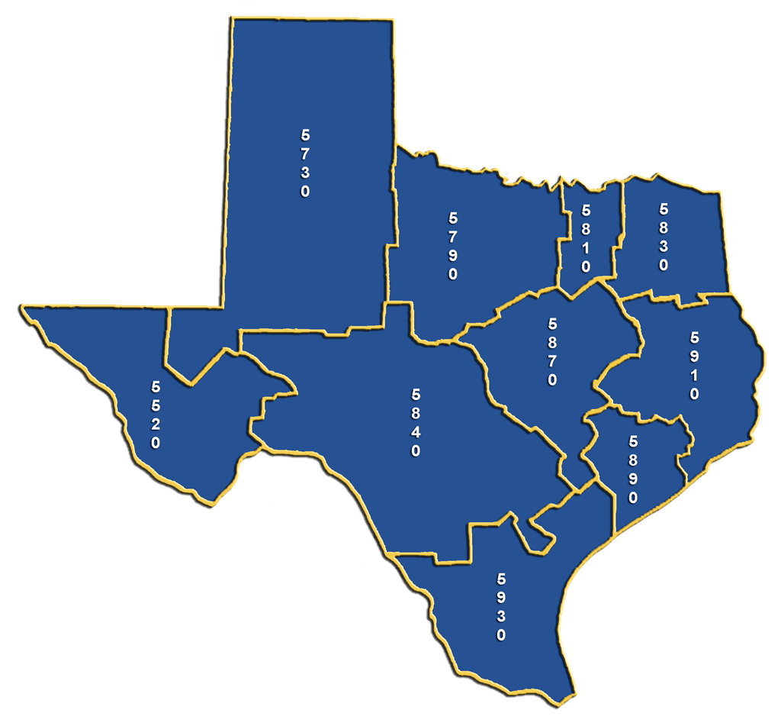

Rotary District 5770 is located in southwest Oklahoma (see yellow area on Oklahoma map above)

