# ROTARY DISTRICT 5910

# DISTRICT GRANT APPLICATION CHECKLIST

# 2025-2026

# APPLICATION DEADLINE - AUGUST 15, 2025

***NO APPLICATIONS ACCEPTED AFTER DEADLINE***

Your Club’s District Grant Application cannot be accepted if any of the following has not been completed. This checklist must accompany your District Grant application.

Rotary Club:

Two club members have completed the online grants training (Modules 1 & 2) ***prior to***

***August 1, 2025***

President and President-Elect have executed the MOU

Goals for Annual Fund and PolioPlus have been entered in Rotary Club Central

Names of Foundation, Public Image and Membership Chairs have been entered at MyRotary.org

Club has paid District 5910 and Rotary International July 2025 invoices in full

Club has a separate bank account or has established separate GL accounts

for proper grant project accounting

Club has no overdue reports for Global or prior year District Grants

All application questions have been answered fully and completely

President’s Signature: __________________________________ Date: _____________________

President’s Name: ______________________________________

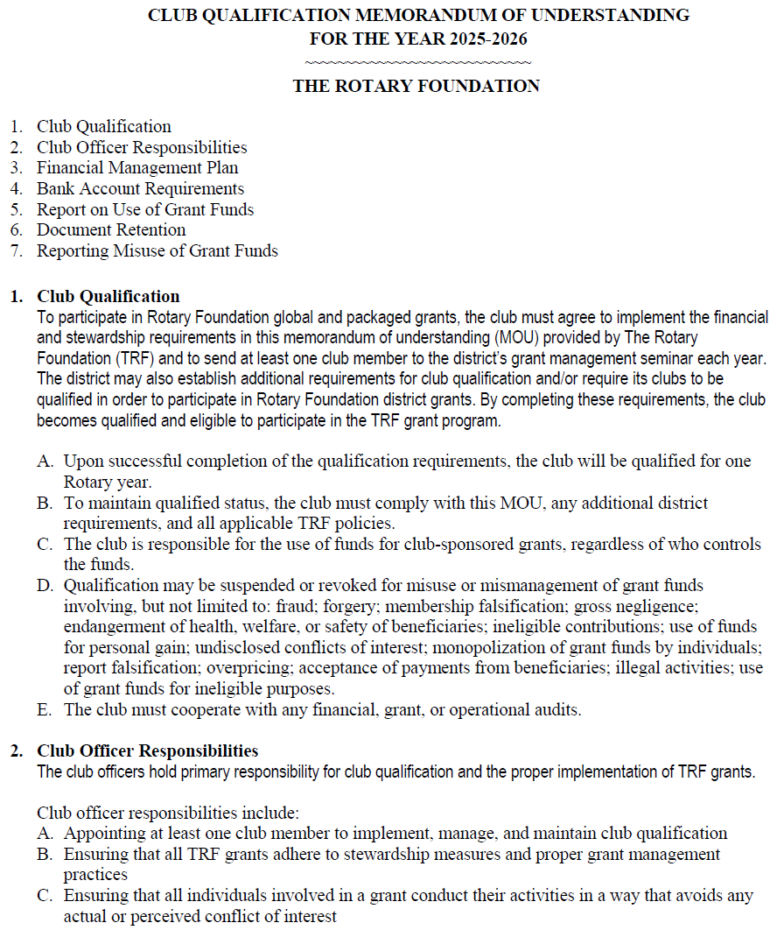

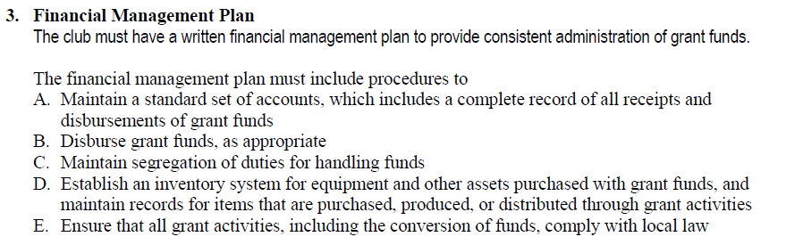

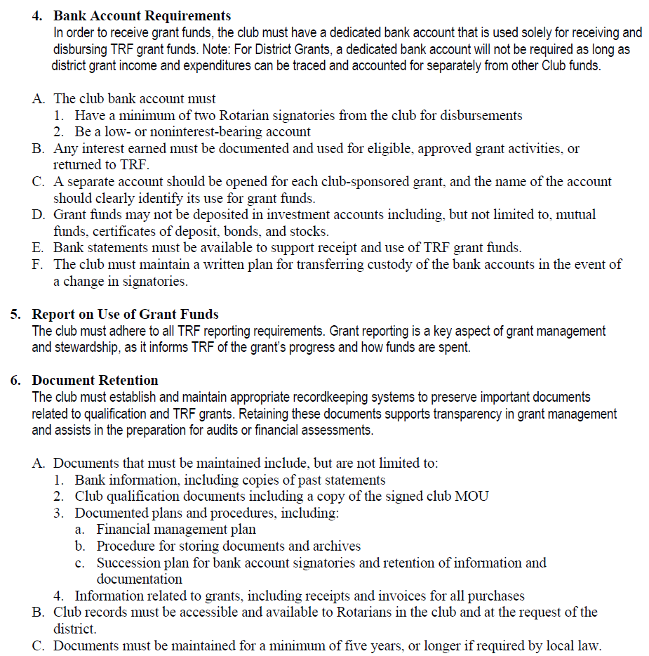

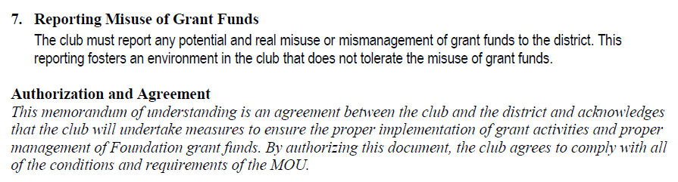

*On behalf of the Rotary Club of _________________________________, the undersigned agree to comply with all of the conditions and requirements of the MOU for Rotary year* ***2025-2026*** *and will notify Rotary International* ***District 5910*** *of any changes or revisions to club policies and procedures related to these requirements.*

|  |  |  |  |  |
| --- | --- | --- | --- | --- |
|  | **Club President** |  |  | **Club President-elect** |
| **Term** |  |  | **Term** |  |
| **Name** |  |  | **Name** |  |
| **Signature** |  |  | **Signature** |  |
| **Date** |  |  | **Date** |  |

|  |  |  |
| --- | --- | --- |
|  | D5910 District Grant Application 2025-2026     |  | | --- | | ***Complete and return to:***  **Ruth Finkelstein Suhler**  **District Grants Chair**  **409-771-7738**    **Email signed copy to:**  [**rotary5910grants@gmail.com**](mailto:rotary5910grants@gmail.com)  **by August 15, 2025** | |

|  |  |
| --- | --- |
| Rotary Club: |  |

|  |  |  |
| --- | --- | --- |
| Our club is currently qualified under rules for Rotary District Grants. | ____ Yes | ____ No |

Names of 2 members who completed Qualifications Training:

_______________________________________ ___________________________________________

Anticipated Start Date ____________________ Expected Completion Date ___________________

###### **Project Description**

1. Briefly describe the project objectives and its location. Description must include

(1) what will be done;

(2) when and where project activities will take place; and

(3) who are the beneficiaries.

1. Humanitarian Efforts: Describe how the project will benefit the community and/or improve the lives of the less fortunate.
2. Number of members of the community whose needs will be met by the implementation of this project. May include how project was identified.
3. Describe non-financial participation by Rotarians in the project (i.e., SPECIFIC Rotarian activities). What percentage of the club’s members will be DIRECTLY involved in carrying out the project?
4. District 5910’s grants will provide funding for an acceptable project. If the District can only provide partial funding, please describe what effect this partial funding would have on your project proposal and what adjustments might need to be made (scaling down of project and/or what other sources of funds would be used, etc.).
5. If this is an international project, explain the ways in which the host and international partners will communicate and work together to implement this project.
6. Publicity Plan:

(1) How will the general public know this is a Rotary sponsored project?

(2) What is your publicity plan?

(3) What tangible Rotary recognition will be connected to this project?

(4) Is the recognition permanent?

1. If the project involves a cooperating organization, please provide the name of the organization(s) and its role.

|  |
| --- |
|  |

###### **Financial Report – Project Budget** *(Club must retain receipts of all expenditures)*

9. Income Amount

|  |  |
| --- | --- |
| 1. District Grant funds to be received from the District |  |
| 2. Rotary Club Funds |  |
| 3. Other Funding |  |
| **Total Project Income** |  |

*Note: Rotary Club Funds must equal or exceed District Grant Funds

10. Expenditures (please be specific and add lines as needed)

|  |  |
| --- | --- |
| 1. |  |
| 2. |  |
| 3. |  |
| 4. |  |
| 5. |  |
| 6. |  |
| 7. |  |
| 8. |  |
| **Total Project Expenditures** |  |

*Note: Total Project Income must equal Total Project Expenditures.

11. **Presidents:** By signing this report, I confirm that to the best of my knowledge these District Grant funds will be spent only for eligible items in accordance with Trustee-approved guidelines as listed in Rotary’s Terms and Conditions for District Grants, and that all of the information contained herein is true and accurate. Receipts for all grant-funded expenditures will be provided to the District. If a cooperating organization is involved in the project, the Club certifies that the cooperating organization will adhere to and abide by the Rotary Terms and Conditions for District Grants.

**Clubs MUST submit the Final Grant Report within 30 days of project completion, but not later than June 1, 2026. Late submission of the Final Grant Report will affect future grant awards.**

In addition, I confirm that this grant application has been approved by the Board of Directors of the club.

President’s Signature ________________________________ Date: _____________________

President’s Name (please print): ___________________________________

President’s Contact Information:

Address: ______________________________________________________________________

Home Phone: ________________ Office Phone: _________________ Cell: _________________

E-mail: ______________________________ Rotary Club: _______________________________

**Rotary Club Contact Information:**

Project Contact: Two Rotarians (one may be the President) must be listed who will provide oversight and management of the project funds for the entire duration of the project.

|  |  |
| --- | --- |
| **Primary Contact**  Name: ____________________________  Rotary Position/Title: _________________  E-mail: ___________________________  Address: __________________________  Telephone: Home ________________  Office: __________________________  Cell: ___________________________  **Address To Mail Grant Payment**  Name: ___________________________  Address: _________________________  City, State Zip: _____________________ | **Secondary Contact**  Name: ______________________________  Rotary Position/Title: ___________________  E-mail: ______________________________  Address: ____________________________  Telephone: Home ________________  Office: __________________________  Cell: ___________________________ |
|  |  |