What is Rotary?
Rotary International is the world’s first and leading service organization. Rotarians form a global network of business and professional leaders who volunteer their time, talents, and resources to serve their communities and the world.
Rotary has rich, sometimes complex, traditions and structures. This presentation outlines the Rotary basics, the fundamentals that make every member even prouder to be a Rotarian.

Rotary’s Beginning
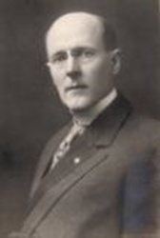
The world's first service club, the Rotary Club of Chicago, formed in 1905 by Paul Harris. He was an attorney, lonely in the big city, who wished to capture in a club the same friendly spirit he had felt in the small towns of his youth. The “Rotary” name comes from the early practice of rotating meetings among members' offices. The first four Rotarians were Gustavus Loehr, Silvester Schiele, Hiram Shorey, and Paul Harris. Soon, the club did a community service project, a public toilet.
Rotary spreads and the Kansas City Rotary Club was organized in 1910, the 13th Club. Within a decade, clubs were chartered from San Francisco to New York to Winnipeg, Canada. By 1921, Rotary clubs were thriving on six continents. A year later, the organization became “Rotary International.” The first six Rotary presidents were Paul Harris, Glenn C. Mead, Russell F. Greiner, Frank L. Mulholland, Allen D. Albert, and Arch C. Klump.
Rotary’s mission expanded beyond serving members’ professional and social interests. Rotarians began pooling their resources and contributing their talents to help those in need.
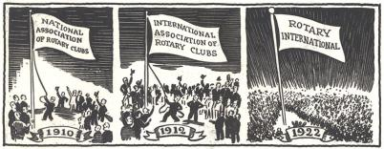

History of the rotary club of kansas city – “Club 13”
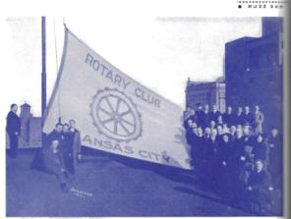
In April 1910, Bruno Batt, a piano dealer from St. Louis and charter President of the St Louis Rotary Club, met with Dr. Johnson in Kansas City and suggested the Kansas Citians form a Rotary Club. The club organized on May 15, 1910, and Lee Mettler was the first president. The 2nd Club President, Russell Greiner, who went on to become R.I. President in 1913.
Russell Greiner was appointed Chairman of a committee to design a Rotary flag. The honor of flying the flag for the first time was accorded to Russell Greiner before a large crowd of Rotary and civic dignitaries on the top of the Baltimore Hotel in Kansas City, January 1915. Today, the Rotary flag is hung in Rotary meetings in nearly 200 countries around the world.
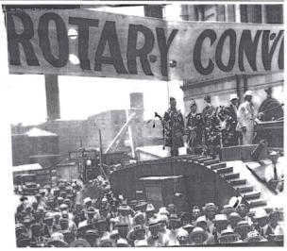
The R.I. Convention came to Kansas City in 1918. With World War I raging, this convention was known as the Win the War Convention. There is a famous photo of conventioneers in front of the new Union Station – the faces of Rotary in 1918, all with their skimmer hats.
Club 13’s Ray Havens was selected Rotary International President in 1922-23. As his good friend Ray Havens prepared to become RI President, Greiner once again became Club President. He served as Club President while his friend served as RI President. Famous Kansas Citians who served as Club 13 Presidents include Joyce Hall, who founded Hallmark, and KC Mayor H. Roe Bartle.
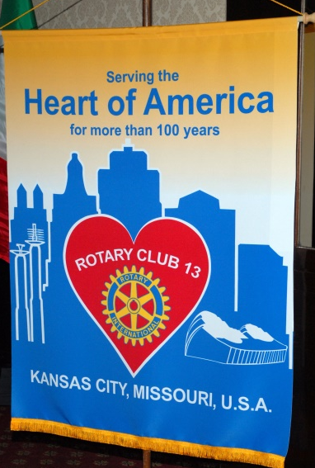
In 1985, the R.I. Convention was once again held in Kansas City, with 12,900 attendees. Rotary launched Polio Plus to fund operations to eradicate polio worldwide, Albert Sabin who discovered oral polio vaccine urged Rotarians to maintain their commitment to immunize around the world.
Club 13 celebrated 100 years of Rotary service in Kansas City in May 2010.

Structure of the Club
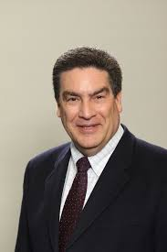
A Rotary Club President term of office is one year beginning July 1st and Joe Privitera is the Club’s current president. Eric Bubb is the Club’s current secretary/treasurer.
The Club’s Board of Directors is composed of 6 Directors each serving 2 year terms, a Secretary-Treasurer serving a one year term, the President-Elect and the Immediate Past President.

Rotary International’s Structure
Rotary’s structure begins with the local club. Each club elects its own officers and enjoys considerable autonomy within the framework of Rotary’s constitution and bylaws. A technical point: Rotarians are members of the local Club. The club is a member of Rotary International.
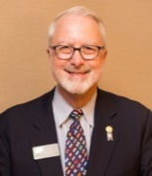
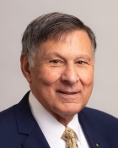
Clubs work together in groups called “districts.” Our District 6040 includes 55 clubs in Kansas City and northern Missouri. There are 531 Rotary Districts in the world, each led by a District Governor. Our district governor this year is Marc Horner (club 13 member). The Governor is supported by assistant governors and various committees. The District’s purpose is to support the clubs.
Districts are organized into Zones with a Rotary International Director representing two Zones. Club 13 is in District 6040 which is in Zone 31. RI Director Floyd Lancia represents Zones 30 & 31.
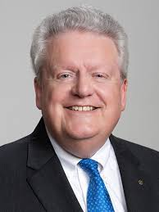
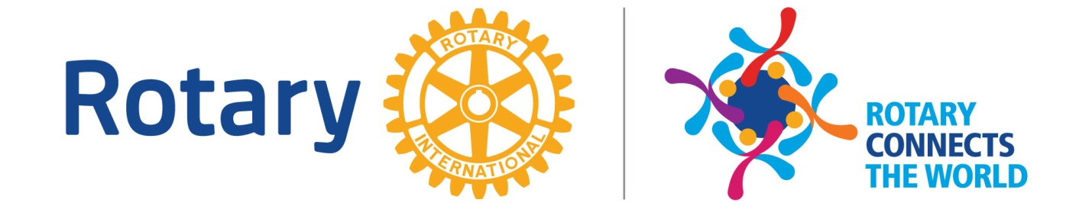
Rotary International is governed by a 19-member Board of Directors, which includes the RI president and president-elect. Directors are elected by representatives from the districts. The RI president, elected annually, develops a theme and service emphases for the year. The RI President is Mark Maloney and the 19/20 theme is “Rotary Connects the World.” Rotary International is headquartered in the Chicago suburb of Evanston, Illinois. There are seven international offices in Argentina, Australia, Brazil, India, Japan, Korea, and Switzerland.

Rotary’s Motto
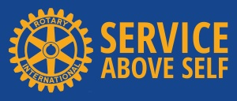
Our motto, Service above Self, exemplifies the humanitarian spirit of the over 1.2 million members of Rotary. It is a constant challenge to all Rotarians. Rotary can touch lives and transform social institutions only if its members embody the ideal of service in their daily lives.

Guiding Principles
These principles have been developed over the years to provide Rotarians with a strong, common purpose and direction. They serve as a foundation for our relationships with each other and the action we take in the world.

The Four-Way Test
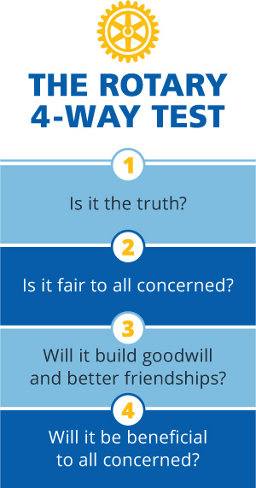
The Four-Way Test is followed by Rotarians around the globe in their personal, business and professional lives. Its words were written by a Rotarian, Herbert J. Taylor, in 1932. He was asked to take charge of the Club Aluminum Company, facing bankruptcy in the Great Depression. Taylor drew up this 24-word code of ethics for all employees to follow. The Four-Way Test became the guide for sales, production, advertising, and all relations with suppliers and customers. The company survived.
The Four-Way Test was adopted by Rotary in 1943. Translated into over 100 languages, it is used by organizations and individuals worldwide. Herb Taylor became president of RI in 1954-55.

The object of rotary
FIRST: The development of acquaintance as an opportunity for service;
SECOND: High ethical standards in business and professions; the recognition of the worthiness of all useful occupations; and the dignifying of each Rotarian’s occupation as an opportunity to serve society;
THIRD: The application of the ideal of service in each Rotarian’s personal, business, and community life;
FOURTH: The advancement of international understanding, goodwill, and peace through a world fellowship of business and professional persons united in the ideal of service.

Avenues of Service
To organize how Rotarians and clubs engage in Service Above Self, there are five avenues of service – five areas in which to demonstrate service.

Club Service
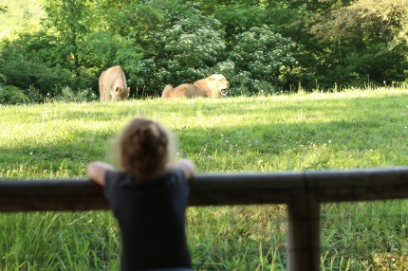
Club Service focuses on strengthening fellowship among Rotarians, and ensuring an effective club through the following committees:
ENTERTAINMENT: Plan social events for Club 13 members and spouses; i.e., Holiday Party, family picnic, events, etc.
INVOCATION: Arrange appropriate invocations for all Rotary meetings.
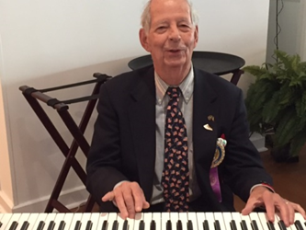
GREETING/MEETING ARANGEMENTS: Coordinate the groups appointed to greet each person attending a Rotary meeting. set up and take down for meetings.
MEMORIAL: Plan an event annually to honor Rotarians who have passed away that year. Program is held in mid-May.
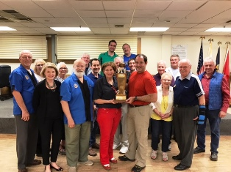
MUSIC: Arrange for music at weekly meetings; i.e. song leadership and piano accompaniment; arrange music for special events.
PROGRAM: Arrange suitable speakers/programs for weekly Rotary meetings; assist in planning programs for special meetings.
BOWLING LEAGUE: Bowlers meet weekly on Wednesdays at 4:30 pm, Sept. – April.
MEMBERSHIP DEVELOPMENT & RETENTION: Maintain a strong club membership by continually reviewing the unfilled classifications; follow-up on all new member prospects, urge members to submit proposals and organize the guest days. Mentor and guide members to become involved in activities and projects throughout the year.
TYROTARIAN: Integrate new members into club and activities during their first year.

Vocational
Vocational service reminds Rotarians to serve others through their occupations and professions, and to practice high ethical standards.

Community service
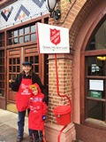
Community service encompasses the projects and activities our club undertakes to improve life in our community. Wherever there is a Rotary club, there are local Rotary projects that benefit the youth and adults in the area.
COMMUNITY SERVICE: Research new ideas for community service projects that heretofore have not been recognized by our club. Salvation Army Bell Ringing, Venture Fund Projects, etc.
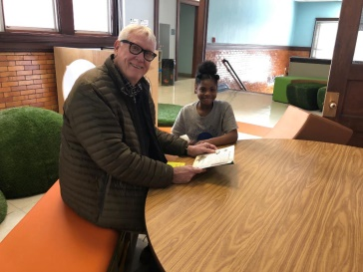
DOWNTOWN: As THE Downtown civic club, we have a responsibility to take part in any major effort to improve the Downtown area. Working with other civic organizations or acting on our own, this committee should develop projects to make downtown more active and attractive.
LITERACY: Assist in teaching adults to read. Participate in the annual Dictionary project. Continue to participate in the annual Corporate Spelling Bee event.
ECOLOGY: Establish environmental leadership and awareness for Club 13 members and our community.

Youth Service
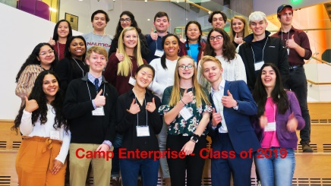
Our Club supports the New Generation through committees and projects.
CAMP ENTERPRISE: Plan and execute a one-day camp for high school students each fall. Purpose of session is to educate young people in principles of Free Enterprise system.
ROTARACT: Organize Community based and University based clubs of 18 -30 year olds to conduct service projects and professional development projects in our community using the RI Rotaract program.
INTERACT: Organize High School students to conduct service projects and professional development projects in our community using the RI Interact program.
EDUCATION EXCELLENCE: To help improve Kansas City School District teacher and student performance and appreciation, by presenting awards and scholarships to staff and students.
SHORT TERM & LONG TERM YOUTH EXCHANGE: Work with District leadership to select short term and long term youth exchange students.
RYLA (ROTARY YOUTH LEADERSHIP AWARDS): Nominate a student to attend this District wide project.

International Service
International Service is the avenue of service to those beyond this nation’s boundaries. Rotary’s humanitarian efforts encircle the globe, promoting world understanding and peace.
INTERNATIONAL SERVICE COMMITTEE
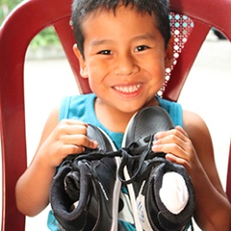
Enlist hosts for the Group Study Exchange, and the Friendship Exchange. Aids in hosting foreign visitors. Promote RI projects and assist with any special international projects. Projects may include the following:
Shoes for Orphan Souls
Ongoing projects and support in Zambia, Africa
THE ROTARY FOUNDATION COMMITTEE
Publicize availability of scholarships, and other educational awards available from the RI Foundation. Interview and recommend candidates to the district for scholarships; promote the Foundation by contributing to the R.I. Foundation. Promote Paul Harris Fellow Program and R.I. Benefactor program as well as the EREY "Every Rotarian Every Year" program.

Club 13’s signature project
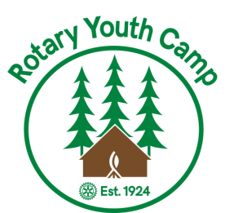
The Rotary Youth Camp
During the early years of Club 13’s existence, it was very involved with the Boys Hotel located on Armour Boulevard. Every summer the Boys Hotel sponsored Camp BoHoCa, a camp open to all deserving and needy boys in Kansas City. This camp closed in 1923. Robert W. Gees, then Club 13 President, saw the need of a recreational camp for deserving and needy youngsters. About 4 miles east of Unity Farm on Colbern Road, Mr. and Mrs. Gees found an ideal location for the camp – 40 acres of virgin soil, heavily wooded, with a stream of clear water and a rocky canyon. They acquired this land, put it into the Gees Trust and made it available to the Rotary Club. Its dedication included the following inspiring statement in part: “Contact with nature and the out-of-doors, amid forest and hills, far removed from the dirt and grime and noise of the city, under proper supervision and instruction, is conducive to the improvement of the physical and moral life of the citizen, and thereby promotes the general welfare of the city, state, and nation.” The Rotary Club accepted the challenge and responsibility in 1923 and each year since that date has met its challenge and carried out its responsibility. In 1929, the first swimming pool was built. It was very functional but not built with disabled campers in mind.
- In 1972, in honor of the golden anniversary of the camp, Project 50 was initiated. It was a major renovation project to build new cottages, a new kitchen, storm shelter and conference room and other needed improvements. The cost of over $750,000 was paid for by 1977. Today, there are 12 cottages.
- In 1980, a new Ranger House and Director’s building was added.
- In 1997, the new wheel chair accessible swimming pool was built. The new pool is well suited for children with disabilities.
- In 2005, Cassell Hall, a beautiful dining hall/activity center, replaced the old dining hall.
- In 2008, a comfort station was built. It is a state-of-the-art ADA accessible facility with multiple private shower facilities. The station includes washing machines.
- Currently, a three-year “Centennial Campaign” is underway to fund the construction of a new ADA compliant Health Administration Building.
Each year, the camp serves approximately 1,500 summer campers and 5,000 off-season campers from many area schools, religious groups and scouting organizations. During the summer the camp provides all facilities, meals and swimming instructors at no charge to the organizations. Rotary employs a full time year-around Camp Superintendent, Laurie Mozley.
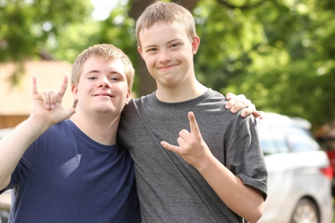
Through the summer, organizations send groups of children with disabilities or disadvantaged youths in groups of 40 to 100 and they stay at the camp 4 to 10 days. Participating organizations include the following:
- Down Syndrome Guild
- Boy Scouts
- Joshua Center for Tourette Syndrome
- Kansas City Indian Center
- Camp Rise
- Heart of America Indian Center
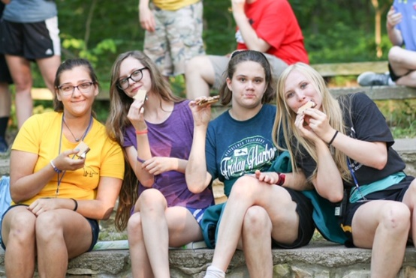
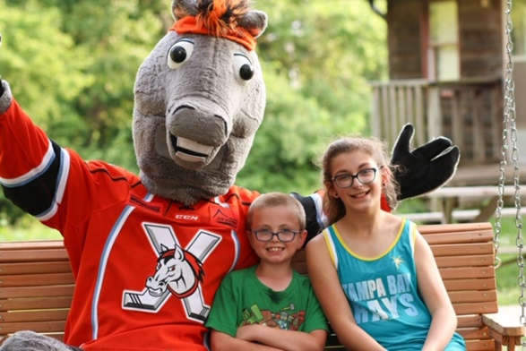
Every child with a disability deserves a little “normalcy” in their lives and the Rotary Youth Camp provides that over and over again. This is captured in the quote from a parent who sent her disabled child to the Rotary Youth Camp, “This camp gives my child something I can’t give him.”

How is the camp funded?
The Kansas City Rotary Club Foundation was established in 1973 under the leadership of Past President Bud Stiller with final approval by the IRS as a publicly supported organization in 1980 through the efforts of Bill G. Dietrich. Anyone who makes a contribution of $1,000 will become a KC Rotary Club Foundation Fellow.
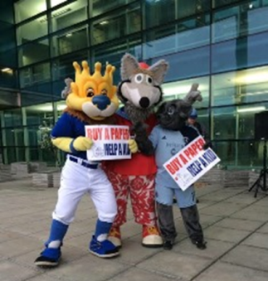
The primary goal of the Foundation is to insure the perpetuation of the Rotary Youth Camp.
Greater Kansas City Day is an annual fundraiser for the Rotary Youth Camp. Started in 1988, it is held on opening day of the Kansas City Royals. Approximately 1,500 volunteers from Club 13 and other local Rotary Clubs stand on street corners “selling” a special issue of the Kansas City Star. You will hear “Buy a Paper, Help the Kids” throughout the metro area. Volunteers are rewarded with a picnic at the ball park and tickets to a subsequent game.

The Rotary Foundation
As the world’s leading non-government, non-religious humanitarian foundation, The Rotary Foundation has many programs accomplishing various important missions.
The “Every Rotarian Every Year” initiative simply means that each member should give regularly to the Foundation. The recommended level is $100 per year (or more). When a Rotarian’s gifts total $1,000, he or she becomes a Paul Harris Fellow.
Polioplus is the name for Rotary’s dream of a polio-free planet. In 1985, Rotarians committed to eradicate Polio. By the time the world is certified polio-free, Rotary’s contributions to the global polio eradication effort will exceed US$2.2 billion, including US$985 million in matching funds from the Bill & Melinda Gates Foundation. Rotary’s contribution to the Global Polio Eradication Initiative since 1988 accounts for nearly 14% of all contributions through June 2017 and represents approximately 42% of private sector contributions.
Grants: Rotary members contribute their skills, expertise, and resources to help solve some of the world’s toughest problems. From providing clean water to promoting peace worldwide, Rotary Foundation grants bring service project ideas to life. In fiscal year 2018, The Rotary Foundation provided more than $86 million in grants.

How Can you become involved in rotary?
Our club is the hub of Rotary, where the most meaningful work is carried out. Our club needs to be effective, which means we must:
- sustain or increase our membership base
- participate in service project that benefit our communities and those in other countries
- contribute to The Rotary Foundation
- develop leaders capable of serving in the club, and beyond
To do this, each Rotarian must take responsibility.
Attendance: Attending weekly club meetings allows us to enjoy club fellowship, enrich our professional and personal knowledge, and meet other business leaders in this community.
Service: All Rotarians are committed to Service Above Self, for our community and those in need throughout the world. Find the ways you will serve.
Committees: Select a committee to serve on and attend its scheduled meetings.
Bring a friend or co-worker to meetings and to events. Share Rotary with others.
Attend social events and fellowship opportunities like Bowling, Book Discussion Group, Rambling Rotarians and After Hours.
Attend District Rotary meetings and get involved at that level.
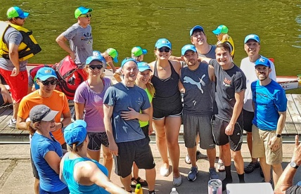
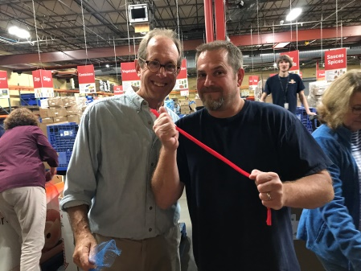
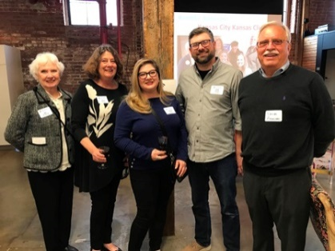
Visit www.Rotary.org, www.rotary6040.org and www.rotary13.org
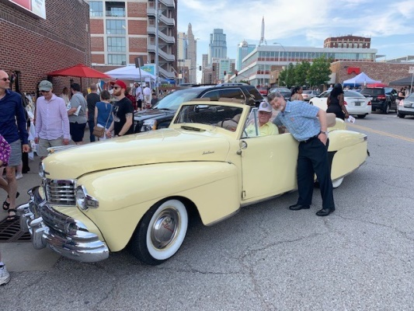
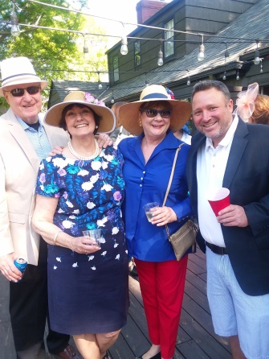
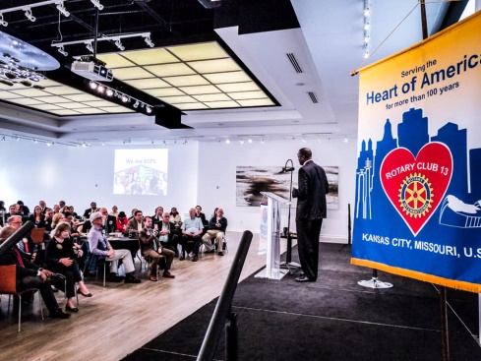

club communications
ClubRunner is the program we use to communicate with members about Club events. It also has an online directory that the members can update and use to find the contact information of other members. *Please note*- The online directory is for the personal use of members only and is not for general distribution, nor is it to be used as a commercial, charitable, political or personal mailing list.
You can get to this site by going to www.rotary13.org and clicking “Member Login” on the top right side of the Screen.
Your login is: FirstName.LastName.4680 (ex. Mandy.Sheldon.4680)
Your temporary password is: 4680
(Click on “Member Area” after you log in.)
You should change your password upon your first log in. On the first screen you come to, the Admin Screen, Under “My ClubRunner,” Changing your password is the second option.
The Admin Screen will allow you to do a lot of things, you can look at the online directory, upload a photo, edit your profile, register for events, look at the newsletter, etc.
When you receive an “e-vite” about a Club 13 event you can respond by clicking on “Attend or Decline” then log in and respond. You will then see this sign-up “commitment” listed at the bottom of your weekly newsletter, the Buzz Saw, as a reminder.
**NOTE: When sign-ups for events or projects are on the tables at lunch, you will not see them under commitments on the Buzz Saw – so please add them to your calendar!
There is a Mobile App of ClubRunner that features a Membership Directory. You can find this on your Smart Phone by searching your app store for “Clubrunner.” Once you download, you will need to log in.
For Questions, contact:
Mandy Sheldon
Executive Director
816-842-2322 mandy.sheldon@rotary13.org

new member “TYRO” checklist
The following checklist is to assist new Rotarians in developing their involvement, relationships and participation in the activities of Rotary Club 13. The goal is to complete the checklist within 3 months.
- This program will be in effect for members who join after January 1, 2019.
- New Lunch Members will continue to be known as “Tyrotarians” and will have a red ribbon affixed to their badge until completion of the following requirements:
  - Complete a New Member orientation
  - Attend four (4) lunch meetings
  - Give an invocation or welcome
  - Join an active committee
  - Participate in at least one (1) service project
- New Satellite Members will have the following requirements:
  - Complete a New Member orientation
  - Participate in at least one (1) service project
  - Attend two (2) meetings
- New Organizational Members will have the following requirement:
  - All named representatives will complete a new member orientation
- New members should notify the Rotary Office by email of their participation in an event or activity. The email should be sent to mandy.sheldon@rotary13.org .
- The Rotary office will maintain a contemporary record of activities completed per the New Member checklist
- Progress reports towards their completed requirements goal will be e-mailed monthly.
- Former Club 13 members who rejoin within 3 years will be exempted from the Orientation Program requirements.

welcome to rotary!
As a new member, you have the opportunity to become more involved in your community, and to help other parts of the world, through our club and Rotary International. Involvement is the key. Get to know your fellow Rotarians, and join arms with them to serve mankind.
You are welcome at any Rotary club anywhere in the world, where you will learn the local culture, where to go, what to do, and also see how Rotary enriches lives on this planet.
We encourage you to like and follow our Facebook and Twitter pages to stay up to date with everything going on in the Club.
Rotary Club 13 @rotary13

