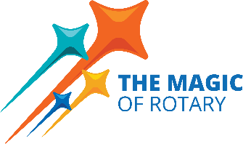
The Rotary Foundation grants & scholarships
resources and responsibilities for a
D6040 Rotary Club President

District Grants Chair: Beth Franklin, Bethfranklin@kw.com 816-665-5054
Global Grants Chair: Pat Knauss, plknauss@gmail.com 660-200-5106
Scholarships: Brad Kleindl, brad.kleindl@park.edu 816-719-1640
Resources;
Found at www.Rotary6040.org under the Foundation tab:
- District Grant Resources
  - 2024-2025 District Grant Guidelines document
  - 2024-2025 Memorandum of Understanding
  - 2024-2025 District Grant Application
  - 2024-2025 District Grant Final Report

- Global Grant Resources
  - 2024-2025 Global Grant Guidelines
  - 2024-2025 Letter of Intent

- Scholarships
  - District Scholarship Guidelines and Application
  - Global Grant Scholarship Guidelines and Application

Responsibilities with dates:
- May 31, 2024
  - 2023-2024 Completed District grant reports for the 2023/2024 Rotary Year are due to the D6040 District Grant Chair; Beth Franklin. These must be completed before the 2024-2025 grant requests from a club can be considered.
- June 15, 2024:
  - 2024-2025 Club President and Club Grants Manager, a minimum of two people, must complete on-line Grants Management Training on Rotary.org Learning Center.
  - Club Memorandum of Understanding signed by the 2024-2025 Club President and President-Elect is due to D6040 Grants Sub-Committee Chair.
    - Send copies of the Certificates of Completion for the online courses with the MOU.

- July 15, 2024:
  - Grant applications for 2024/2025 Rotary Year are due to D6040 District Grant Chair; Beth Franklin

- March 1, 2025:
  - Forward reviewed and interviewed District Scholarship applications to the District Scholarship Chair; Brad Kleindl

- May 1, 2025:
  - Forward reviewed and interviewed Global Scholarship applications to the District Scholarship Chair; Brad Kleindl

- May 31, 2025
  - Completed District grant reports for the 2024/2025 Rotary Year are due to the D6040 District Grant Chair; Beth Franklin

